SUPPLEMENTAL DIGITAL CONTENT

a Phase 2b, Randomized, Placebo-Controlled, Double-Blind, Dose-Ranging Study OF THE NEUROKININ 3 RECEPTOR ANTAGONIST FEZOLINETANT FOR VASOMOTOR SYMPTOMS associated with menopause

Graeme L. Fraser, PhD; Samuel Lederman, MD; Arthur Waldbaum, MD;
Robin Kroll, MD; Nanette Santoro, MD; Misun Lee, PhD; Laurence Skillern, MD;
Steven Ramael, MD

CONTENTS

Table S1. Secondary Efficacy Outcomes: Frequency of Moderate/Severe VMS and Severity per 24 Hours in Weeks 1 and 2, Full Analysis Set

Table S2. Secondary Efficacy Outcomes: Frequency of Mild/Moderate/Severe VMS and Severity per 24 Hours, Full Analysis Set

Table S3. Liver Function Tests, Safety Analysis Set

Figure S1. Response Rates and Odds of Response with Fezolinetant Versus Placebo Based on ≥50% Reduction in Frequency of Moderate/Severe VMS at Last On-Treatment Visit, Full Analysis Set

Figure S2. Endometrial Thickness, Safety Analysis Set

Table S1. Secondary Efficacy Outcomes: Frequency of Moderate/Severe VMS and Severity per 24 Hours in Weeks 1 and 2, Full Analysis Set
Wk | Treatment group (n) | Frequency of moderate/severe VMS  per 24 hoursª |  |  |  | Severity of moderate/severe VMS  per 24 hoursª
 |  | Change from baseline | Difference from placebo |  |  | Change from baseline | Difference from placebo
 |  | Mean (SE) | Mean (SE) | 95% CI | P value | Mean (SE) | Mean (SE) | 95% CI | P value
1 | Placebo (n=42) | -2.1 (0.59) | — | — | — | -0.1 (0.10) | — | — | —
 | Fezolinetant
 | 15 mg BID (n=45) | -3.8 (0.56) | -1.7 (0.78) | -3.23, -0.17 | .0297 | -0.4 (0.09) | -0.3 (0.13) | -0.60, -0.08 | .0098
 | 30 mg BID (n=43) | -5.3 (0.58) | -3.1 (0.78) | -4.66, -1.58 | <.0001 | -0.5 (0.10) | -0.4 (0.13) | -0.63, -0.11 | .0048
 | 60 mg BID (n=43) | -5.7 (0.57) | -3.6 (0.78) | -5.10, -2.02 | <.0001 | -0.6 (0.10) | -0.5 (0.13) | -0.80, -0.28 | <.0001
 | 90 mg BID (n=41) | -6.4 (0.60) | -4.2 (0.79) | -5.78, -2.66 | <.0001 | -0.8 (0.10) | -0.7 (0.13) | -1.00, -0.47 | <.0001
 | 30 mg QD (n=41) | -3.3 (0.60) | -1.2 (0.79) | -2.76, 0.36 | .1378 | -0.1 (0.10) | -0.1 (0.13) | -0.32, 0.21 | .6761
 | 60 mg QD (n=44) | -4.7 (0.56) | -2.6 (0.78) | -4.13, -1.05 | .0010 | -0.4 (0.09) | -0.3 (0.13) | -0.57, -0.05 | .0188
 | 120 mg QD (n=44) | -4.7 (0.58) | -2.6 (0.78) | -4.10, -1.04 | .0011 | -0.4 (0.10) | -0.4 (0.13) | -0.61, -0.10 | .0067
2 | Placebo (n=42) | -3.7 (0.60) | — | — | — | -0.2 (0.12) | — | — | —
 | Fezolinetant
 | 15 mg BID (n=44) | -5.3 (0.57) | -1.6 (0.79) | -3.20, -0.07 | .0405 | -0.5 (0.12) | -0.4 (0.17) | -0.68, -0.03 | .0335
 | 30 mg BID (n=42) | -6.8 (0.59) | -3.1 (0.80) | -4.70, -1.55 | .0001 | -0.7 (0.12) | -0.6 (0.17) | -0.91, -0.25 | .0007
 | 60 mg BID (n=43) | -6.8 (0.58) | -3.1 (0.80) | -4.66, -1.52 | .0001 | -1.0 (0.12) | -0.8 (0.17) | -1.14, -0.48 | <.0001
 | 90 mg BID (n=39) | -7.3 (0.61) | -3.7 (0.81) | -5.26, -2.07 | <.0001 | -1.2 (0.13) | -1.1 (0.17) | -1.41, -0.74 | <.0001
 | 30 mg QD (n=41) | -5.4 (0.61) | -1.7 (0.81) | -3.34, -0.15 | .0325 | -0.3 (0.13) | -0.2 (0.17) | -0.50, 0.17 | .3227
 | 60 mg QD (n=43) | -6.0 (0.57) | -2.4 (0.80) | -3.92, -0.78 | .0035 | -0.6 (0.12) | -0.4 (0.17) | -0.77, -0.11 | .0085
 | 120 mg QD (n=43) | -5.7 (0.59) | -2.1 (0.79) | -3.61, -0.49 | .0102 | -0.8 (0.12) | -0.6 (0.17) | -0.95, -0.30 | .0002
ª From mixed effect model for repeated measures, with change from baseline as the dependent variable and treatment group, visit, and smoking status as factors and baseline measurement as a covariate, as well as interaction of treatment by week and an interaction of baseline measurement by week.
Table S2. Secondary Efficacy Outcomes: Frequency of Mild/Moderate/Severe VMS and Severity per 24 Hours, Full Analysis Set
Wk | Treatment group (n) | Frequency of mild/moderate/severe VMS  per 24 hoursª |  |  |  | Severity of mild/moderate/severe VMS  per 24 hoursª
 |  | Change from baseline | Difference from placebo |  |  | Change from baseline | Difference from placebo
 |  | Mean (SE) | Mean (SE) | 95% CI | P value | Mean (SE) | Mean (SE) | 95% CI | P value
4 | Placebo (n=42) | -4.0 (0.63) | — | — | — | -0.3 (0.13) | — | — | —
 | Fezolinetant
 | 15 mg BID (n=40) | -5.7 (0.60) | -1.7 (0.84) | -3.36, -0.06 | .0428 | -0.8 (0.12) | -0.5 (0.18) | -0.85, -0.16 | .0046
 | 30 mg BID (n=41) | -7.0 (0.62) | -3.0 (0.84) | -4.65, -1.34 | .0004 | -1.0 (0.13) | -0.6 (0.18) | -0.99, -0.29 | .0003
 | 60 mg BID (n=40) | -7.2 (0.61) | -3.2 (0.84) | -4.88, -1.58 | .0001 | -1.1 (0.13) | -0.8 (0.18) | -1.14, -0.45 | <.0001
 | 90 mg BID (n=37) | -8.1 (0.64) | -4.1 (0.85) | -5.73, -2.37 | <.0001 | -1.4 (0.13) | -1.1 (0.18) | -1.41, -0.70 | <.0001
 | 30 mg QD (n=40) | -6.0 (0.64) | -2.0 (0.85) | -3.64, -0.28 | .0225 | -0.8 (0.13) | -0.4 (0.18) | -0.77, -0.06 | .0209
 | 60 mg QD (n=43) | -6.8 (0.60) | -2.8 (0.84) | -4.49, -1.19 | .0008 | -0.9 (0.12) | -0.6 (0.18) | -0.93, -0.24 | .0011
 | 120 mg QD (n=42) | -7.1 (0.62) | -3.1 (0.84) | -4.70, -1.42 | .0003 | -1.1 (0.13) | -0.7 (0.18) | -1.07, -0.38 | <.0001
12 | Placebo (n=37) | -5.7 (0.58) | — | — | — | -0.8 (0.15) | — | — | —
 | Fezolinetant
 | 15 mg BID (n=38) | -7.1 (0.54) | -1.4 (0.76) | -2.90, 0.09 | .0653 | -1.2 (0.15) | -0.4 (0.21) | -0.80, 0.02 | .0596
 | 30 mg BID (n=37) | -7.6 (0.57) | -2.0 (0.76) | -3.46, -0.47 | .0102 | -1.3 (0.15) | -0.4 (0.21) | -0.85, -0.03 | .0360
 | 60 mg BID (n=31) | -8.5 (0.57) | -2.9 (0.77) | -4.38, -1.36 | .0002 | -1.6 (0.15) | -0.7 (0.21) | -1.15, -0.32 | .0006
 | 90 mg BID (n=31) | -8.8 (0.59) | -3.2 (0.78) | -4.72, -1.67 | <.0001 | -1.6 (0.16) | -0.8 (0.21) | -1.23, -0.39 | .0002
 | 30 mg QD (n=33) | -7.4 (0.59) | -1.8 (0.78) | -3.30, -0.25 | .0231 | -1.0 (0.15) | -0.2 (0.21) | -0.62, 0.21 | .3227
 | 60 mg QD (n=36) | -8.0 (0.55) | -2.4 (0.76) | -3.88, -0.87 | .0021 | -1.3 (0.15) | -0.5 (0.21) | -0.89, -0.07 | .0220
 | 120 mg QD (n=36) | -8.1 (0.57) | -2.5 (0.76) | -3.96, -0.97 | .0013 | -1.3 (0.15) | -0.4 (0.21) | -0.84, -0.02 | .0380
ªFrom mixed effect model for repeated measures with change from baseline as the dependent variable and treatment group, visit, smoking status as factors and baseline measurement as a covariate, as well as interaction of treatment by week and an interaction of baseline measurement by week.
Table S3. Liver Function Tests, Safety Analysis Set
Parameter | Placebo (n=42) | Fezolinetant, n (%)
 |  | 15 mg BID (n=43) | 30 mg BID (n=41) | 60 mg BID (n=41) | 90 mg BID (n=40) | 30 mg QD (n=41) | 60 mg QD (n=43) | 120 mg QD (n=42)
AST or ALT, n (%)
>3 × ULN | 0 | 0 | 1 (2.4) | 3 (7.3) | 2 (5.0) | 0 | 1 (2.3) | 2 (4.8)
>5 × ULN | 0 | 0 | 0 | 1 (2.4) | 2 (5.0) | 0 | 1 (2.3) | 1 (2.4)
>8 × ULN | 0 | 0 | 0 | 1 (2.4) | 1 (2.5) | 0 | 1 (2.3) | 0
>10 × ULN | 0 | 0 | 0 | 0 | 0 | 0 | 1 (2.3) | 0
Total bilirubin, n (%)
>1.5 × ULN | 0 | 0 | 1 (2.4) | 0 | 0 | 0 | 1 (2.3) | 0
>2.0 × ULN | 0 | 0 | 0 | 0 | 0 | 0 | 0 | 0
Alkaline phosphatase >1.5 × ULN, n (%) | 0 | 0 | 2 (4.9) | 1 (2.4) | 0 | 2 (4.9) | 2 (4.7) | 0
ALT and/or AST >3 × ULN and total bilirubin 2 × ULN, n (%) | 0 | 0 | 0 | 0 | 0 | 0 | 0 | 0
ALT and/or AST >3 × ULN and ALP <2 × ULN and total bilirubin >2 × ULN, n (%) | 0 | 0 | 0 | 0 | 0 | 0 | 0 | 0
ALT=alanine aminotransferase; AST=aspartate aminotransferase; ULN=upper limit of normal.

Figure S1. Response Rates and Odds of Response with Fezolinetant Versus Placebo Based on ≥50% Reduction in Frequency of Moderate/Severe VMS at Last On-Treatment Visit, Full Analysis Set

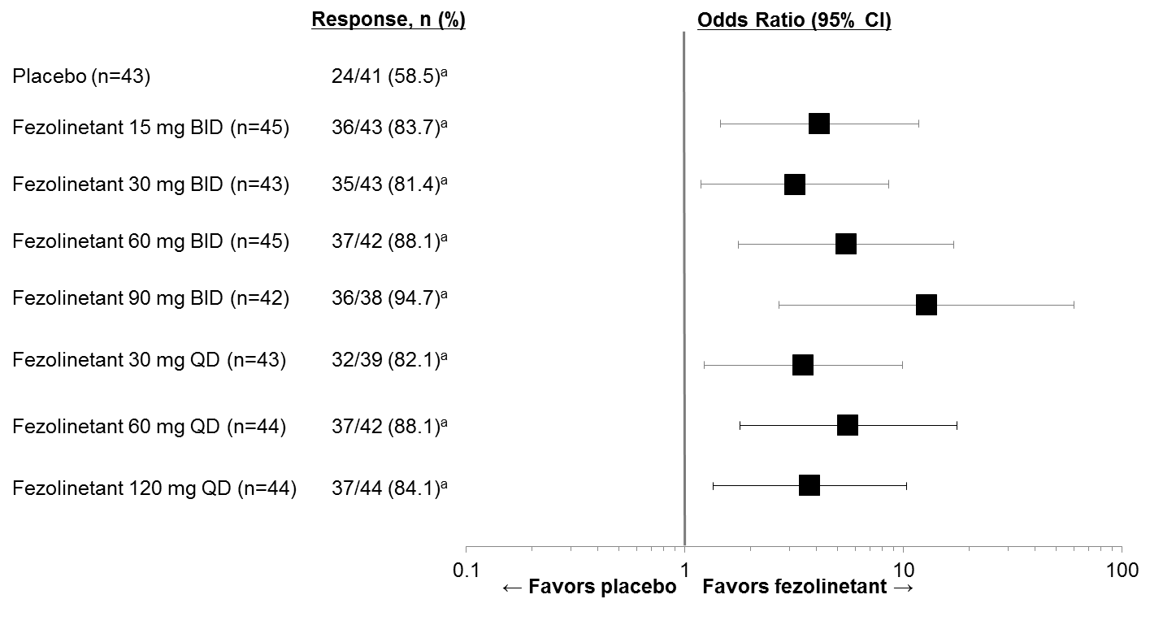
VMS=vasomotor symptoms.
ªP<.05 for all pairwise comparisons of fezolinetant vs placebo, with no adjustments for multiplicity.
Figure S2. Endometrial Thickness, Safety Analysis Set

