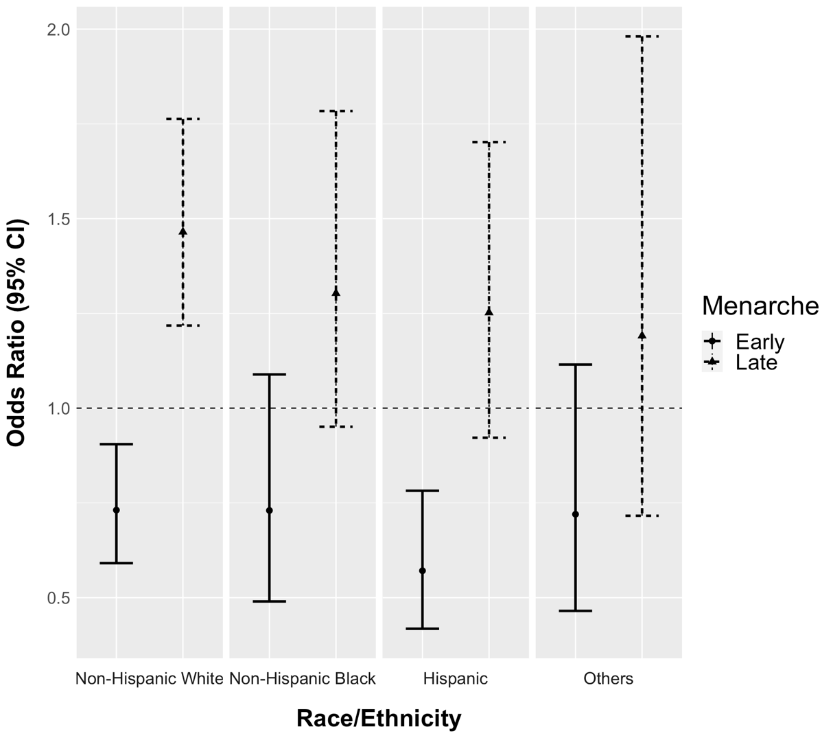
Supplemental Digital Content 3. Associations between age at menarche (reference group: normal menarche) and ideal cardiovascular health (CVH) by race/ethnicity. (n= 20,447)

