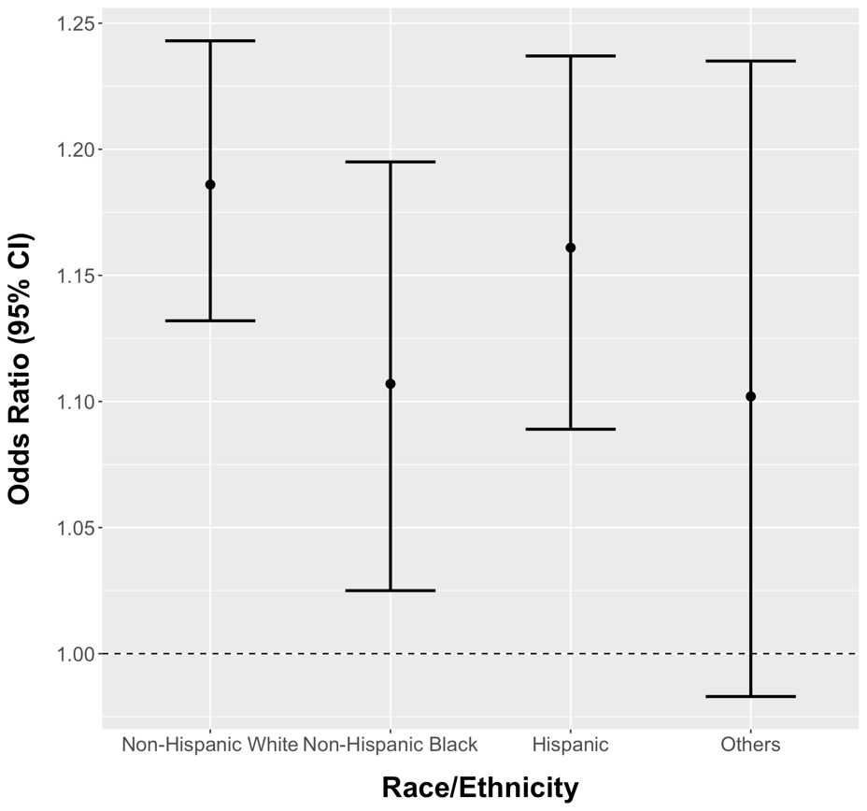
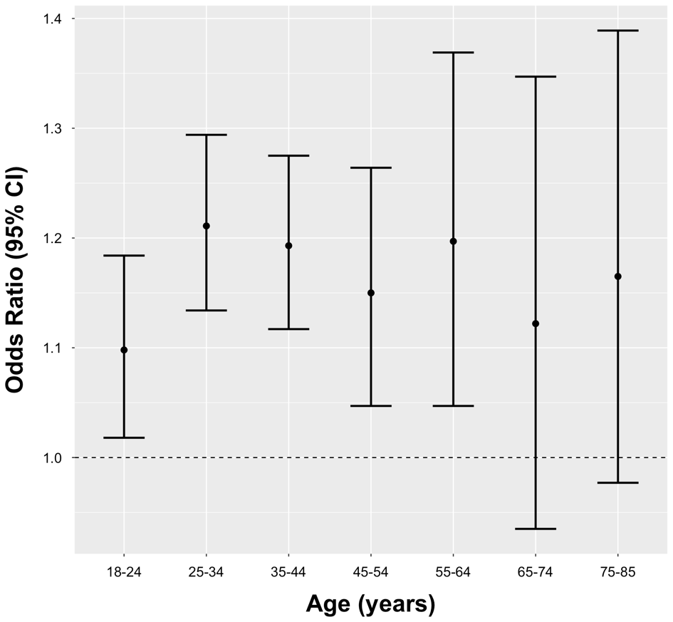

Supplemental Digital Content 4. Associations between age at menarche (each one-year increase in age at menarche) and ideal cardiovascular health (CVH) by age at interview or race/ethnicity. (n= 20,447)

