Supplemental Figure 1. Local hospital catchment areas in Chicago, Illinois

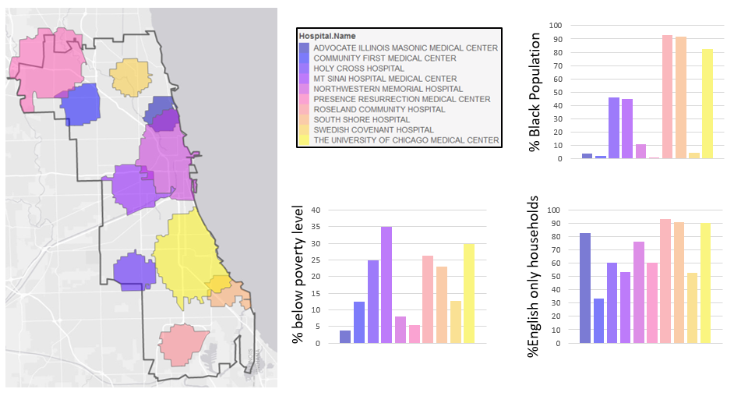

This map (left) illustrates 10 local hospital catchment areas in Chicago, IL. Each color indicates a different hospital catchment area, and the black boundary indicates the single health service area (HSA #14023) designated for the Chicago area. These catchment areas were determined based on a hospital’s location and size by scaling each hospital’s target population to the number of staffed hospital beds and by multiplying the number of hospital beds by 416.6, which represents 2.4 hospital beds per 1000 people.¹⁶ For instance, a hospital with 200 beds would have a neighborhood population of 83,333 people. The local geographic catchment area was then defined as the collection of population-weighted block group centroids that fall within a circle centered at the hospital’s latitude and longitude that captures the hospital’s target population.¹⁷ In effect, the center of the circle was each hospital’s latitude and longitude, and block group centroids were included until the neighborhood population was reached. Catchment area boundaries reflect the boundaries of the most distant block groups.

The bar graphs (right) illustrate the variation in social risk factors (SRFs) for each hospital. For example, using the HAS approach, Advocate Illinois Masonic Medical Center (left, dark blue) and University of Chicago Medical Center (right, yellow) have the same ‘health service area,’ but in reality, serve drastically different patient populations and neighborhoods.

