Supplemental Digital content

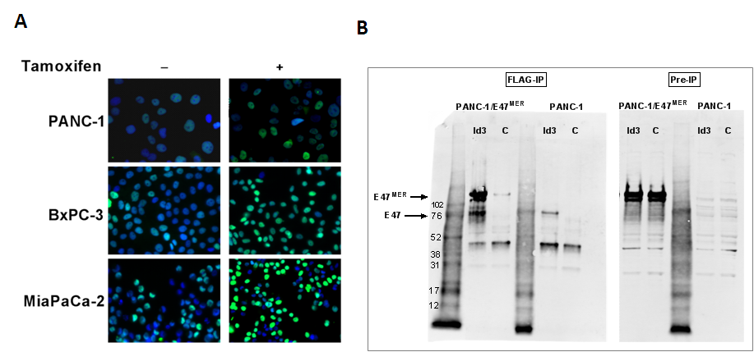

Figure S1. E47 is highly expressed in PDA/E47 cells and interacts with ID3. (A) Immunostaining for E47 (green) and DAPI (blue) in PDA/E47 lines expressing tamoxifen inducible E47^{MER}, with and without 48 hours of tamoxifen treatment. Note: The PDA/E47 cultures contain a minority of cells not expressing high levels of E47. (B) FLAG-Id3 (Id3) or control vector (C) was transfected into control parental PANC-1 cells and PANC-1/E47 cells. Right hand gel (Pre-IP) shows input. Extracts were immunoprecipitated with anti-FLAG antibody and immunoblotted with anti-E47 antibody. Note that despite the low level of endogenous E47 (mw 76kD) in all Pre-IP samples, FLAG-Id3 precipitates endogenous E47 from both cell lines. In PANC-1/E47 cells, FLAG-Id3 also precipitates the E47^{MER} protein. Thus, the data indicate that E47 and Id3 efficiently bind to each other in PDA cells.

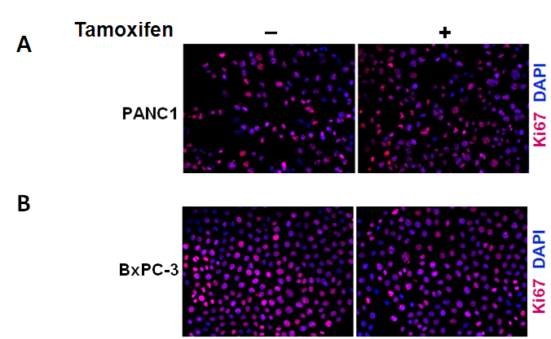

Figure S2. Tamoxifen alone does not inhibit Ki67 expression in PDA cells. Concurrent with the E47-inducible cell lines shown in Figure 1 (A) parental PANC-1 cells and (B) BxPC-3 cells lacking inducible E47 were treated with tamoxifen for 48 hours and immunostained for Ki67 (red) and DAPI (blue), 100x. Note that parental cells treated with tamoxifen remain Ki67 positive, indicating that E47, not tamoxifen, is responsible for cell cycle arrest in PDA cells shown in Figure.1.

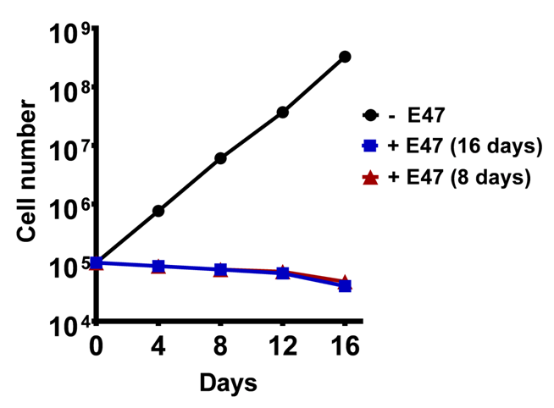

Figure S3. Temporary induction of E47 results in sustained growth arrest in PDA cells. PANC-1/E47 cells were cultured for a total of 16 days under 3 conditions: (i) without tamoxifen [-E47, black], (ii) with tamoxifen [+E47 (16 days), blue], and (iii) with tamoxifen for 8 days, followed by 8 days without tamoxifen [+E47 (8 days), red]. On day 16, cell numbers between samples in which E47 was induced for 8 days vs. 16 days did not significantly differ (p=0.2903) indicating that growth arrest was maintained in the absence of continued E47 induction. (n=3 for each condition). Data shown is a representative of 4 independent experiments.

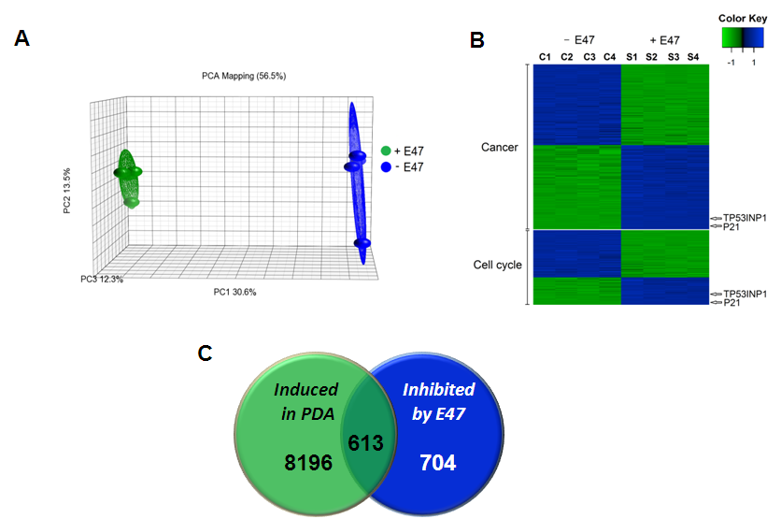

Figure S4. E47 regulates ‘Cancer’ and ‘Cell Cycle’ gene sets in PDA cells. (A) Principal component analysis of microarray data from four biological replicates of PANC-1/E47 cells treated with (S1-S4) or without (C1-C4) tamoxifen. Significant differences in gene expression are induced by E47 activity. (B) Functional enrichment analysis. “Cancer” and “Cell Cycle” gene sets are among those most highly regulated by E47 (P < 0.001) and both sets identify p21 and TP53INP1 as E47 target genes. (C) Similar to results obtained with the GSE 16515 dataset in Fig. 1, a Venn diagram depicts genes upregulated in human PDA tumors (relative to adjacent tissue) (GSE15471,red) when compared to genes downregulated by E47 activity in PANC-1/E47 cells (GSE55999, blue) (p=2.7E-14).

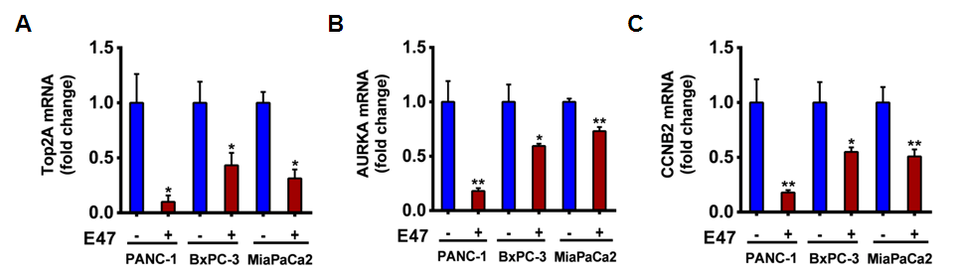

Figure S5. E47 reduces the expression of cell cycle genes that are highly expressed in PDA tumors. Validation of microarray data by qRT-PCR showing that the expression of (A) Top2a, (B) Aurka, and (C) Ccnb2 are significantly reduced by E47 activity in PANC-1/E47, BxPC-3/E47 and Mia PaCa-2/E47 cell lines. (*p< 0.05,**p< 0.01) (n = 3 per group)

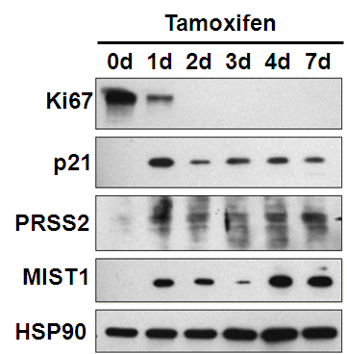

Figure S6. E47 activity leads to changes in protein levels of cell cycle and acinar differentiation genes. Immunoblot analysis of Ki67, p21^{CIP1/WAF1}, PRSS2 (trypsinogen, trypsin) and MIST1 in PANC-1/E47 cells cultured without or with tamoxifen (days 0-7). E47 activity rapidly leads to a decrease in Ki67 accumulation and increases in p21, PRSS2 and MIST1 protein levels. HSP90 serves as a loading control.

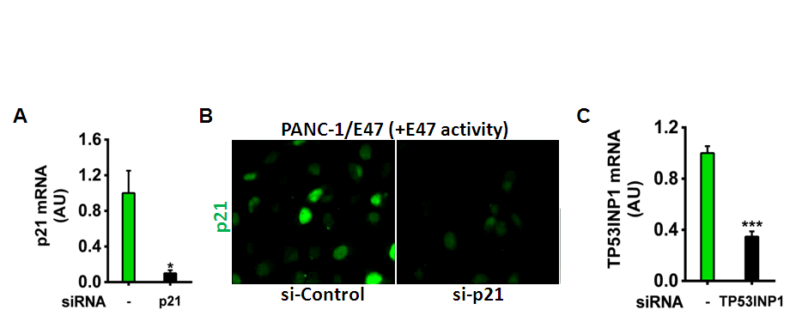
Figure S7. siRNA knockdown of p21 and TP53INP1 in PANC-1/E47 cells with induced E47 activity. (A) siRNA to p21 decreases p21 mRNA by 90% compared with controls (-) (*p = 0.02, n = 3 per group). (B) Immunostaining for p21 demonstrates that si-p21 also diminishes p21 protein levels, 400x. Shown are data for one of the two p21 siRNAs tested. (C) siRNA to TP53INP1 decreases TP53INP1 mRNA by 65% compared with controls (-) (***p< 0.001, n = 3 per group). Shown are data for one of two TP53INP1 siRNAs tested.

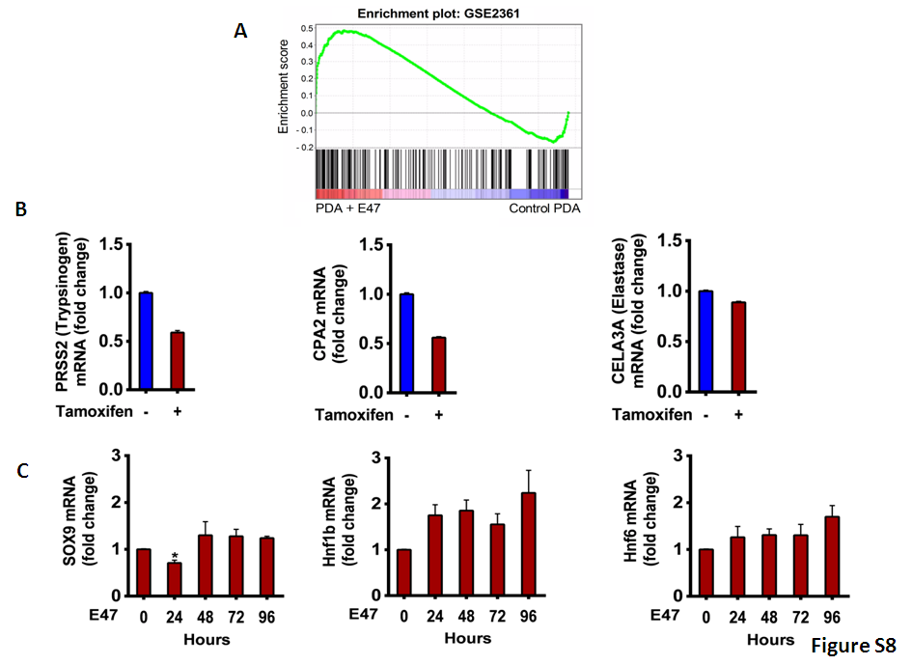
Figure S8. Expression of exocrine and duct specific genes upon induced E47 activity. (A) Similar to results obtained in Fig. 3, Gene Set Enrichment Analysis using a second pancreas tissue geneset (GSE2361) demonstrates that exocrine genes are significantly enriched by E47 activity. All genes were ranked on the basis of the differential expression in PDA cells with or without E47 activity. The green curve indicates the running enrichment score: 0.48, FDR: 0.0017. (B) Tamoxifen alone does not induce acinar genes in the parental PANC-1 cells. (C) E47 does not induce ductal gene expression in PDA cells. mRNA expression levels of ductal genes; Sox9, Hnf1b, and Hnf6 in PANC-1/E47 cells before (0 hours) and following tamoxifen induction (24 to 96 hours). Note that Sox9 expression is mildly reduced at 24 hours. (*p< 0.05, n = 3 per group).

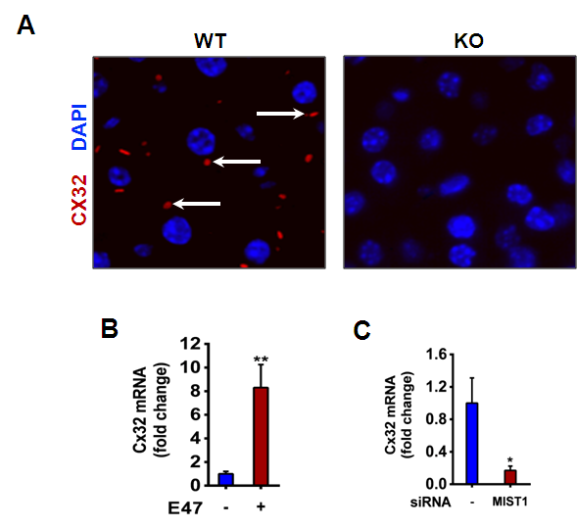

Figure S9. MIST1 regulates Cx32 expression in vitro and in vivo. (A) Pancreata from adult Mist1^{+/+} (WT) and Mist1^{-/-} (KO) mice were immunostained for the gap junction protein connexin 32 (CX32, red) and nuclei are counterstained with DAPI. Note that CX32-containing gap junction complexes (red) are readily detected in WT samples (arrows) but are not found in tissue lacking MIST1 protein. (B) qRT-PCR for Cx32 shows that E47 induces Cx32 gene expression in the BxPC-3/E47 cell line, similar to results in PANC-1 cells (Fig. 4), (C) siRNA to Mist1 significantly reduces Cx32 expression. (*p< 0.05 **p< 0.01, n = 3 per group).

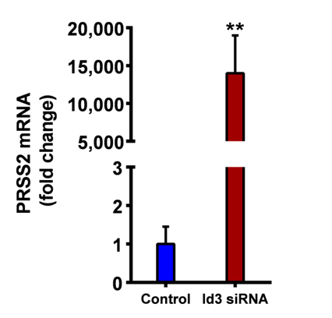

Figure S10. Id3 knockdown in PDA cells induces PRSS2 gene expression. qRT-PCR of PRSS2 mRNA levels in parental PANC-1 cells transfected with control or Id3-specific siRNA. Shown are results for one of two Id3 siRNAs tested. (**p< 0.01. n = 3 per group).

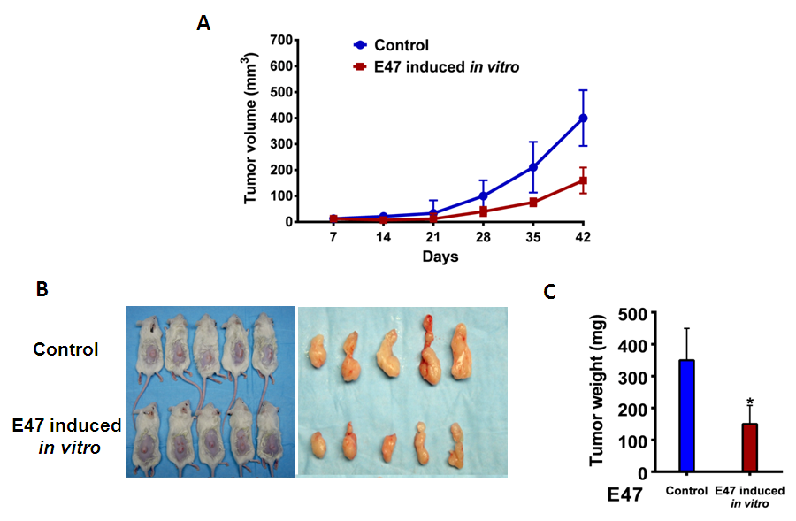

Figure S11. E47 inhibits tumor formation in a xenograft model. BxPC-3/E47 cells were untreated (without tamoxifen induction of E47) (Control), or treated with tamoxifen for 2 days in vitro prior to transplantation. (A) Tumor growth as measured by ultrasound. (B) Comparison of animals and explanted tumors at 42 days post-transplant. (C) Weights of explanted tumors.

