Adult 2-week Bile Duct Ligation
DUCT LIGATION
CONTROL
D
C
B
A
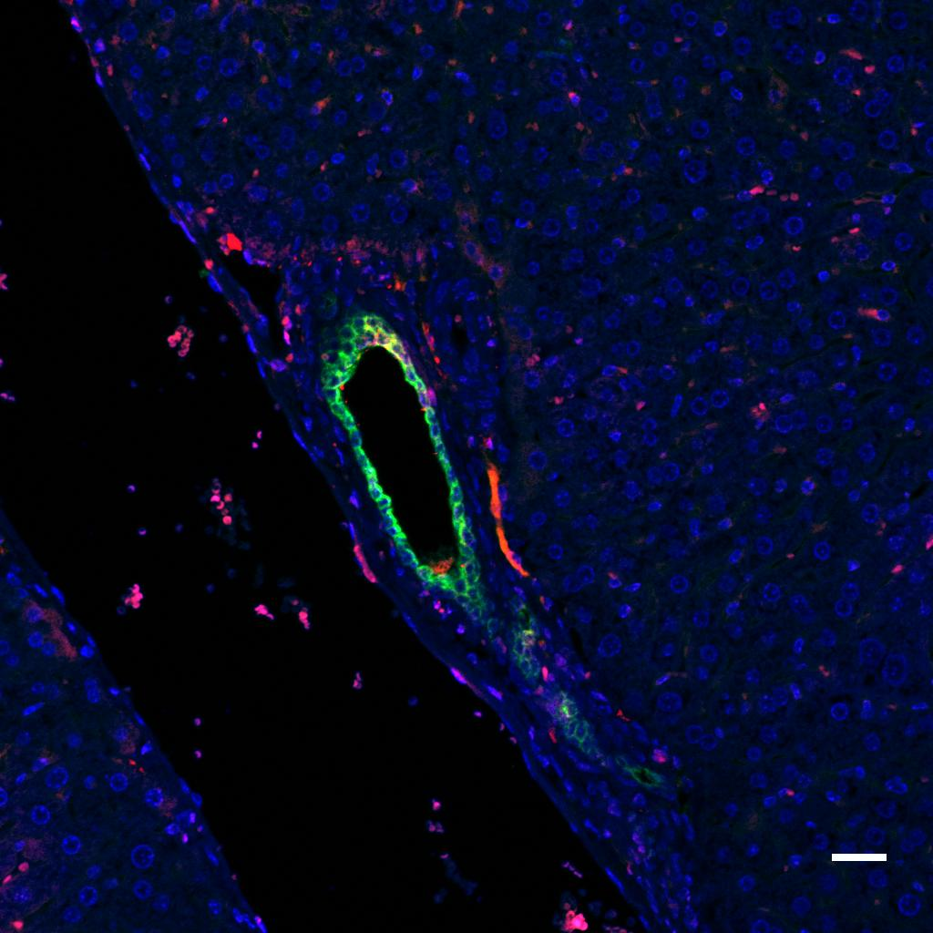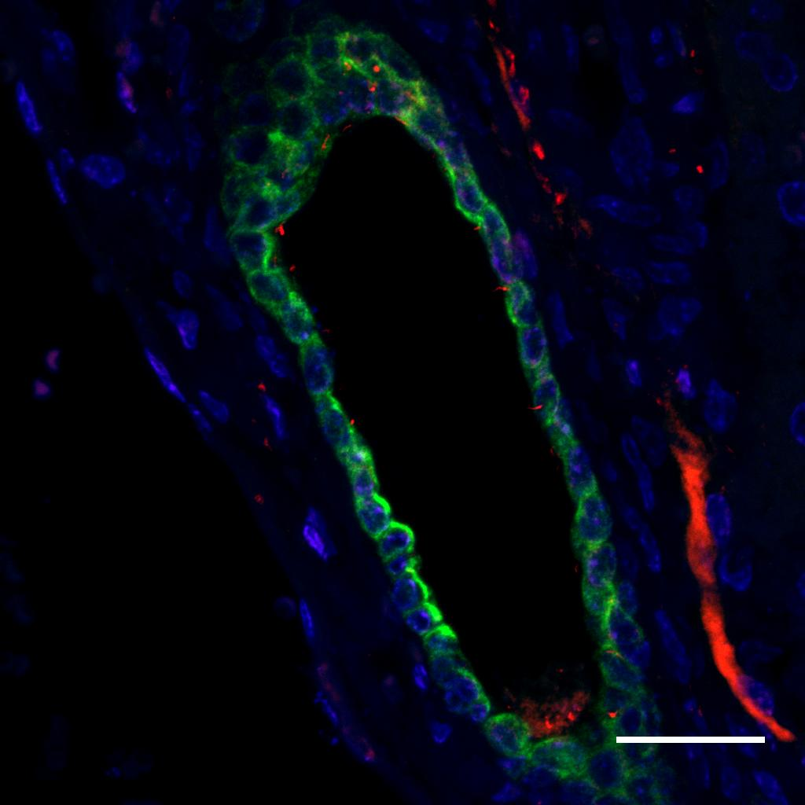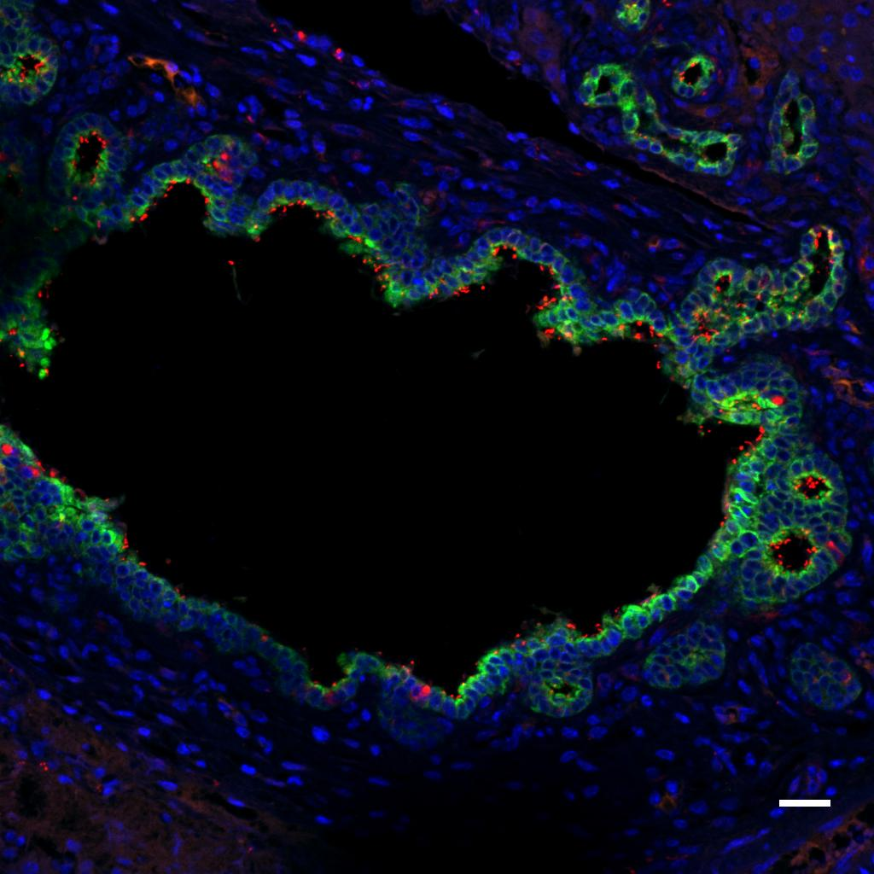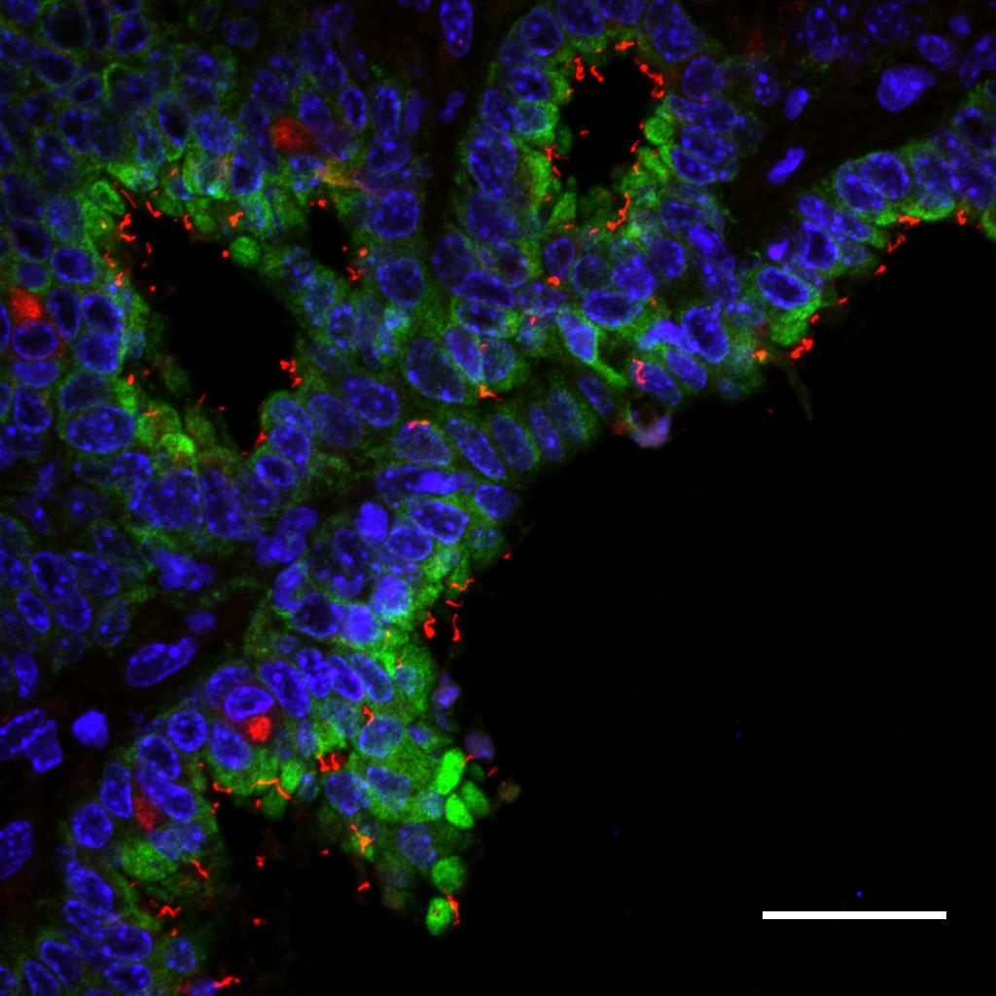
Supplemental Figure. Bile duct ligation in adult mice does not cause decreased cilia. Mice underwent (A, B) sham surgery or (C, D) bile duct ligation. Livers were removed after 14 days and stained with antibodies against acetylated alpha tubulin for primary cilia (red), K19 for cholangiocytes (green), and with the nuclear stain DAPI (blue). Large bile ducts and peribiliary glands within the liver near hilar structures demonstrated abundant cilia in both groups of animals. Representative confocal micrographs from 3 livers examined per condition, original magnification × 20 (A, C), and × 63 (B, D). Bar = 25 μmol/L.

