Figure 2. Assessment of risk of bias and applicability of the included articles
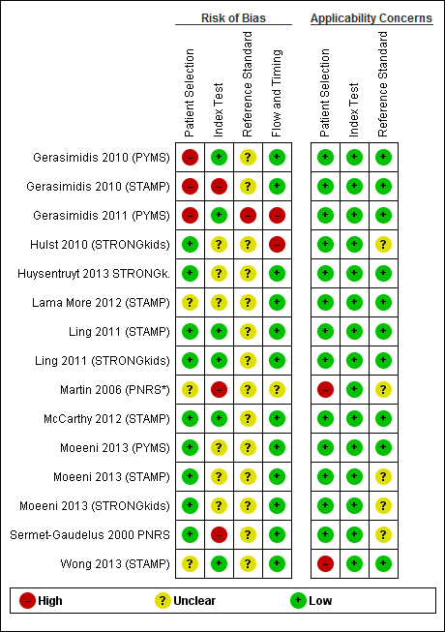
*Adapted version of the PNRS; Studies reporting on more than one screening tool were mentioned more than once because of possible methodological differences per screening tool in the same report; Results of the QUADAS tool are expressed as a high, unclear or low risk of bias and a high, unclear or low risk of applicability concerns.

