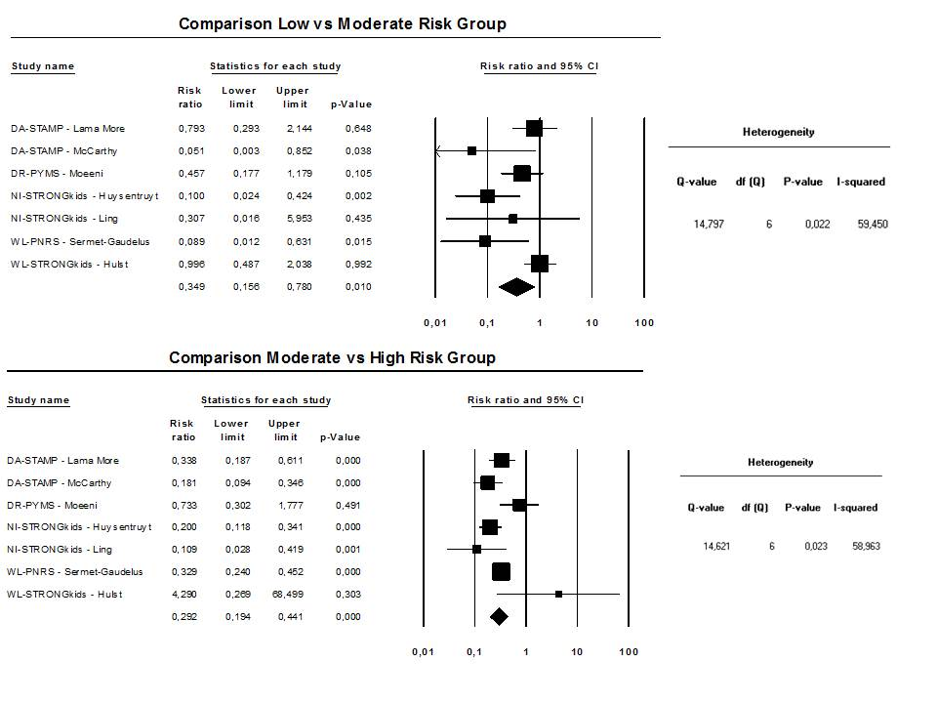
Figure 4. Overall risk ratios of nutritional screening tools assessing nutritional risk

DA: dietetic assessment; DR: dietetic referral; NI: nutritional intervention; WL: >2% weight loss

