Supplemental Digital Content

Supplemental Figure 1. Study flow diagram
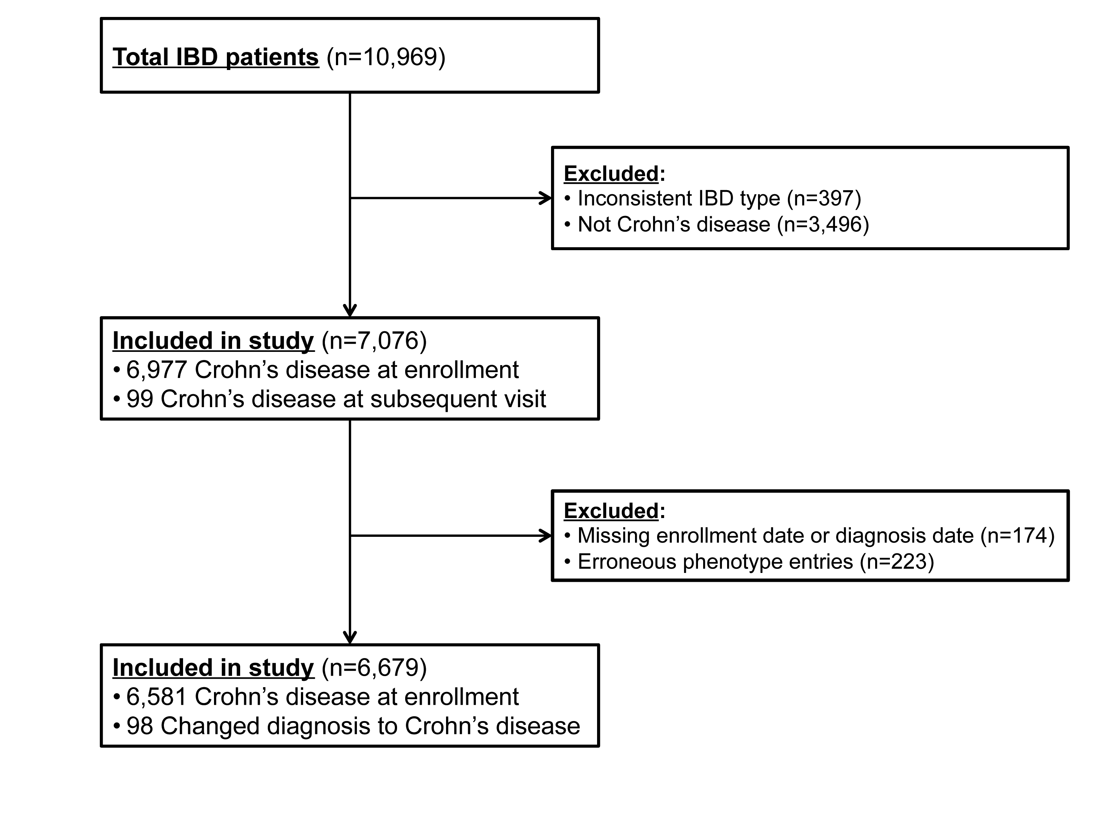

Supplemental Figure 2. Time to Development of Perianal Disease by Age at IBD Diagnosis
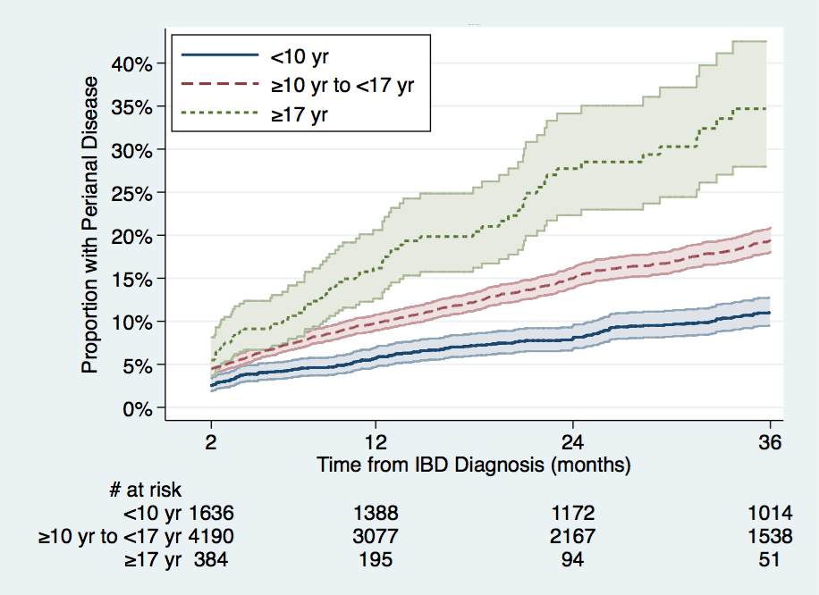
Time from IBD diagnosis to perianal disease in patients based on age at initial IBD diagnosis. The first 60 days after IBD diagnosis were excluded to allow for lack of precision of IBD diagnosis date (month/year).

Supplemental Figure 3. Interaction Between Race and Age at Diagnosis
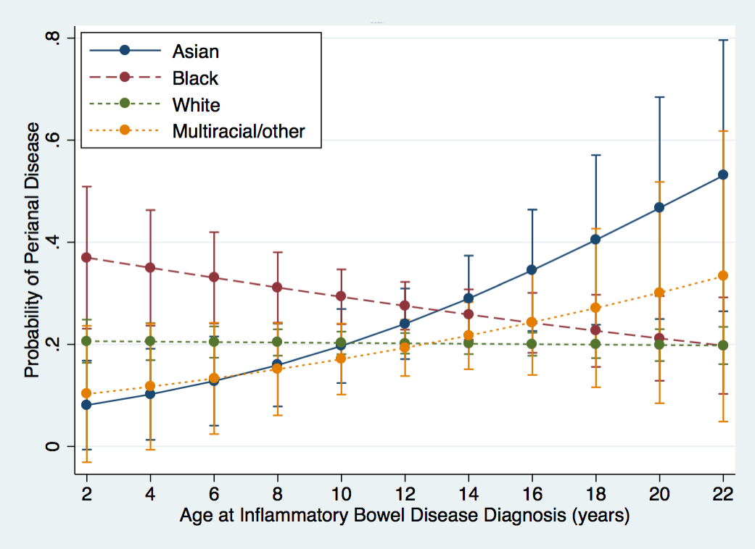
Probability of developing perianal disease based on age at initial IBD diagnosis and race. Note Asians have increased probability of perianal disease with increasing age at diagnosis (OR=1.14; p=0.01). Age at diagnosis was not significantly associated with probability of perianal disease for blacks (p=0.61) or Multiracial/others (p=0.24).
Supplemental Figure 4. Time to Perianal Disease by Race and Age at Diagnosis
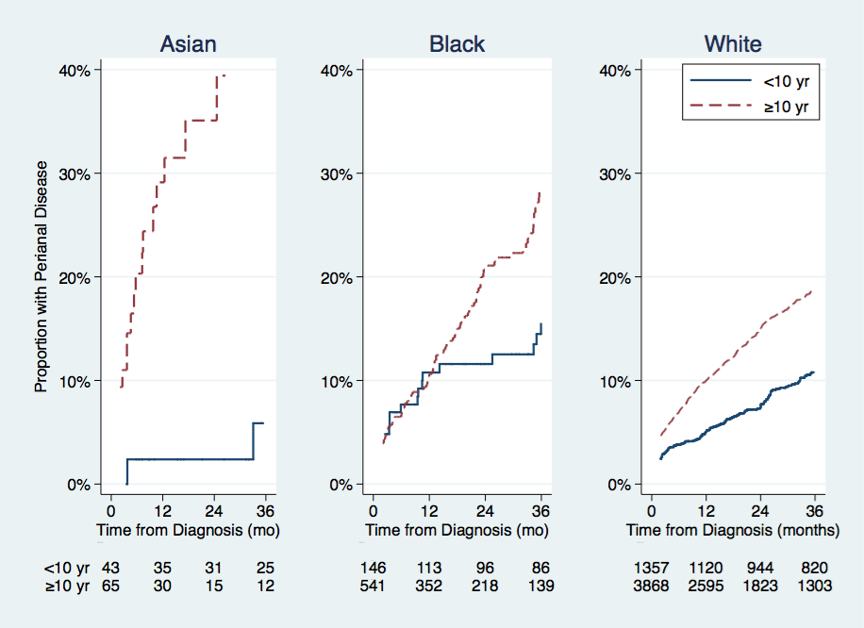
Time from IBD diagnosis to perianal disease in patients based on race and age at initial IBD diagnosis. Note that the rate of increase for Asian patients with IBD diagnosis at 10 years of age or later is higher than that for those with diagnosis prior to 10 years. This difference is significantly greater then that of white patients (HR; 1.14; p=0.012). There was no significant interaction with age at diagnosis for black patients (p=0.61).
Supplemental Table 1. ImproveCareNow Network Participating Sites

Advocate Children's Hospital, Oak Lawn, IL
Advocate Children's Hospital, Park Ridge, IL
Arkansas Children's Hospital, Little Rock, AR
Arnold Palmer Children's Hospital, Orlando, FL
Barbara Bush Children's Hospital at Maine Medical Center, Portland, ME
Baystate Medical Center, Springfield, MA
Boys Town National Research Hospital, Omaha, NE
Cincinnati Children's Hospital Medical Center
CHOA - Children's at Scottish Rite - GI Care for Kids, Atlanta, GA
Carilion Clinic Children's Hospital, Roanoke, VA
CHOA - Children's at Egleston - Emory Children's Center, Atlanta, GA
Children's Hospital at Montefiore, Bronx, NY
Children's Hospital of the King's Daughters, Norfolk, VA
Children's Mercy Hospital, Kansas City, MO
Colorado Children's Hospital, Aurora, CO
Cook Children's Hospital, Fort Worth, TX
Dell Children's Hospital of Central Texas, Austin, TX
Great Ormond Street Hospital, London, UK
Greenville Children's Hospital, Greenville, SC
Helen DeVos Children’s Hospital, Grand Rapids, MI
Inova Pediatric GI Center, Falls Church, VA
Kravis Children's Hospital at Mount Sinai, New York, NY
Levine Children's Hospital, Charlotte, NC
MassGeneral Hospital for Children, Boston, MA
Mayo Clinic, Rochester, MN
Northwest Pediatric Gastroenterology / Randall Children's Hospital, Portland, OR
Nationwide Children's Hospital, Columbus, OH
Nemours | Alfred I. duPont Hospital for Children, Wilmington, DE
Nemours Children's Specialty Care, Jacksonville FL
New Hampshire's Hospital for Children, Manchester, NH
OHSU Doernbecher Children's Hospital, Portland, OH
Oakland Children's Hospital & Research Center, Oakland, CA
Oklahoma University Medical Center, Oklahoma City, OK
Pediatric Gastroenterology & Nutrition Associates, Las Vegas, NV
Penn State Hershey Children's Hospital, Hershey, PA
Riley Hospital for Children, Indianapolis, IN
Seattle Children's Hospital, Seattle, WA
St. Louis Children's Hospital | Washington University, St. Louis, MO
St. Luke's Children's Hospital, Boise, ID
Texas Children's Hospital, Houston, TX
Boston Children's Hospital, Boston, MA
UCSF Benioff Children's Hospital, San Francisco, CA
UT Southwestern Medical Center | Children’s Medical Center of Dallas, Dallas, TX
Children’s of Alabama, Birmingham, AL
University of Iowa Children's Hospital, Iowa City, IA
University of Michigan | C.S. Mott Children’s Hospital, Ann Arbor, MI
University of Minnesota, Minneapolis, MN
University of North Carolina at Chapel Hill, Chapel Hill, NC
University of Vermont Children's Hospital, Burlington, VT
Yale-New Haven Children's Hospital, New Haven, CT

Supplemental Table 2. Perianal Examination and Phenotype Classification as Recorded in the ImproveCareNow Registry

- Perianal Examination Findings*
  - Normal or asymptomatic skin tag, non-draining fistula without tenderness, no deep fissuring or abscess
  - Mildly inflamed skin tag(s), 1 to 2 indolent fistulas with scant drainage (NO tenderness, deep fissures or abscess)
  - Severely inflamed skin tag(s) active fistula with drainage, tenderness, abscess, or deep fissure
  - Not assessed
  - Don’t know
- Perianal Phenotype**
  - No
  - Yes
  - Don’t know
- Disease Location***
  - Lower GI Disease
    - None
    - Ileal only
    - Colonic only
    - Ileocolonic
    - Not assessed
    - Don’t know
  - Upper Tract Disease, Proximal to Ligament of Treitz
    - No
    - Yes
    - Not assessed
    - Don’t Know
  - Upper Tract Disease, Distal to Ligament of Treitz
    - No
    - Yes
    - Not assessed
    - Don’t Know

*Perianal examination finding definitions provided by ImproveCareNow Network.
**Paris phenotype perianal disease modifier after Levine, et al.(28)
***Macroscopic assessment of disease location.

Supplemental Table 3. Race and Ethnicity in the ImproveCareNow Registry

- Race
  - American Indian / Alaska Native
  - Asian
  - Native Hawaiian or Other Pacific Islander
  - Black or African American
  - White
  - More than One Race
  - Other
  - Don’t Know
- Ethnicity
  - Hispanic
  - Non-Hispanic
  - Not Assessed/Collected

