Supplementary Table 3. A. Results of the ANOVA for the number of OTUs. Listed values are p-values for the main effects. B. Results of the ANOVA for Shannon diversity. Listed values are p-values for the main effects.

A
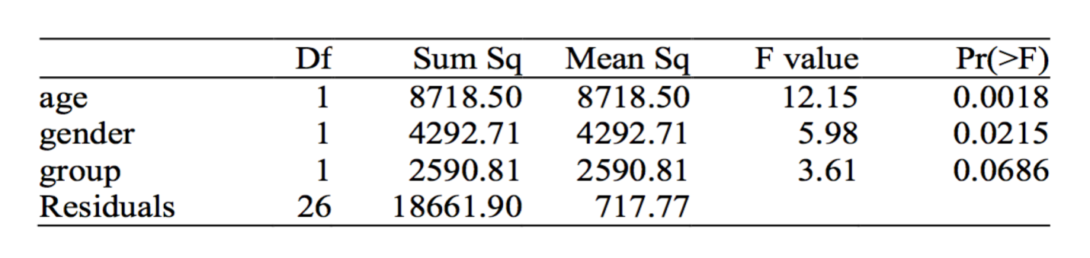

B
