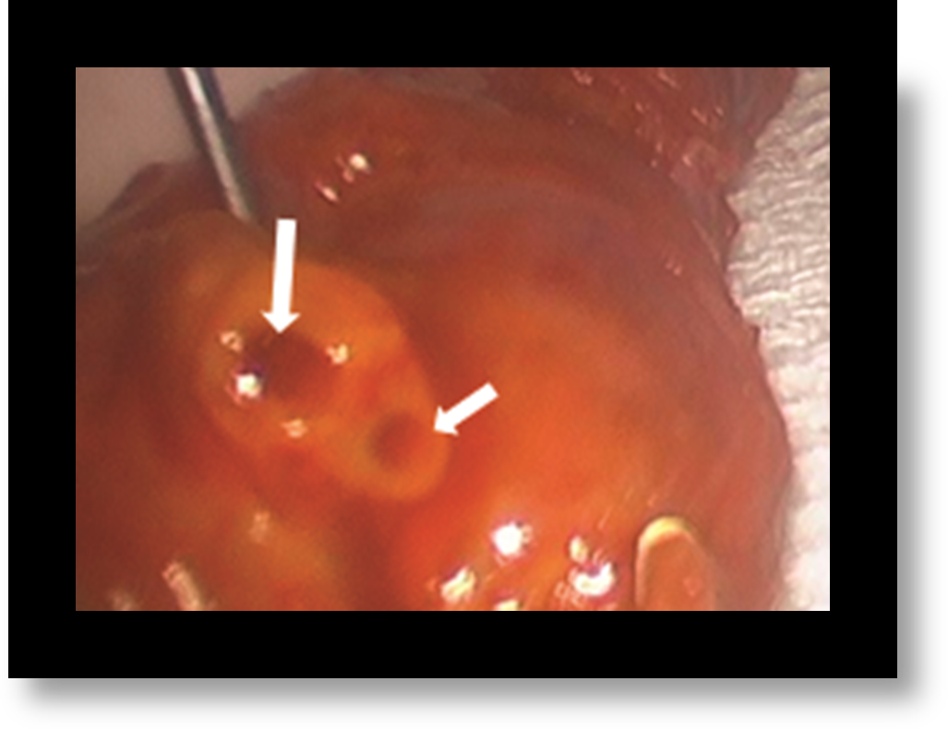Supplementary Image 1:
Intra-operative picture clearly demonstrating two separate ductal lumens (white arrows) when transected.

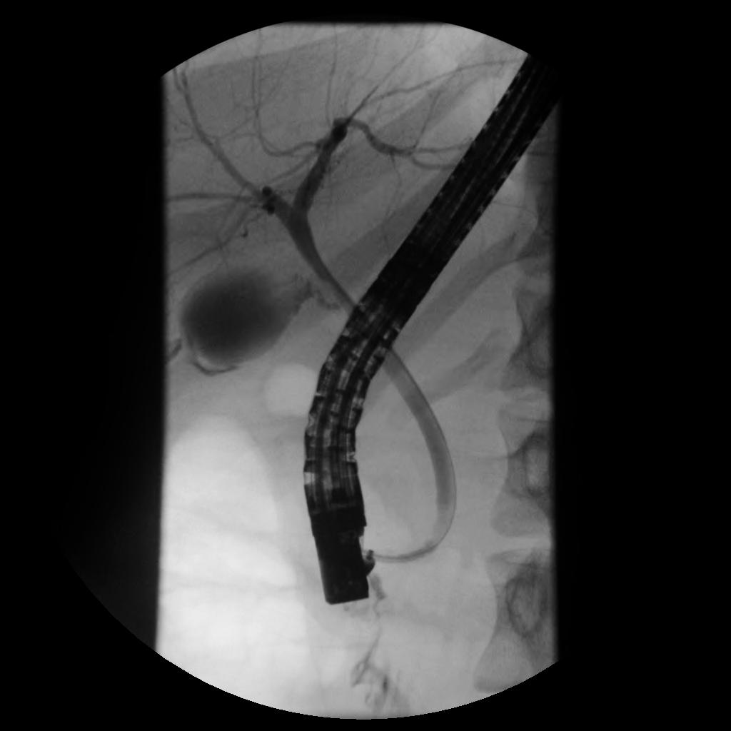

Supplementary Image 2:
The distal common bile duct is visible while contrast is being injected during the ERCP. There is continuity from the level of the duodenal wall to the biliary tree without reflux into the pancreatic duct system.

