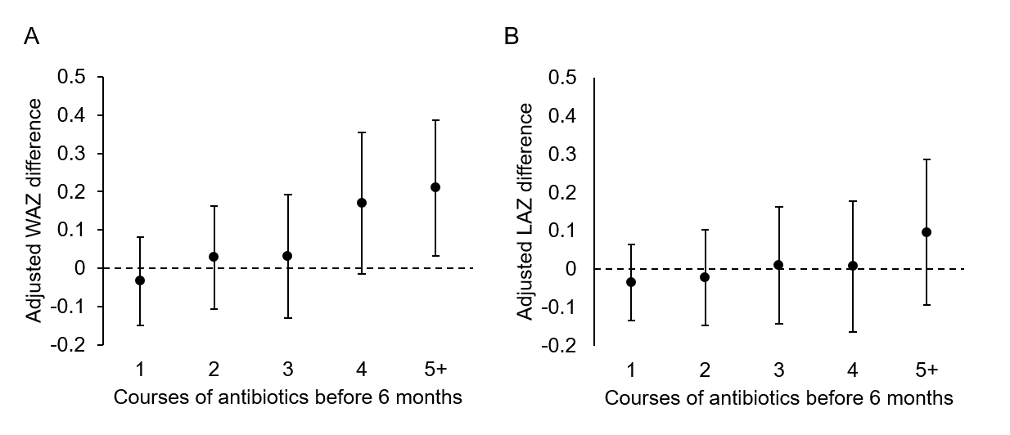
Figure, Supplemental Digital Content 2. Adjusted difference in anthropometric z-scores associated with number of antibiotic courses received in the first 6 months of life compared to no antibiotic exposure among 1954 children followed in the MAL-ED birth cohort until at least 6 months of age with subsequent anthropometry. A: weight-for-age z-scores (WAZ); B: length-for-age z-scores (LAZ).

