APPENDIX FIGURES AND TABLES
Appendix figure S1: Risk of bias graph: review authors' judgements about each risk of bias item, presented in A) as percentages across all included studies, and in B) separately for each included study.
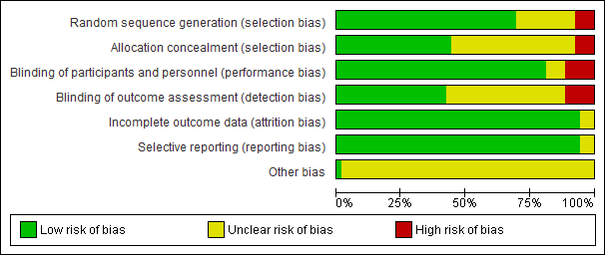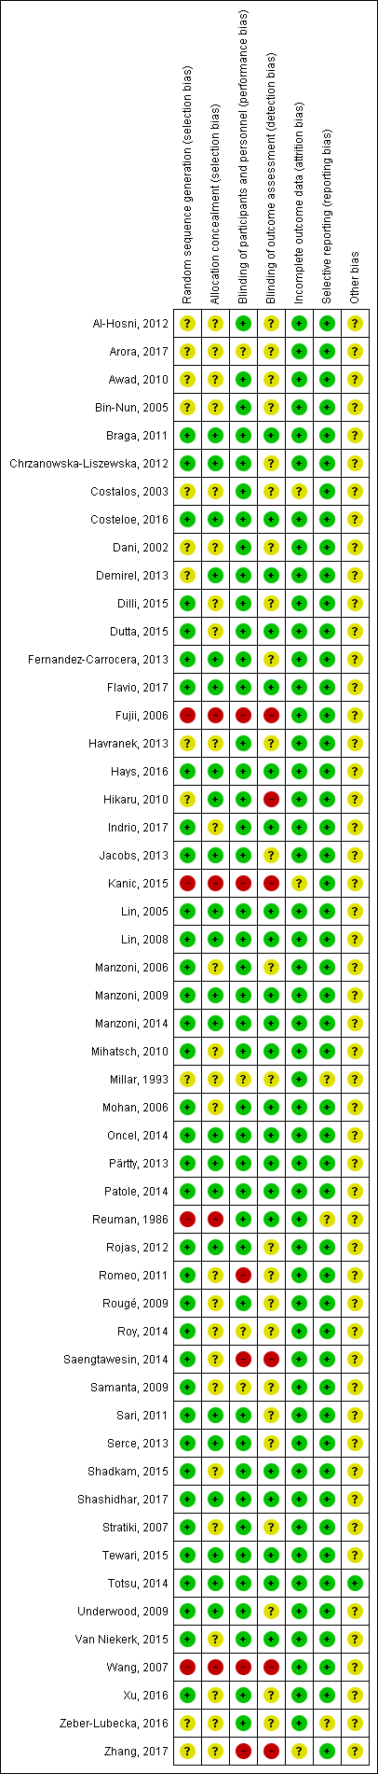

Appendix figure S2: Classis pair-wise forest plots on placebo versus the specified probiotic strain or combinations to reduce mortality.
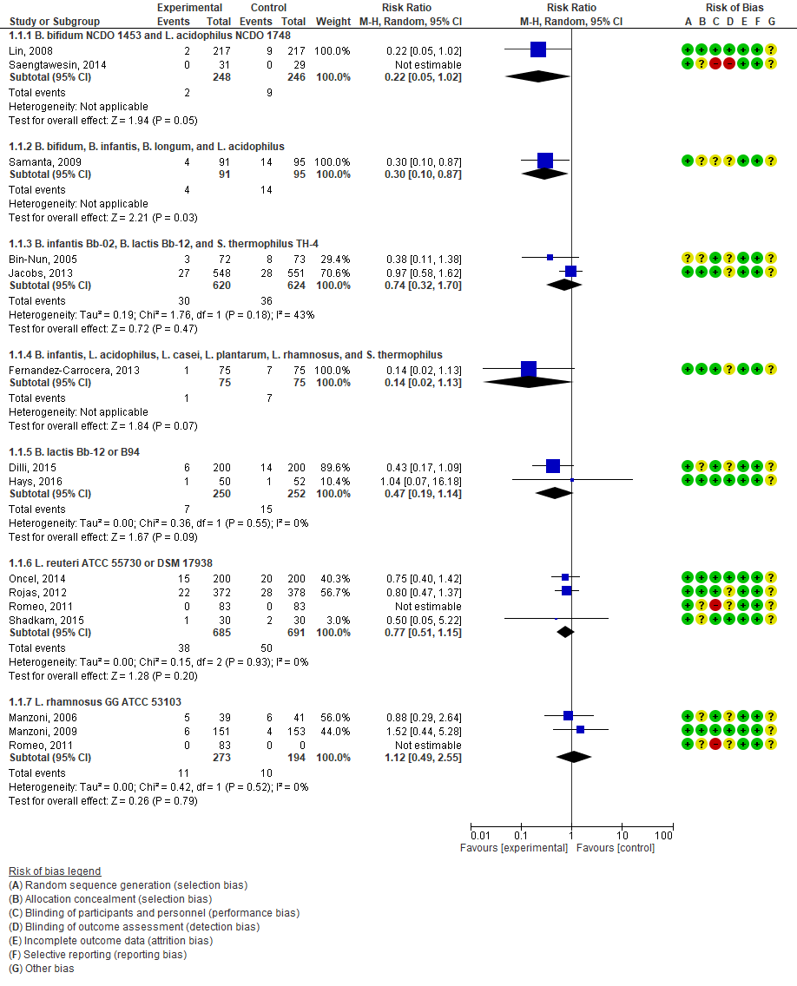
Appendix figure S3: Funnel plot of studies on mortality.
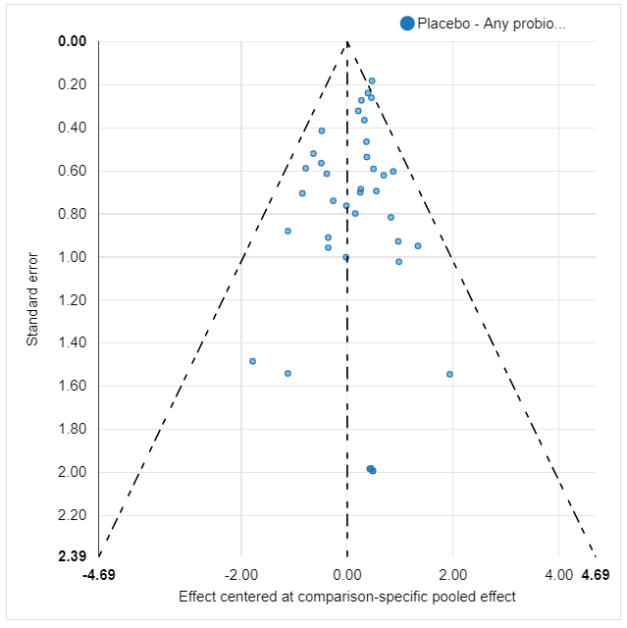

Appendix figure S4: Classis pair-wise forest plots on placebo versus the specified probiotic strain or combinations to reduce NEC grade 2 or 3.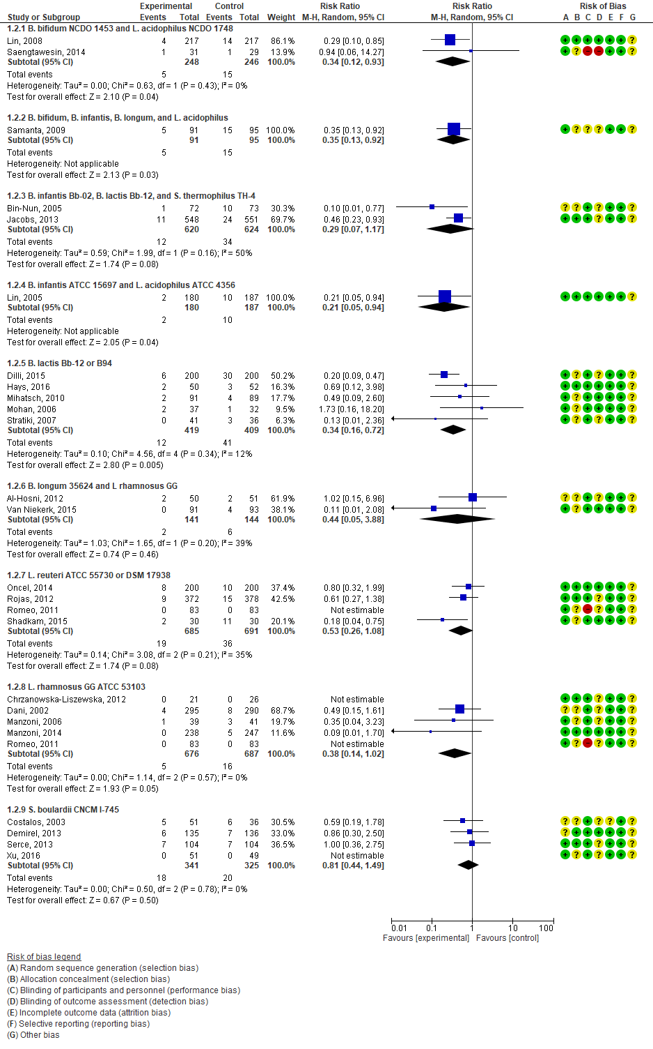
Appendix figure S5: Node-splitting consistency model. There were no inconsistencies detected between direct and indirect evidence for reducing NEC grades 2 or 3.
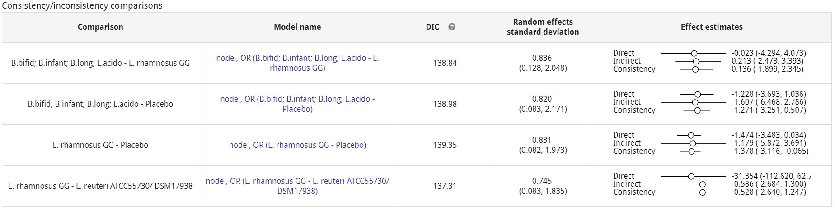

Appendix figure S6: Funnel plot of studies on NEC grades 2 or 3.
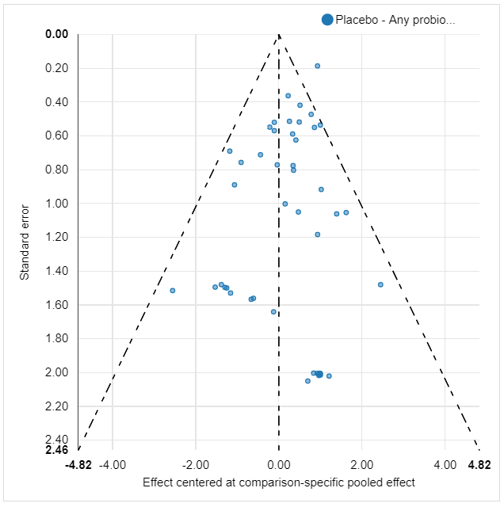

Appendix figure S7: Classis pair-wise forest plots on placebo versus the specified probiotic strain or combinations to reduce sepsis.
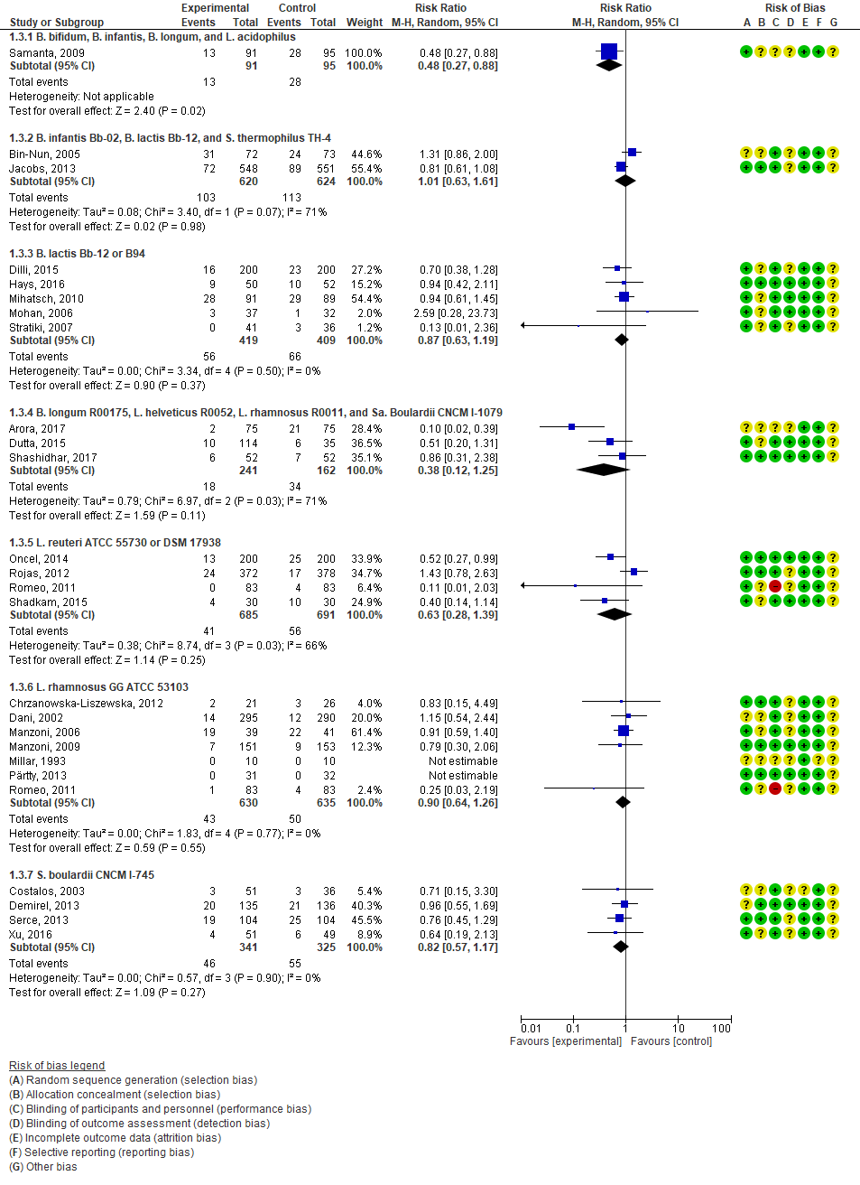

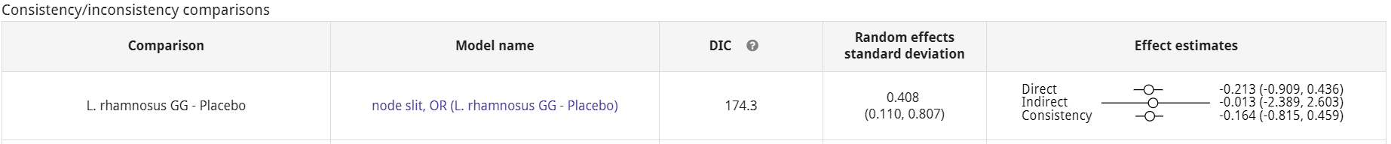
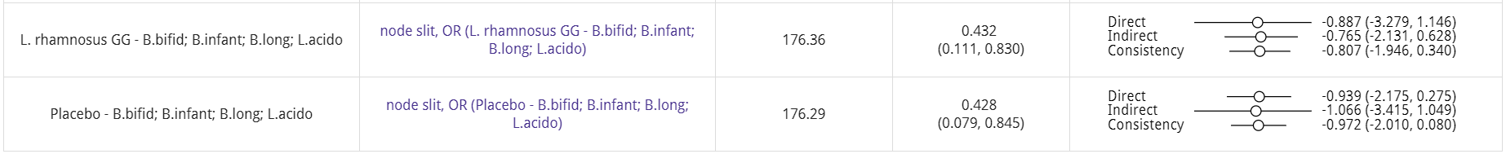
Appendix figure S8: Node-splitting consistency model. There were no inconsistencies detected between direct and indirect evidence for reducing LOS.

Appendix figure S9: Funnel plot of studies on LOS.
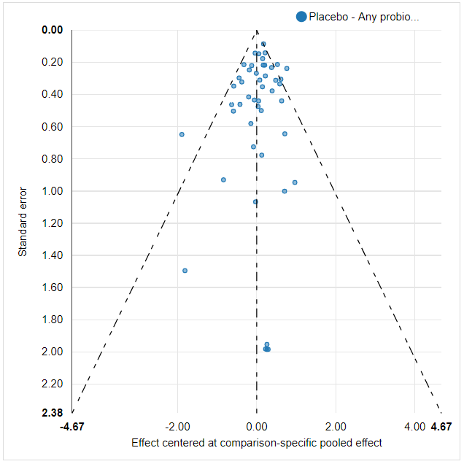

Appendix figure S10: Classis pair-wise forest plots on placebo versus the specified probiotic strain or combinations to reduce time until full enteral feeding (d).
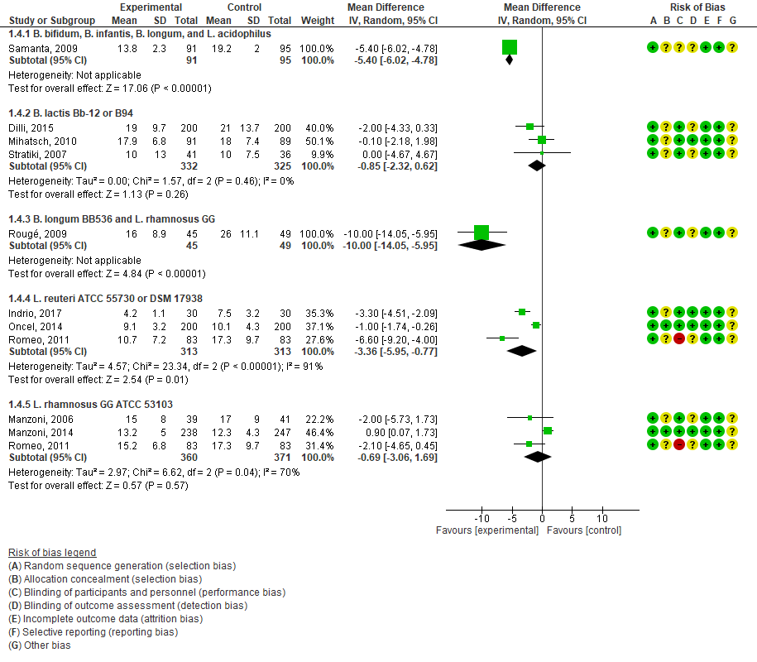

Appendix figure S11: Node-splitting consistency model.
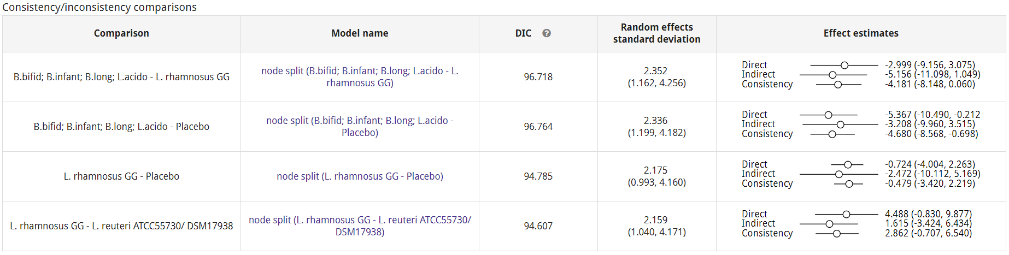

Appendix figure 12: Funnel plot of studies on time to reach full enteral feeding.
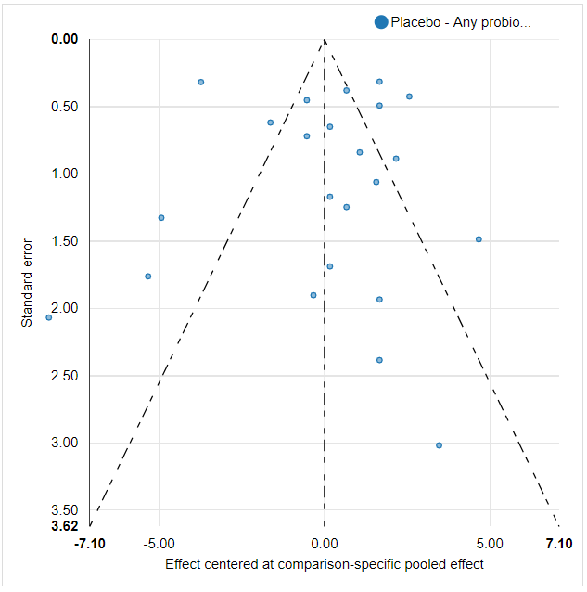

Table S1: Overview of all identified strains that were used in the RCTs. Name of the first author and manufacturer are displayed between brackets. If multiple strains were administered in a product or study arm together, a number denotes to the total number of strains in that arm.
Bacillus:
Ba. clausii 4 strains: O/C, N/R84, T84, Sin8 | Tewari (Enterogermina)
Ba. coagulans (previously L. sporogenes) | Sari (DMG Italia)
Ba. subtilis R0179 (CNCM I-3471) | Zhang 2 (Medilac-Vita)
Bifidobacterium:
B. bifidum | Roy 4 (Prowel, Alkem); Samanta 4; Underwood 4 (ProBioPlus DDS, UAS)
B. bifidum NCDO 1453 | Lin 2008 2 (Infloran Berna); Saengtawesin 2 (Infloran Berna)
B. bifidum OLB6378 | Totsu (Meiji)
B. breve | Braga 2 (Yakult LB)
B. breve BBG-001 (YIT4010) | Costeloe (Yakult Honsha)
B. breve M-16V | Fujii; Hikaru (Morinaga); Patole (Morinaga); Wang (Morinaga)
B. infantis | Fernández-Carrocera 6 (Italmex); Samanta 4; Underwood 4 (ProBioPlus DDS, UAS)
B. infantis ATCC 15697 (DSM 20088; S12) | Lin 2005 2 (Infloran)
B. infantis Bb-02 (DSM 96579) | Jacobs 3 (ABC Dophilus); Bin-Nun 3 (ABC Dophilus)
B. infantis PTA-5843 | Kanic 3 (Linex)
B. lactis | Roy 4 (Prowel, Alkem)
B. lactis B94 (Lafti) | Dilli (Maflor)
B. lactis Bb-12 (DSM 15954; Chr Hansen; BL 818; NCC 2818)* | Bin-Nun 3 (ABC Dophilus); Jacobs 3 (ABC Dophilus); Mihatsch (Nestlé); Mohan (Nestlé); Hays 1&2 (Nestlé); Stratiki (Nestlé)
B. longum | Roy 4 (Prowel, Alkem); Samanta 4; Underwood 4 (ProBioPlus DDS, UAS)
B. longum 35624 (NCIMB 41003; Bifantis) ** | Al Hosni 2 (Align); Havranek 2 (Align); Van Niekerk 2 (ProB2, C Pharm)
B. longum BB536 (ATCC BAA-999; BL 999; NCC3001) | Hays 1&2 (Nestlé); Rougé 2 (Morinaga)
B. longum R00175 (CNCM I-3470) | Arora 4 (Darolac, Aristo); Dutta 4 (Darolac, Aristo); Shashidhar 4 (Darolac, Aristo)
Enterococcus:
E. faecium PTA-5844 | Kanic 3 (Linex)
E. faecium R0026 | Zhang 2 (Medilac-Vita)
Lactobacillus:
L. acidophilus | Fernández-Carrocera 6 (Italmex); Roy 4 (Prowel, Alkem); Samanta 4; Underwood 4 (ProBioPlus DDS, UAS)
L. acidophilus ATCC 4356 | Lin 2005 2 (Infloran)
L. acidophilus LA-5 (DSM 13241; Chr Hansen) | Reuman
L. acidophilus Lb | Awad (Lacteol fort)
L. acidophilus NCDO 1748 | Lin 2008 2 (Infloran Berna); Saengtawesin 2 (Infloran Berna)
L. casei | Braga 2 (Yakult LB); Fernández-Carrocera 6 (Italmex)
L. gasseri PTA-5845 | Kanic 3 (Linex)
L. helveticus R0052 (CNCM I-1722) *** | Arora 4 (Darolac, Aristo); Dutta 4 (Darolac, Aristo); Shashidhar 4 (Darolac, Aristo)
L. plantarum | Fernández-Carrocera 6 (Italmex)
L. reuteri ATCC 55730 (SD2112) | Romeo
L. reuteri DSM 17938 | Indrio (BioGaia); Oncel (BioGaia); Rojas (BioGaia); Shadkam (BioGaia)
L. rhamnosus | Fernández-Carrocera 6 (Italmex)
L. rhamnosus GG (ATCC 53103; NCC4007; Chr Hansen) | Al Hosni 2 (Culturelle); Chrzanowska- Liszewska (Vitis); Dani (Dicoflor); Havranek 2 (Culturelle); Manzoni 2006 (Dicoflor); Manzoni 2009 (Dicoflor); Manzoni 2014 (Dicoflor); Millar (Valio); Pärtty (Mead Johnson); Romeo; Rougé 2 (Valio); Underwood (Culturelle); Van Niekerk 2 (ProB2, C Pharm)
L. rhamnosus R0011 (CNCM I-1720) | Arora 4 (Darolac, Aristo); Dutta 4 (Darolac, Aristo); Shashidhar 4 (Darolac, Aristo)
Sacharomyces:
Sa. boulardii CNCM I-745 | Costalos; Demirel (Reflor); Serce (Reflor); Xu (Bioflor); Zhang (Bioflor)
Sa. boulardii CNCM I-1079 | Arora 4 (Darolac, Aristo); Dutta 4 (Darolac, Aristo); Shashidhar 4 (Darolac, Aristo)
Sa. boulardii CNCM I-3799 | Zeber-Lubecka (Dierol; Sequoia)
Streptococcus:
S. thermophilus | Fernández-Carrocera 6 (Italmex)
S. thermophilus TH-4 (DSM 15957; Chr Hansen) | Jacobs 3 (ABC Dophilus); Bin-Nun 3 (ABC Dophilus)

* Previously also known as B. bifidum Bb-12
** Previously also known as B. infantis 35624
*** Previously also known as L. acidophilus R0052
Table S2: All included studies in which data on mortality were available. n/N denotes number of affected infants (n) and number of included infants (N).
 | Placebo | Ba. clausii (4 strains) | Ba. coagulans (L sporogenes) | B. bifidum OLB6378 | B. bifidum NCDO 1453 +  L. acidophilus NCDO 1748 | B. bifidum + B. infantis + B. longum +  L. acidophilus | B. bifidum + B. lactis + B. longum +  L. acidophilus | B. breve BBG-001 | B. breve M-16V | B. breve + L. casei | B. infantis Bb-02 + B. lactis Bb-12 +  S. thermophilus TH-4 | B. infantis ATCC 15697 +  L. acidophilus ATCC 4356 | B. infantis + L. acidoph + L. casei +  L. plantarum + L. rhamnos + S. thermoph | B. infantis PTA-5843 + E. faecium PTA-5844 + L. gasseri PTA-5845 | B. lactis Bb-12 OR B. lactis B94 | B. lactis Bb-12 + B. longum BB536 | B. longum BB536 | B. longum BB536 + L. rhamnosus GG | B. longum 35624 + L. rhamnosus GG | B. longum R00175 + L. helveticus R0052 +  L. rhamn R0011 + Sa. boul CNCM I-1079 | L. acidophilus Lb | L. acidophilus LA-5 (DSM 13241) | L. reuteri ATCC 55730 OR L. reuteri DSM 17938 | L. rhamnosus GG ATCC 53103 | Sa. boulardii CNCM I-745 | Sa. boulardii CNCM I-3799
Al-Hosni, 2012 | 4/51 |  |  |  |  |  |  |  |  |  |  |  |  |  |  |  |  |  | 3/50
Arora, 2017 | 2/75 |  |  |  |  |  |  |  |  |  |  |  |  |  |  |  |  |  |  | 0/75
Awad, 2010 | 5/16 |  |  |  |  |  |  |  |  |  |  |  |  |  |  |  |  |  |  |  | 4/36
Bin-Nun, 2005 | 8/73 |  |  |  |  |  |  |  |  |  | 3/72
Braga, 2011 | 27/112 |  |  |  |  |  |  |  |  | 26/119
Costeloe, 2016 | 56/660 |  |  |  |  |  |  | 54/650
Demirel, 2013 | 5/136 |  |  |  |  |  |  |  |  |  |  |  |  |  |  |  |  |  |  |  |  |  |  |  | 5/135
Dilli, 2015 | 14/200 |  |  |  |  |  |  |  |  |  |  |  |  |  | 6/200
Dutta, 2015 | 2/35 |  |  |  |  |  |  |  |  |  |  |  |  |  |  |  |  |  |  | 8/114
Fernández-Carrocera, 2013 | 7/75 |  |  |  |  |  |  |  |  |  |  |  | 1/75
Hays, 2016 | 1/52 |  |  |  |  |  |  |  |  |  |  |  |  |  | 1/50 | 1/47 | 3/48
Hikaru, 2010 | 4/100 |  |  |  |  |  |  |  | 0/108
Jacobs, 2013 | 28/551 |  |  |  |  |  |  |  |  |  | 27/548
Kanic, 2015 | 3/40 |  |  |  |  |  |  |  |  |  |  |  |  | 2/40
Lin, 2005 | 20/187 |  |  |  |  |  |  |  |  |  |  | 7/180
Lin, 2008 | 9/217 |  |  |  | 2/217
Manzoni, 2006 | 6/41 |  |  |  |  |  |  |  |  |  |  |  |  |  |  |  |  |  |  |  |  |  |  | 5/39
Manzoni, 2009 | 4/153 |  |  |  |  |  |  |  |  |  |  |  |  |  |  |  |  |  |  |  |  |  |  | 6/151
Mihatsch, 2010 | 1/89 |  |  |  |  |  |  |  |  |  |  |  |  |  |  | 2/91
Oncel, 2014 | 20/200 |  |  |  |  |  |  |  |  |  |  |  |  |  |  |  |  |  |  |  |  |  | 15/200
Patole, 2014 | 0/76 |  |  |  |  |  |  |  | 0/76
Reuman, 1986 | 3/15 |  |  |  |  |  |  |  |  |  |  |  |  |  |  |  |  |  |  |  |  | 1/15
Rojas, 2012 | 28/378 |  |  |  |  |  |  |  |  |  |  |  |  |  |  |  |  |  |  |  |  |  | 22/372
Romeo, 2011 | 0/83 |  |  |  |  |  |  |  |  |  |  |  |  |  |  |  |  |  |  |  |  |  | 0/83 | 0/83
Rougé, 2009 | 4/49 |  |  |  |  |  |  |  |  |  |  |  |  |  |  |  |  | 2/45
Roy, 2014 | 8/56 |  |  |  |  |  | 7/56
Saengtawesin, 2014 | 0/29 |  |  |  | 0/31
Samanta, 2009 | 14/95 |  |  |  |  | 4/91
Sari, 2011 | 4/111 |  | 3/110
Serce, 2013 | 4/104 |  |  |  |  |  |  |  |  |  |  |  |  |  |  |  |  |  |  |  |  |  |  |  | 5/104
Shadkam, 2015 | 2/30 |  |  |  |  |  |  |  |  |  |  |  |  |  |  |  |  |  |  |  |  |  | 1/30
Shashidhar, 2017 | 3/52 |  |  |  |  |  |  |  |  |  |  |  |  |  |  |  |  |  |  | 1/52
Tewari, 2015 | 14/121 | 12/123
Totsu, 2014 | 0/130 |  |  | 2/153
Van Niekerk, 2015 | 6/93 |  |  |  |  |  |  |  |  |  |  |  |  |  |  |  |  |  | 5/91
Zeber-Lubecka, 2016 | 0/27 |  |  |  |  |  |  |  |  |  |  |  |  |  |  |  |  |  |  |  |  |  |  |  |  | 0/28
Total infants (n/N) | 316/  4512 | 12/  123 | 3/  110 | 2/  153 | 2/  248 | 4/  91 | 7/  56 | 54/  650 | 0/  184 | 26/  119 | 30/  620 | 7/  180 | 1/  75 | 2/  40 | 7/  250 | 3/  138 | 3/  48 | 2/  45 | 8/  141 | 9/  241 | 4/  36 | 1/  15 | 38/  685 | 11/  273 | 10/  239 | 0/  28
Total studies | 36 | 1 | 1 | 1 | 2 | 1 | 1 | 1 | 2 | 1 | 2 | 1 | 1 | 1 | 2 | 2 | 1 | 1 | 2 | 3 | 1 | 1 | 4 | 3 | 2 | 1

Table S3: All included studies in which data on NEC grades 2 or 3 were available. n/N denotes number of affected infants (n) and number of included infants (N).
 | Placebo | Ba. clausii (4 strains) | Ba. coagulans (L sporogenes) | Ba. subtilis R0179 + E. faecium R0026 | B. bifidum OLB6378 | B. bifidum NCDO 1453 +  L. acidophilus NCDO 1748 | B. bifidum + B. infantis + B. longum +  L. acidophilus | B. bifidum + B. lactis + B. longum +  L. acidophilus | B. breve BBG-001 | B. breve M-16V | B. breve + L. casei | B. infantis Bb-02 + B. lactis Bb-12 +  S. thermophilus TH-4 | B. infantis ATCC 15697 +  L. acidophilus ATCC 4356 | B. infantis + L. acidoph + L. casei +  L. plantarum + L. rhamnos + S. thermoph | B. infantis PTA-5843 + E. faecium PTA-5844 + L. gasseri PTA-5845 | B. lactis Bb-12 OR B. lactis B94 | B. lactis Bb-12 + B. longum BB536 | B. longum BB536 | B. longum BB536 + L. rhamnosus GG | B. longum 35624 + L. rhamnosus GG | B. longum R00175 + L. helveticus R0052 +  L. rhamn R0011 + Sa. boul CNCM I-1079 | L. acidophilus Lb | L. reuteri ATCC 55730 OR L. reuteri DSM 17938 | L. rhamnosus GG ATCC 53103 | Sa. boulardii CNCM I-745 | Sa. boulardii CNCM I-3799
Al-Hosni, 2012 | 2/51 |  |  |  |  |  |  |  |  |  |  |  |  |  |  |  |  |  |  | 2/50
Arora, 2017 | 4/75 |  |  |  |  |  |  |  |  |  |  |  |  |  |  |  |  |  |  |  | 0/75
Awad, 2010 | 5/16 |  |  |  |  |  |  |  |  |  |  |  |  |  |  |  |  |  |  |  |  | 0/36
Bin-Nun, 2005 | 10/73 |  |  |  |  |  |  |  |  |  |  | 1/72
Braga, 2011 | 4/112 |  |  |  |  |  |  |  |  |  | 0/119
Chrzanowska-Liszewska, 2012 | 0/26 |  |  |  |  |  |  |  |  |  |  |  |  |  |  |  |  |  |  |  |  |  |  | 0/21
Costalos, 2003 | 6/36 |  |  |  |  |  |  |  |  |  |  |  |  |  |  |  |  |  |  |  |  |  |  |  | 5/51
Costeloe, 2016 | 66/660 |  |  |  |  |  |  |  | 61/650
Dani, 2002 | 8/290 |  |  |  |  |  |  |  |  |  |  |  |  |  |  |  |  |  |  |  |  |  |  | 4/295
Demirel, 2013 | 7/136 |  |  |  |  |  |  |  |  |  |  |  |  |  |  |  |  |  |  |  |  |  |  |  | 6/135
Dilli, 2015 | 30/200 |  |  |  |  |  |  |  |  |  |  |  |  |  |  | 6/200
Dutta, 2015 | 0/35 |  |  |  |  |  |  |  |  |  |  |  |  |  |  |  |  |  |  |  | 6/114
Fernández-Carrocera, 2013 | 12/75 |  |  |  |  |  |  |  |  |  |  |  |  | 6/75
Fujii, 2006 | 0/8 |  |  |  |  |  |  |  |  | 0/11
Hays, 2016 | 3/52 |  |  |  |  |  |  |  |  |  |  |  |  |  |  | 2/50 | 5/47 | 1/48
Hikaru, 2010 | 0/100 |  |  |  |  |  |  |  |  | 0/108
Jacobs, 2013 | 24/551 |  |  |  |  |  |  |  |  |  |  | 11/548
Kanic, 2015 | 5/40 |  |  |  |  |  |  |  |  |  |  |  |  |  | 0/40
Lin, 2005 | 10/187 |  |  |  |  |  |  |  |  |  |  |  | 2/180
Lin, 2008 | 14/217 |  |  |  |  | 4/217
Manzoni, 2006 | 3/41 |  |  |  |  |  |  |  |  |  |  |  |  |  |  |  |  |  |  |  |  |  |  | 1/39
Manzoni, 2014 | 5/247 |  |  |  |  |  |  |  |  |  |  |  |  |  |  |  |  |  |  |  |  |  |  | 0/238
Mihatsch, 2010 | 4/89 |  |  |  |  |  |  |  |  |  |  |  |  |  |  | 2/91
Mohan, 2006 | 1/32 |  |  |  |  |  |  |  |  |  |  |  |  |  |  | 2/37
Oncel, 2014 | 10/200 |  |  |  |  |  |  |  |  |  |  |  |  |  |  |  |  |  |  |  |  |  | 8/200
Patole, 2014 | 1/76 |  |  |  |  |  |  |  |  | 0/77
Rojas, 2012 | 15/378 |  |  |  |  |  |  |  |  |  |  |  |  |  |  |  |  |  |  |  |  |  | 9/372
Romeo, 2011 | 0/83 |  |  |  |  |  |  |  |  |  |  |  |  |  |  |  |  |  |  |  |  |  | 0/83 | 0/83
Rougé, 2009 | 1/49 |  |  |  |  |  |  |  |  |  |  |  |  |  |  |  |  |  | 2/45
Roy, 2014 | 2/56 |  |  |  |  |  |  | 1/56
Saengtawesin, 2014 | 1/29 |  |  |  |  | 1/31
Samanta, 2009 | 15/95 |  |  |  |  |  | 5/91
Sari, 2011 | 10/111 |  | 6/110
Serce, 2013 | 7/104 |  |  |  |  |  |  |  |  |  |  |  |  |  |  |  |  |  |  |  |  |  |  |  | 7/104
Shadkam, 2015 | 11/30 |  |  |  |  |  |  |  |  |  |  |  |  |  |  |  |  |  |  |  |  |  | 2/30
Shashidhar, 2017 | 6/52 |  |  |  |  |  |  |  |  |  |  |  |  |  |  |  |  |  |  |  | 2/52
Stratiki, 2007 | 3/36 |  |  |  |  |  |  |  |  |  |  |  |  |  |  | 0/41
Tewari, 2015 | 0/121 | 0/123
Totsu, 2014 | 0/130 |  |  |  | 0/153
Underwood, 2009 |  |  |  |  |  |  | 1/31 |  |  |  |  |  |  |  |  |  |  |  |  |  |  |  |  | 1/30
Van Niekerk, 2015 | 4/93 |  |  |  |  |  |  |  |  |  |  |  |  |  |  |  |  |  |  | 0/91
Wang 2007 | 0/33 |  |  |  |  |  |  |  |  | 0/33
Xu, 2016 | 0/49 |  |  |  |  |  |  |  |  |  |  |  |  |  |  |  |  |  |  |  |  |  |  |  | 0/51
Zeber-Lubecka, 2016 | 0/27 |  |  |  |  |  |  |  |  |  |  |  |  |  |  |  |  |  |  |  |  |  |  |  |  | 0/28
Zhang, 2017 |  |  |  | 3/80 |  |  |  |  |  |  |  |  |  |  |  |  |  |  |  |  |  |  |  |  | 4/80
Total infants (n/N) | 309/  5101 | 0/  123 | 6/  110 | 3/  80 | 0/  153 | 5/  248 | 6/  122 | 1/  56 | 61/  650 | 0/  229 | 0/  119 | 12/  620 | 2/  180 | 6/  75 | 0/  40 | 12/  419 | 5/  47 | 1/  48 | 2/  45 | 2/  141 | 8/  241 | 0/  36 | 19/  685 | 6/  706 | 22/  421 | 0/  28
Total studies | 43 | 1 | 1 | 1 | 1 | 2 | 2 | 1 | 1 | 4 | 1 | 2 | 1 | 1 | 1 | 5 | 1 | 1 | 1 | 2 | 3 | 1 | 4 | 6 | 5 | 1

Table S4: All included studies in which data on LOS were available. n/N denotes number of affected infants (n) and number of included infants (N).
 | Placebo | Ba. clausii (4 strains) | Ba. coagulans (L sporogenes) | Ba. subtilis R0179 + E. faecium R0026 | B. bifidum OLB6378 | B. bifidum NCDO 1453 +  L. acidophilus NCDO 1748 | B. bifidum + B. infantis + B. longum +  L. acidophilus | B. bifidum + B. lactis + B. longum +  L. acidophilus | B. breve BBG-001 | B. breve M-16V | B. breve + L. casei | B. infantis Bb-02 + B. lactis Bb-12 +  S. thermophilus TH-4 | B. infantis ATCC 15697 +  L. acidophilus ATCC 4356 | B. infantis + L. acidoph + L. casei +  L. plantarum + L. rhamnos + S. thermoph | B. infantis PTA-5843 + E. faecium PTA-5844 + L. gasseri PTA-5845 | B. lactis Bb-12 OR B. lactis B94 | B. lactis Bb-12 + B. longum BB536 | B. longum BB536 | B. longum BB536 + L. rhamnosus GG | B. longum 35624 + L. rhamnosus GG | B. longum R00175 + L. helveticus R0052 +  L. rham R0011 + Sa. boul CNCM I-1079 | L. acidophilus Lb | L. reuteri ATCC 55730 OR L. reuteri DSM 17938 | L. rhamnosus GG ATCC 53103 | Sa. boulardii CNCM I-745 | Sa. boulardii CNCM I-3799
Al-Hosni, 2012 | 16/51 |  |  |  |  |  |  |  |  |  |  |  |  |  |  |  |  |  |  | 13/50
Arora, 2017 | 21/75 |  |  |  |  |  |  |  |  |  |  |  |  |  |  |  |  |  |  |  | 2/75
Awad, 2010 | 12/16 |  |  |  |  |  |  |  |  |  |  |  |  |  |  |  |  |  |  |  |  | 18/36
Bin-Nun, 2005 | 24/73 |  |  |  |  |  |  |  |  |  |  | 31/72
Braga, 2011 | 42/112 |  |  |  |  |  |  |  |  |  | 40/119
Chrzanowska-Liszewska, 2012 | 3/26 |  |  |  |  |  |  |  |  |  |  |  |  |  |  |  |  |  |  |  |  |  |  | 2/21
Costalos, 2003 | 3/36 |  |  |  |  |  |  |  |  |  |  |  |  |  |  |  |  |  |  |  |  |  |  |  | 3/51
Costeloe, 2016 | 206/660 |  |  |  |  |  |  |  | 186/  650
Dani, 2002 | 12/290 |  |  |  |  |  |  |  |  |  |  |  |  |  |  |  |  |  |  |  |  |  |  | 14/295
Demirel, 2013 | 21/136 |  |  |  |  |  |  |  |  |  |  |  |  |  |  |  |  |  |  |  |  |  |  |  | 20/135
Dilli, 2015 | 23/200 |  |  |  |  |  |  |  |  |  |  |  |  |  |  | 16/200
Dutta, 2015 | 6/35 |  |  |  |  |  |  |  |  |  |  |  |  |  |  |  |  |  |  |  | 10/114
Fernández-Carrocera, 2013 | 44/75 |  |  |  |  |  |  |  |  |  |  |  |  | 42/75
Fujii, 2006 | 1/8 |  |  |  |  |  |  |  |  | 1/11
Hays, 2016 | 10/52 |  |  |  |  |  |  |  |  |  |  |  |  |  |  | 9/50 | 8/47 | 8/48
Hikaru, 2010 | 22/100 |  |  |  |  |  |  |  |  | 10/108
Jacobs, 2013 | 89/551 |  |  |  |  |  |  |  |  |  |  | 72/548
Kanic, 2015 | 29/40 |  |  |  |  |  |  |  |  |  |  |  |  |  | 16/40
Lin, 2005 | 36/187 |  |  |  |  |  |  |  |  |  |  |  | 22/180
Lin, 2008 | 24/217 |  |  |  |  | 40/217
Manzoni, 2006 | 22/41 |  |  |  |  |  |  |  |  |  |  |  |  |  |  |  |  |  |  |  |  |  |  | 19/39
Manzoni, 2009 | 9/153 |  |  |  |  |  |  |  |  |  |  |  |  |  |  |  |  |  |  |  |  |  |  | 7/151
Mihatsch, 2010 | 29/89 |  |  |  |  |  |  |  |  |  |  |  |  |  |  | 28/91
Millar, 1993 | 0/10 |  |  |  |  |  |  |  |  |  |  |  |  |  |  |  |  |  |  |  |  |  |  | 0/10
Mohan, 2006 | 1/32 |  |  |  |  |  |  |  |  |  |  |  |  |  |  | 3/37
Oncel, 2014 | 25/200 |  |  |  |  |  |  |  |  |  |  |  |  |  |  |  |  |  |  |  |  |  | 13/200
Pärtty, 2013 | 0/32 |  |  |  |  |  |  |  |  |  |  |  |  |  |  |  |  |  |  |  |  |  |  | 0/31
Patole, 2014 | 12/76 |  |  |  |  |  |  |  |  | 17/77
Rojas, 2012 | 17/378 |  |  |  |  |  |  |  |  |  |  |  |  |  |  |  |  |  |  |  |  |  | 24/372
Romeo, 2011 | 4/83 |  |  |  |  |  |  |  |  |  |  |  |  |  |  |  |  |  |  |  |  |  | 0/83 | 1/83
Rougé, 2009 | 13/49 |  |  |  |  |  |  |  |  |  |  |  |  |  |  |  |  |  | 15/45
Roy, 2014 | 42/56 |  |  |  |  |  |  | 31/56
Saengtawesin, 2014 | 1/29 |  |  |  |  | 2/31
Samanta, 2009 | 28/95 |  |  |  |  |  | 13/91
Sari, 2011 | 26/111 |  | 29/110
Serce, 2013 | 25/104 |  |  |  |  |  |  |  |  |  |  |  |  |  |  |  |  |  |  |  |  |  |  |  | 19/104
Shadkam, 2015 | 10/30 |  |  |  |  |  |  |  |  |  |  |  |  |  |  |  |  |  |  |  |  |  | 4/30
Shashidhar, 2017 | 7/52 |  |  |  |  |  |  |  |  |  |  |  |  |  |  |  |  |  |  |  | 6/52
Stratiki, 2007 | 3/36 |  |  |  |  |  |  |  |  |  |  |  |  |  |  | 0/41
Tewari, 2015 | 11/121 | 8/123
Totsu, 2014 | 13/130 |  |  |  | 6/153
Underwood, 2009 |  |  |  |  |  |  | 2/31 |  |  |  |  |  |  |  |  |  |  |  |  |  |  |  |  | 4/30
Van Niekerk, 2015 | 10/93 |  |  |  |  |  |  |  |  |  |  |  |  |  |  |  |  |  |  | 15/91
Wang 2007 | 0/33 |  |  |  |  |  |  |  |  | 0/33
Xu, 2016 | 6/49 |  |  |  |  |  |  |  |  |  |  |  |  |  |  |  |  |  |  |  |  |  |  |  | 4/51
Zeber-Lubecka, 2016 | 0/27 |  |  |  |  |  |  |  |  |  |  |  |  |  |  |  |  |  |  |  |  |  |  |  |  | 0/28
Zhang, 2017 |  |  |  | 5/80 |  |  |  |  |  |  |  |  |  |  |  |  |  |  |  |  |  |  |  |  | 1/80
Total infants (n/N) | 1255/  5049 | 8/  123 | 29/  110 | 5/  80 | 6/  153 | 42/  248 | 15/  122 | 31/  56 | 186/  650 | 28/  229 | 40/  119 | 103/  620 | 22/  180 | 42/  75 | 16/  40 | 56/  419 | 8/  47 | 8/  48 | 15/  45 | 28/  141 | 18/  241 | 18/  36 | 41/  685 | 47/  660 | 47/  421 | 0/  28
Total studies | 45 | 1 | 1 | 1 | 1 | 2 | 2 | 1 | 1 | 4 | 1 | 2 | 1 | 1 | 1 | 5 | 1 | 1 | 1 | 2 | 3 | 1 | 4 | 8 | 5 | 1

Table S5: All included studies in which data on time to reach full enteral feeding were available. Data presented as mean ± SD (N), where N denotes number of included infants.
 | Placebo | Ba. coagulans (L sporogenes) | B. bifidum + B. infantis +  B. longum + L. acidophilus | B. breve BBG-001 (YIT4010) | B. breve M-16V | B. breve + L. casei | B. infantis Bb-02 + B. lactis Bb-12 + S. thermophilus TH-4 | B. lactis Bb-12 OR B. lactis B94 | B. longum BB536 +  L. rhamnosus GG | B. longum 35624 +  L. rhamnosus GG | B. longum R00175 +  L. helveticus R0052 +  L. rhamnosus R0011 +  Sa. boulardii CNCM I-1079 | L. reuteri ATCC 55730 OR  L. reuteri DSM 17938 | L. rhamnosus GG ATCC 53103 | Sa. boulardii CNCM I-745
Arora, 2017 | 10.7 ± 3.3  (75) |  |  |  |  |  |  |  |  |  | 8.5 ± 2.1  (75)
Braga, 2011 | 17.4 ± 5.7  (112) |  |  |  |  | 15.2 ± 5.2 (119)
Costalos, 2003 | 9.9 ± 4.5  (36) |  |  |  |  |  |  |  |  |  |  |  |  | 9.3 ± 2.7  (51)
Costeloe, 2016 | 14 ± 8.9  (660) |  |  | 14 ± 8.9  (650)
Demirel, 2013 | 13.2 ± 12.8  (136) |  |  |  |  |  |  |  |  |  |  |  |  | 11.7 ± 4.7  (135)
Dilli, 2015 | 21 ± 13.7  (200) |  |  |  |  |  |  | 19 ± 9.7  (200)
Havranek, 2013 | 22.1 ± 8.5  (16) |  |  |  |  |  |  |  |  | 23.9 ± 8.3  (15)
Indrio, 2017 | 7.5 ± 3.2  (30) |  |  |  |  |  |  |  |  |  |  | 4.2 ± 1.1  (30)
Jacobs, 2013 | 12 ± 5.2  (551) |  |  |  |  |  | 12 ± 5.2  (548)
Manzoni, 2006 | 17 ± 9  (41) |  |  |  |  |  |  |  |  |  |  |  | 15 ± 8  (39)
Manzoni, 2014 | 12.3 ± 4.3  (247) |  |  |  |  |  |  |  |  |  |  |  | 13.2 ± 5.0  (238)
Mihatsch, 2010 | 18 ± 7.4  (89) |  |  |  |  |  |  | 17.9 ± 6.8 (91)
Oncel, 2014 | 10.1 ± 4.3  (200) |  |  |  |  |  |  |  |  |  |  | 9.1 ± 3.2  (200)
Patole, 2014 | 12 ± 13  (76) |  |  |  | 12 ± 10.8  (77)
Romeo, 2011 | 17.3 ± 9.7  (83) |  |  |  |  |  |  |  |  |  |  | 10.7 ± 7.2  (83) | 15.2 ± 6.8  (83)
Rougé, 2009 | 26 ± 11.1  (49) |  |  |  |  |  |  |  | 16 ± 8.9  (45)
Samanta, 2009 | 19.2 ± 2.0  (95) |  | 13.8 ± 2.3  (91)
Sari, 2011 | 18.3 ± 9.8 (111) | 17.3 ± 8.7  (110)
Shashidhar, 2017 | 12.7 ± 8.9  (52) |  |  |  |  |  |  |  |  |  | 11.2 ± 8.3  (52)
Stratiki, 2007 | 10 ± 7.5  (36) |  |  |  |  |  |  | 10 ± 13  (41)
Underwood, 2009 |  |  | 9 ± 5.2  (30) |  |  |  |  |  |  |  |  |  | 12 ± 6.7  (28)
Van Niekerk, 2015 | 10.5 ± 4.0  (93) |  |  |  |  |  |  |  |  | 9.8 ± 3.2  (91)
Total infants (N) | 2988 | 110 | 121 | 650 | 77 | 119 | 548 | 332 | 45 | 106 | 127 | 313 | 388 | 186
Total studies | 21 | 1 | 2 | 1 | 1 | 1 | 1 | 3 | 1 | 2 | 2 | 3 | 4 | 2

