SUPPLEMENTARY FILE 2
Forest plot of change in pain frequency post-intervention for probiotics compared to placebo.
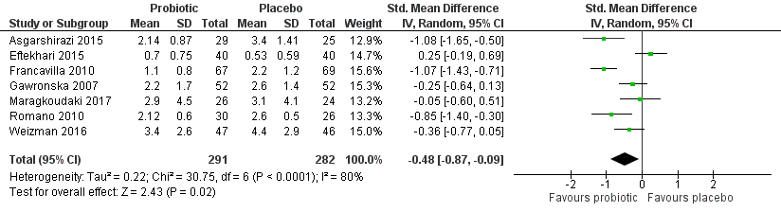

Forest plot of change in pain intensity post-intervention for probiotics compared to placebo.
