Supplementary Figure 1- Flow of patients in the study. AP- acute pancreatitis; ARP- acute recurrent pancreatitis.

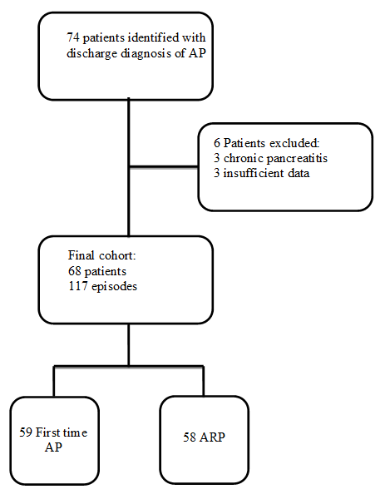

Supplementary Figure 2- Recurrence free survival following a first episode of acute pancreatitis.

