Supplementary Figure 1. Number of endoscopies with biopsies performed per patient during study period (January 2016–August 2018).

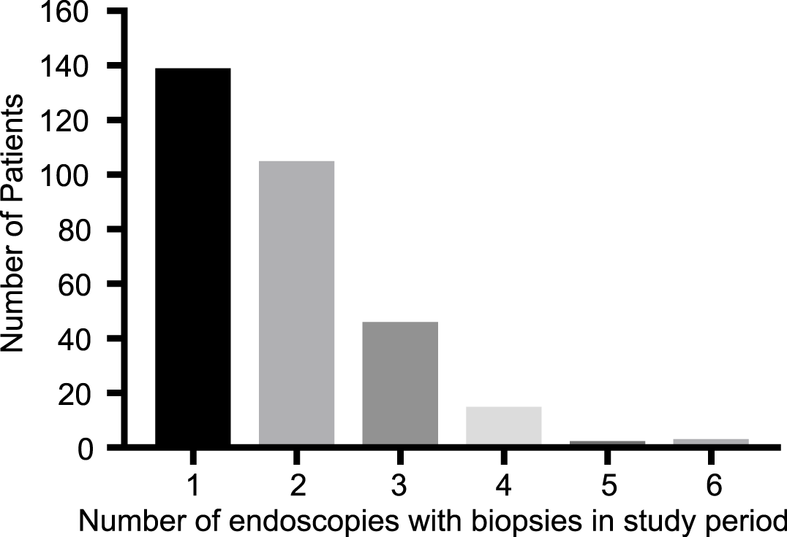

Supplementary Figure 2. Medication use in patients with history of non-long-gap esophageal atresia (non-LGEA) and long-gap esophageal atresia (LGEA). Distribution of medication use was significantly different between non-LGEA and LGEA endoscopies by Chi-square analysis (p< 0.001).

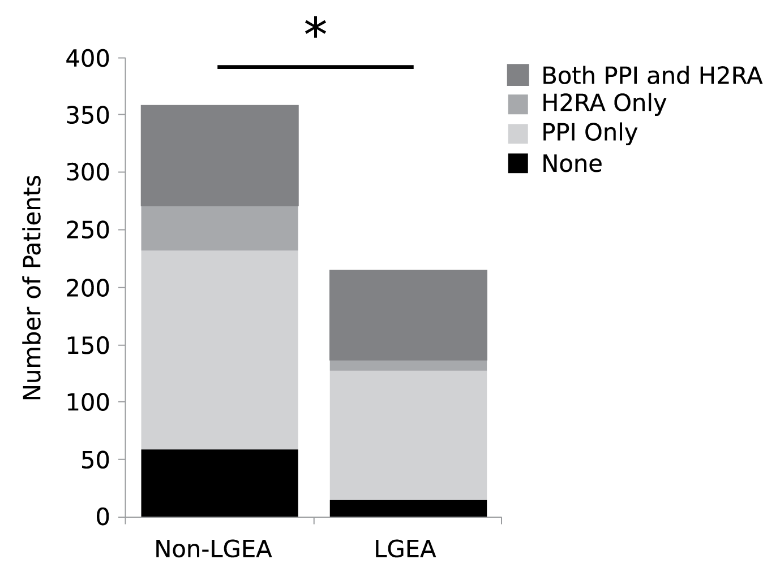
Supplementary Figure 3. Responsiveness of histologic esophagitis with > 15 eosinophils/HPF to acid suppressive therapies. Responsiveness is defined as improvement to ≤ 15 eosinophils/HPF on subsequent endoscopy.
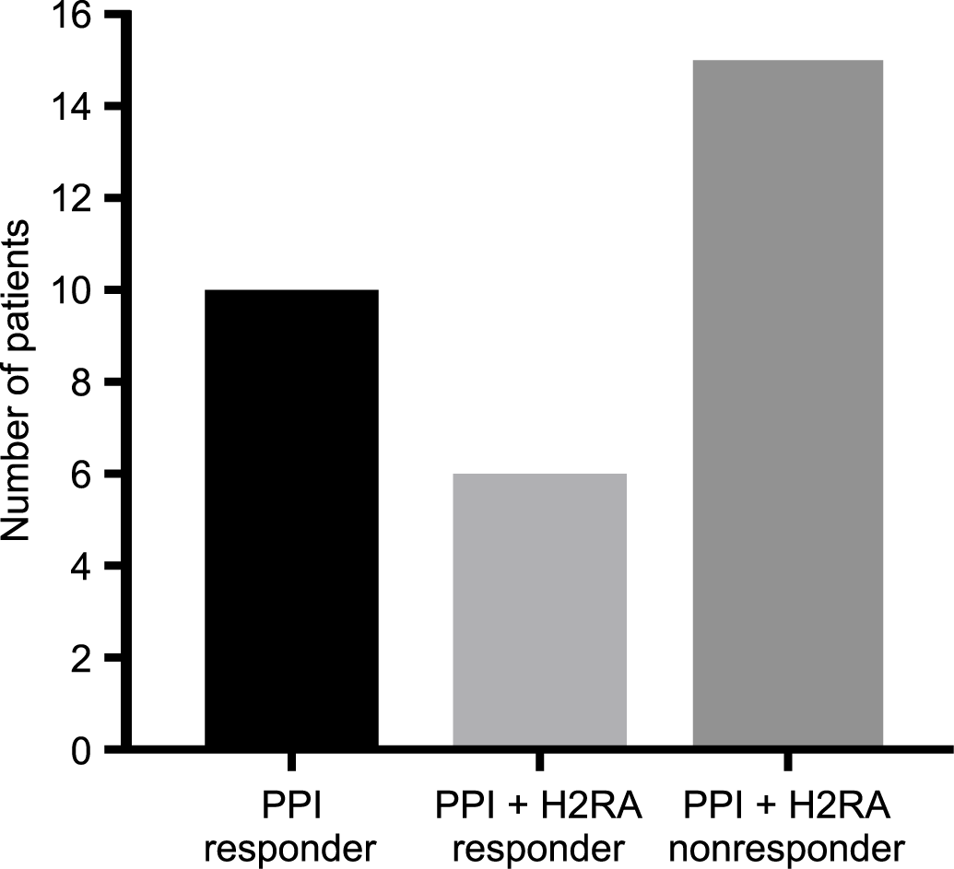

Supplementary Table 1. Supp. Table 1a: Number of patients (N) on no medications, PPI only, H2RA only and both PPI and H2RA. Dose equivalents of PPI and H2RA are expressed in terms of omeprazole equivalents and ranitidine equivalents, respectively. IQR = interquartile range. Supp. Table 1b: Medication use at time of endoscopy expressed in terms of omeprazole equivalents or ranitidine equivalents as appropriate. The Wilcoxon rank sum test was used to compare dosing across gap-length cohorts as indicated. P values ≤ 0.05 are considered statistically significant and are denoted by bold face type and an asterisk (*). IQR = interquartile range.

Supplementary Table 1a: Medication Use at All Endoscopies During Study Period (N = 574)
 | N |  | Median total daily dose, omeprazole equivalents, mg/kg (IQR) |  |  | Median total daily dose, ranitidine equivalents, mg/kg (IQR)
None | 75 |  | - |  |  | -
PPI Only | 285 |  | 1.68 (1.18–1.99) |  |  | -
H2RA Only | 49 |  | - |  |  | 3.77 (3.03–6.58)
Both PPI and H2RA | 165 |  | 1.8 (1.47–2.06) |  |  | 4.9 (2.96–5.36)
Supplementary Table 1b: Medication Use at All Endoscopies During Study Period by Gap Length
 | Non-LGEA |  |  | LGEA
 | N = 358 | Median Total Daily Dose, Omeprazole Equivalents, mg/kg (IQR) | Median Total Daily Dose, Ranitidine Equivalents, mg/kg (IQR) | N = 216 | Median Total Daily Dose, Omeprazole Equivalents, mg/kg (IQR) |  | Median Total Daily Dose, Ranitidine Equivalents, mg/kg (IQR) | P value
None | 59 | - | - | 15 | - |  | - | -
PPI Only | 173 | 1.61 (1.17–2.00) | - | 113 | 1.61 (1.27–1.98) |  | - | 0.956
H2RA Only | 39 | - | 5.11 (3.46–7.00) | 9 | - |  | 2.75 (2.31–4.53) | 0.035*
Both PPI and H2RA | 87 | 1.72 (1.21–2.00) | 3.86 (2.94–5.15) | 78 | 1.81 (1.58–2.10) |  | 4.08 (3.09–5.63) | 0.054,0.164

