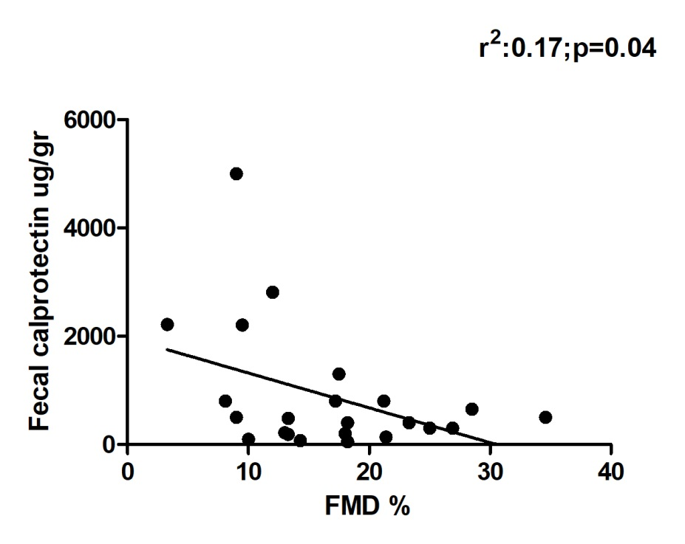

Suppl Figure 1. Plot of FMD % versus fecal calprotectin from 26 IBD patients in our cohort. The line in the plot represents the regression model (r²:0.17;p=0.04).

