Supplemental Digital Content
Supplemental Figure 1. Annual prevalence of paediatric home PN and assessment for home PN in Victoria
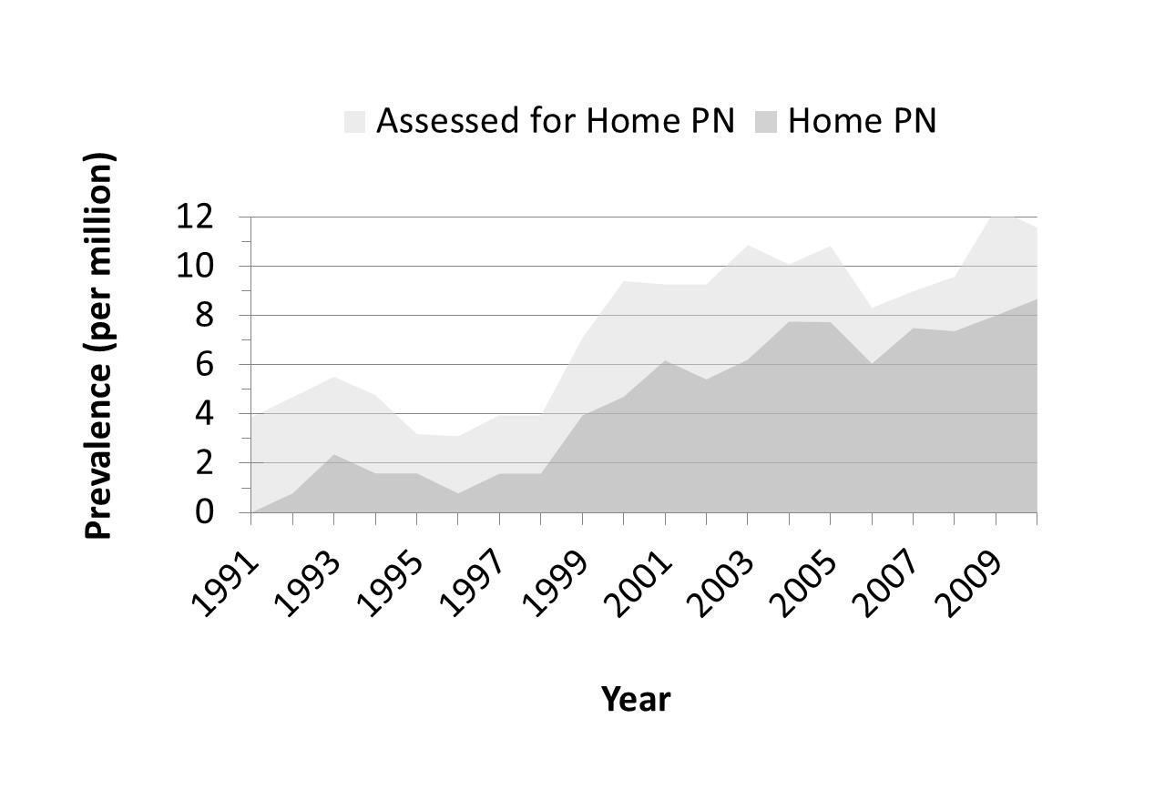

Supplemental Figure 2. Kaplan-Meier curve of PN weaning in patients with short bowel syndrome who commenced PN in the first versus the second decade of the study period
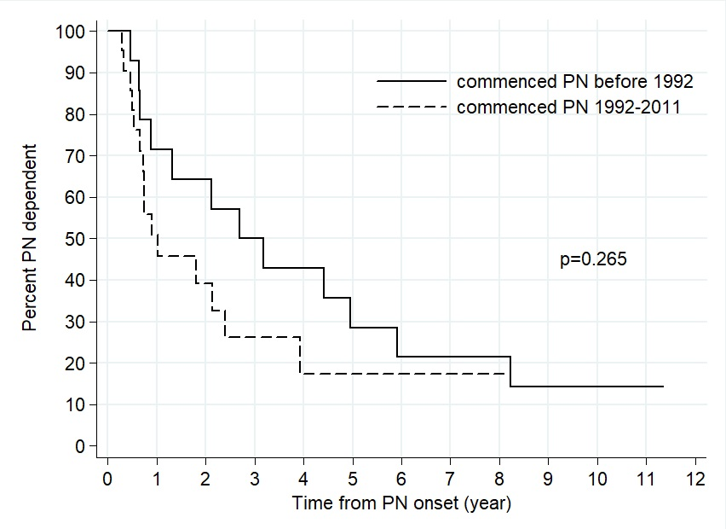

Supplemental Figure 3. Kaplan-Meier curves of PN-dependency in SBS survivors in relation to small bowel length and ileocaecal valve status
