Figure, Supplemental Digital Content 1. Faecal calprotectin of an imaginary patient with Crohn’s disease plotted over time. Time-to-reach target is defined as the first calprotectin measurement below 250 μg/g after the start of induction therapy (in this case 6 months). Time-to-first flare is defined as the time from the first calprotectin measurement below 250 μg/g until reappearance of symptoms with calprotectin values above 250 μg/g (in this case 6 months)

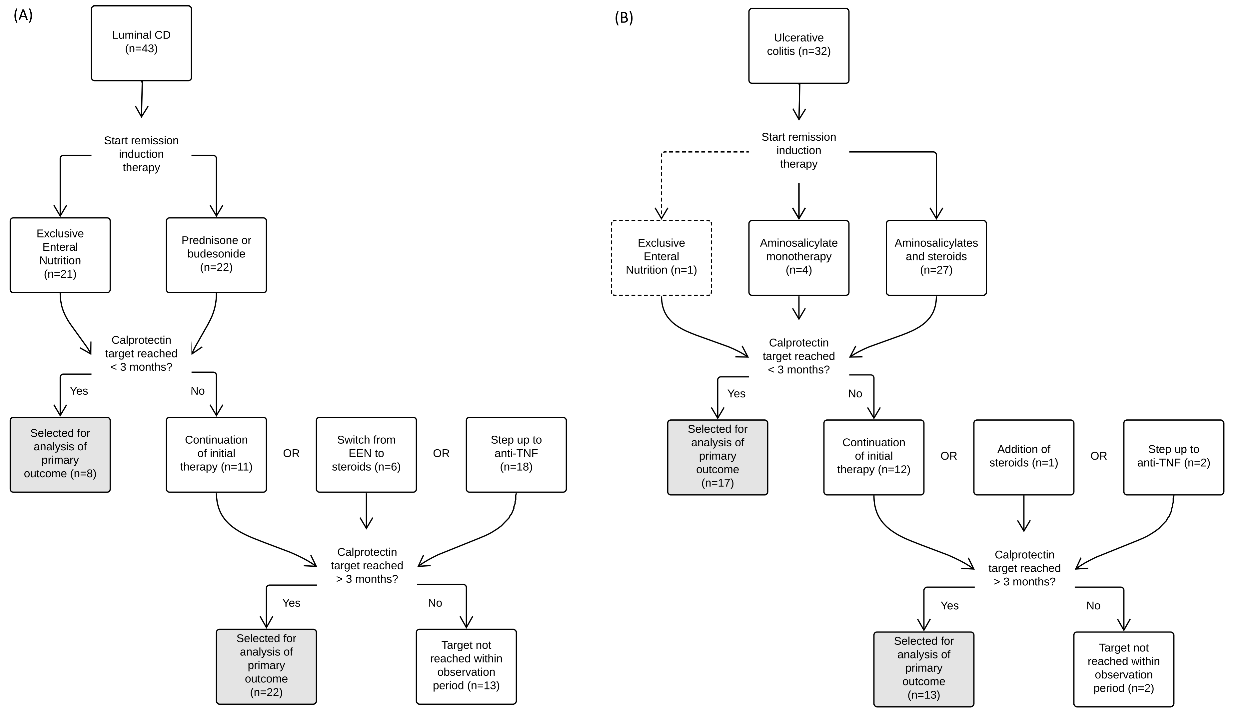
Figure, Supplemental Digital Content 2. Flow of patients with (a) Crohn’s disease and (b) ulcerative colitis in the first year postdiagnosis indicating how many reached the treatment target within 12 weeks, and how many at a later stage.

Table, Supplemental Digital Content 3. Impact of initial choice of induction therapy on one year outcomes
Crohn’s disease
Induction + maintenance therapy | n | Median time-to-reach target (range) | n | Median time-to-flare (range)
EEN + thiopurine | 6 | 7.5 weeks (4 – 24) | 3 | 7 weeks (1 – 42)
Steroids + thiopurine | 10 | 14.5 weeks (4 – 58) | 2 | 41.5 weeks (34 – 49)

Ulcerative colitis
Induction + maintenance therapy | n | Median time-to-reach target (range) | n | Median time-to-flare (range)
Steroids + 5-ASA | 19 | 11 weeks (3 – 56) | 15 | 22 weeks (5 – 55)
Steroids + thiopurine + 5-ASA | 7 | 11 weeks (2 – 35) | 3 | 40 weeks (20 – 73)
5-ASA | 3 | 5 weeks (3 – 63) | 1 | 43 weeks

Figure, Supplemental Digital Content 4. Overview of changes in faecal calprotectin from baseline to the moment of reaching the target range (ΔFC↓) and from the last result in range to the first out-of-range result (ΔFC↑).

