Supplementary Figure 1: Screenshot: automated analysis of MMS database software misinterprets two swallows (arrows) as being a non-acid retrograde bolus movement.
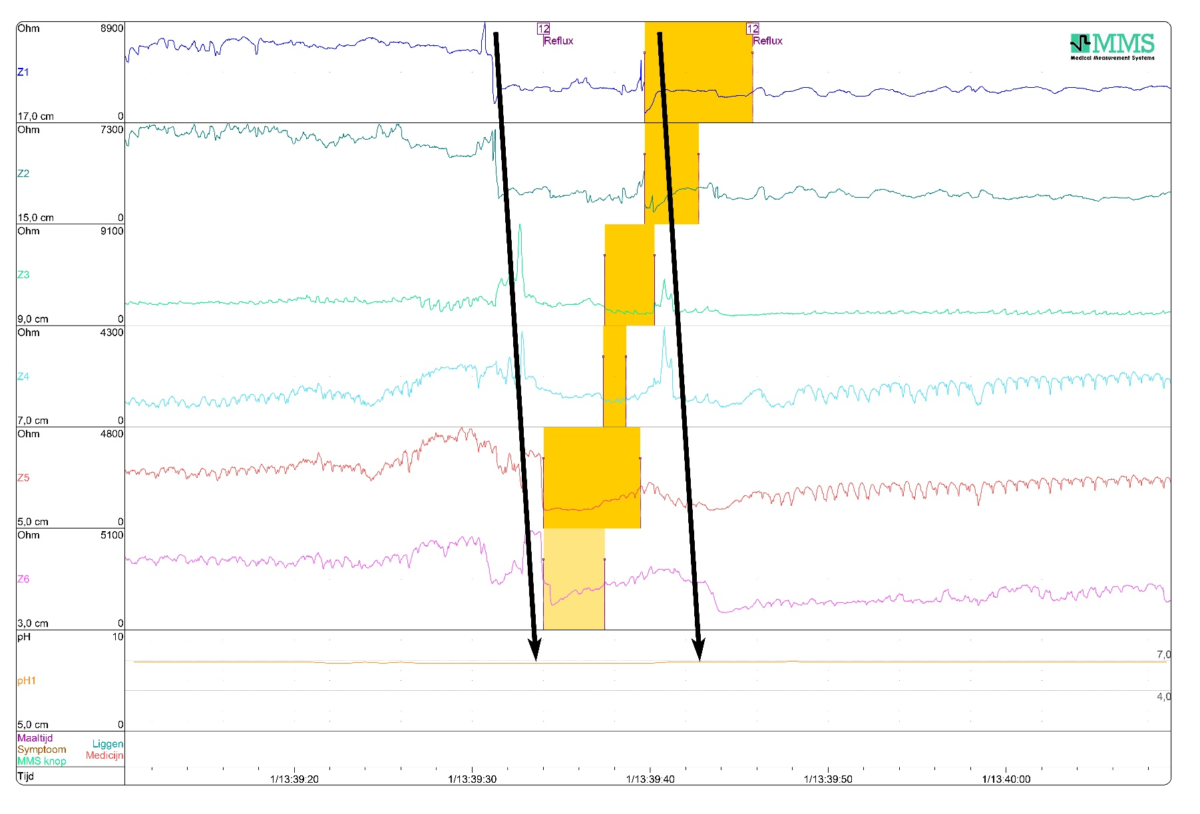

Supplementary Table 1: Patient demographics of included children (n=57) and children without pH-MII study (n=52).
Non-parametric Mann-Whitney U test for continues variables and Pearson’s chi-square test or Fisher’s exact test for categorical variables. ª Esophageal atresia Gross type A versus other types (Gross type C + D). ^{b} Thoracoscopy versus thoracotomy (including conversion).

 | Children included (N=57)  n (%) / median (min; max; IQR) | Children not included (N=52)  n (%) / median (min; max; IQR) | p-value
Male gender | 29 (50.9) | 34 (65.4) | 0.126
Gestational age (weeks) | 38.3 (28.9; 42.3; 36.8-40.1) | 37.7 (32.0; 41.3; 35.9-39.9) | 0.163
Prematurity | 14 (24.6) | 21 (40.4) | 0.077
Birthweight (gram) | 2685 (854; 3810; 2150-3125) | 2750 (1180; 3995; 1909-3270) | 0.785
Small for gestational age | 8 (14.0) | 8 (15.4) | 0.842
Type of esophageal atresia
Gross type A | 1 (1.8) | 5 (9.6) | 0.101ª
Gross type C | 55 (96.5) | 47 (90.4)
Gross type D | 1 (1.8) | 0
Type of esophageal correction
Primary anastomosis | 53 (93.0) | 47 (90.4) | 0.734
Delayed anastomosis | 4 (7.0) | 5 (9.6)
Type of surgery
Thoracoscopy | 25 (43.9) | 26 (50.0) | 0.459^{b}
Thoracotomy | 31 (54.4) | 22 (42.3)
Converted | 1 (1.8) | 2 (3.8)
Unknown | 0 | 1 (1.9)

Supplementary Table 2: Gastrointestinal questionnaire 8-year old children (24/33=72.7%)
Manterola score: Manterola et al. Initial validation of a questionnaire for detecting gastroesophageal reflux disease in epidemiological settings. J Clin Epidemiol. 2002;55(10):1041-5. ª Cooked eggs(n=1); hot dogs (n=1); garden peas, beans, cheese and potatoes (n=1); soft drinks (n=1); candy, bananas, apples and hot dogs (n=1). ^{b} The Manterola Questionnaire reported dysphagia in two children, chest pain in three children (one also complained of dysphagia), and regurgitation in two children. In the other five children none of these symptoms were reported. ^{c} A few times a week (n=3); a few times a month (n=2); a few times a year or less (n=2). ^{d} Daily (n=1); a few times a week (n=4); a few times a month (n=1); a few times a year or less (n=3). Two children had a history of Nissen fundoplication. ^{e} Daily (n=1); a few times a week (n=1); a few times a month (n=3); a few times a year or less (n=4).

Questions to detect gastroesophageal reflux | Answer | Manterola score | n (%)
Do you have complaints of burning reflux (burning sensation behind your breastbone)? | Never | 0 | 16 (66.7)
 | At least once a month | 1 | 5 (20.8)
 | At least once a week | 2 | 2 (8.3)
 | Daily | 3 | 1 (4.2)
Do you have complaints of regurgitation of stomach contents? | Never | 0 | 14 (58.3)
 | At least once a month | 1 | 6 (25.0)
 | At least once a week | 2 | 4 (16.7)
 | Daily | 3 | 0
Do you have problems with swallowing? | No | 0 | 18 (75.0)
 | Yes | 1 | 6 (25.0)
Do you have complaints of pain on the chest? | Never | 0 | 17 (70.8)
 | Occasional | 1 | 7 (29.2)
 | Daily | 2 | 0
Do you have nightly coughs? | Never | 0 | 8 (33.3)
 | Occasional | 1 | 16 (66.7)
 | Each night | 2 | 0
Do you have complaints of hoarseness? | No | 0 | 22 (91.7)
 | Yes | 1 | 2 (8.3)
Do you have asthma? | No | 0 | 24 (100)
 | Yes | 1 | 0
Other questions asked | Answer |  | n (%)
Are you able to eat everything? | No |  | 5 (20.8) ª
 | Yes |  | 19 (79.2)
Are you able to eat as much as your peers? | No |  | 7 (29.2)
 | Yes |  | 17 (70.8)
Are you able to eat as fast as others? | No |  | 13 (54.2)
 | Yes |  | 11 (45.8)
Is it necessary to drink while you eat? | No |  | 13 (54.2)
 | Yes |  | 11 (45.8) ^{b}
Do you ever feel nauseous after eating? | No |  | 17 (70.8)
 | Yes |  | 7 (29.2) ^{c}
Are you easily feeling full after eating? | No |  | 15 (62.5)
 | Yes |  | 9 (37.5) ^{d}
Do you ever feel bloated after eating? | No |  | 15 (62.5)
 | Yes |  | 9 (37.5) ^{e}

Supplementary Table 3: Patient demographics of 8-year old children who were asked to fill in the gastrointestinal questionnaire (N=33).
Non-parametric Mann-Whitney U test for continues variables and Pearson’s chi-square test or Fisher’s exact test for categorical variables. ª Esophageal atresia Gross type A versus other types (Gross type C + D). ^{b} Thoracoscopy versus thoracotomy (including conversion).

 | Questionnaire completed (N=24)  n (%) / median (min; max; IQR) | No questionnaire (N=9)  n (%) / median (min; max; IQR) | p-value
Male gender | 9 (37.5) | 6 (66.7) | 0.239
Gestational age (weeks) | 39.0 (28.9; 42.3; 37.3-40.7) | 37.7 (34.6; 40.1; 36.0-38.7)
Prematurity | 4 (16.7) | 3 (33.3) | 0.358
Birthweight (gram) | 3030 (1080; 3810; 2238-3368) | 2615 (1905; 3180; 2143-2925)
Small for gestational age | 3 (12.5) | 1 (11.1) | 1.000
Type of esophageal atresia
Gross type A | 1 (4.2) | 0 | 1.000ª
Gross type C | 22 (91.7) | 9 (100)
Gross type D | 1 (4.2) | 0
Type of esophageal correction
Primary anastomosis | 23 (95.8) | 7 (77.8) | 0.174
Delayed anastomosis | 1 (4.2) | 2 (22.2)
Type of surgery
Thoracoscopy | 6 (25.0) | 2 (22.2) | 1.000^{b}
Thoracotomy | 18 (75.0) | 7 (77.8)
Reflux index (%) | 0.3 (0; 11.8; 0.1-1.9) | 0.3 (0; 14.4; 0.1-2.7) | 0.651
Number of RBM | 20.7 (5.8; 48.9; 12.7-27.1) | 20.9 (0; 53.7; 10.1-35.4) | 0.953

Supplementary Table 4: Change of anti-reflux treatment after pH-MII study
ª Nissen fundoplication surgery was performed prior to the pH-MII study in 7/26 children with normal pH results. ^{b} Nissen fundoplication surgery performed prior to the pH-MII study. ^{c} In one child with normal pH-MII results, anti-reflux medication was started to treat night cough. ^{d} Upper endoscopy revealed normal esophagus in one child (no further actions) and mild esophagitis in two children for which treatment with proton pump inhibitors was started.

Age ≤ 18 months (N=24) | abnormal  pH results  n=2 | indeterminate  pH results  n=6 | normal  pH results  n=14 | unknown  pH results  n=2
Continuation without anti-reflux medication | 0 | 0 | 2 | 0
Discontinuation of anti-reflux medication | 0 | 4 | 12 | 2
Continuation of anti-reflux medication | 1 | 2 | 0 | 0
Fundoplication surgery + discontinuation of anti-reflux medication | 1 | 0 | 0 | 0
Age 8 years (N=33) | abnormal  pH results  n=4 | indeterminate  pH results  n=2 | normal  pH results  n=26 ª | Unknown  pH results  n=1 ^{b}
Continuation without anti-reflux medication | 0 | 2 | 23 | 1
Discontinuation of anti-reflux medication | 0 | 0 | 2 | 0
Start anti-reflux medication | 1 | 0 | 1 ^{c} | 0
Upper endoscopy ± start anti-reflux medication | 3 ^{d} | 0 | 0 | 0

