Figure S2: Relationship between PPI dose and probability of PPI-REE outcome in the pH probe cohort

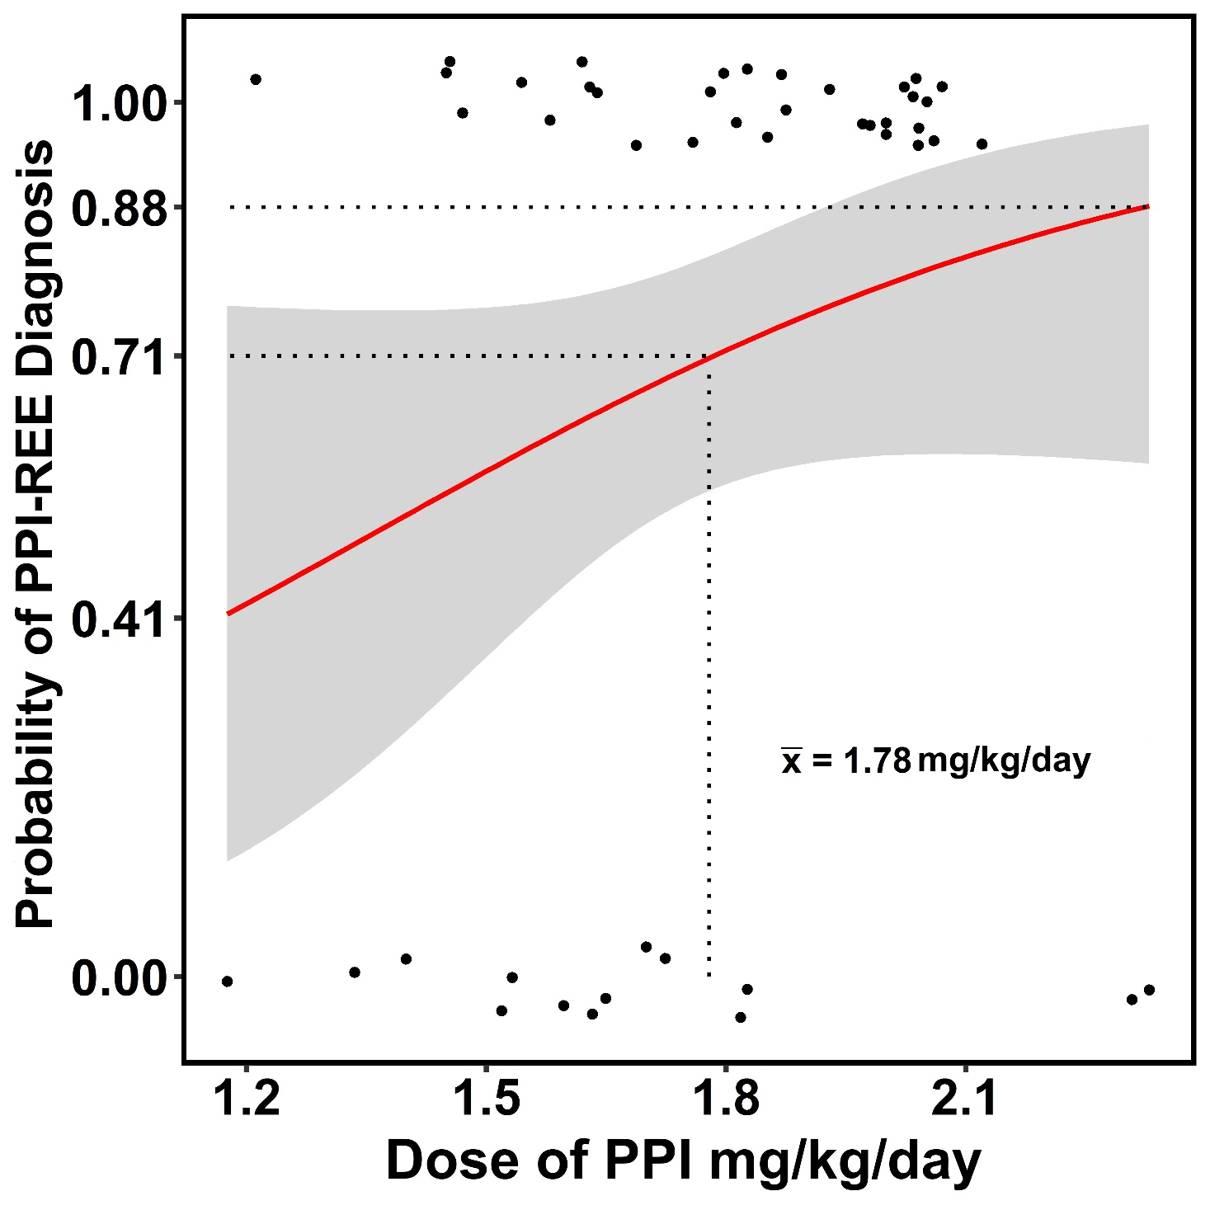

Plot of probability of PPI-REE diagnosis vs daily dose of PPI for the pH probe cohort (red line). Points indicate individuals who were diagnosed as PPI-nonresponsive EoE (near 0 on the y-axis) or PPI-REE (near 1 on the y-axis) and are jittered on the y-axis to minimize overlap and accurately convey point density. The 95% confidence interval is indicated by shading.

