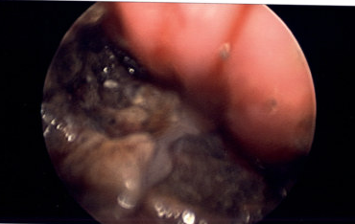

Supplemental Content 1. Necrotic esophageal injury after button battery ingestion

