Supplemental figure 1: Forest plots describing the use of L. reuteri DSM 17938 in preterm infants on mortality and morbidity rates.
a) Mortality:
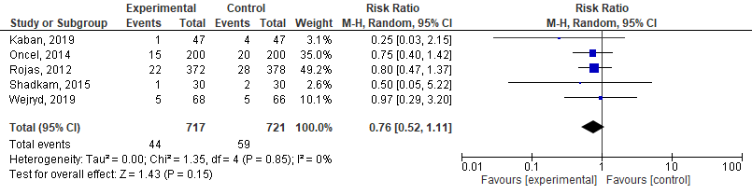
b) NEC stage ≥2:
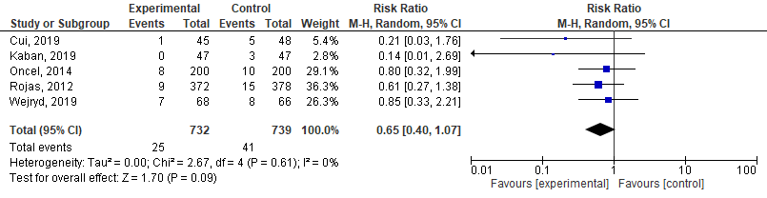
c) Sepsis:
