Supplemental Digital Content 1 – Table S1: Descriptive characteristics of children with CD and controls
 | Celiac Disease  (n=65) | Controls  (n=65) | p-value
Age (years) | 10.2 ± 3.6 | 10.1 ± 3.7 | 0.96
Male:Female (%) | 25:4 (38.5:61.5) | 25:4 (38.5:61.5) | 1.00
Duration on GFD (years, including range) | 3.6 ± 2.8  (0.5 – 12.6) | - | -
Weight (kg) | 31.7 (23.4-46.2) | 38.6 (24.2-53.2) | 0.18
Weight Z-score | -0.06 ± 1.05 | 0.47 ± 0.96 | 0.003
Height (cm) | 138.3 ± 21.4 | 140.5 ± 21.8 | 0.55
Height Z-score | 0.01 ±1.28 | 0.41 ± 1.17 | 0.07
BMI Z-score | -0.02 ± 0.88 | 0.41 ± 1.09 | 0.02
Results presented as mean ± standard deviation or median (interquartile range) unless stated otherwise
BMI – body mass index
GFD – gluten-free diet

Supplemental Digital Content 2 – Figure S1: Distribution of IRSD in (a) celiac and (b) control groups
(a)
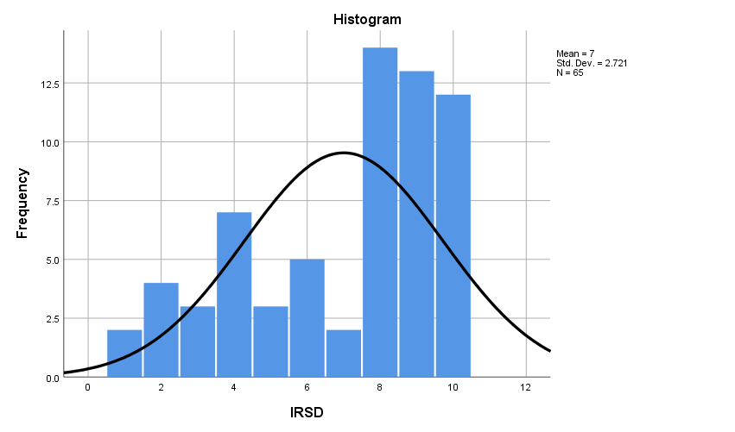

(b)
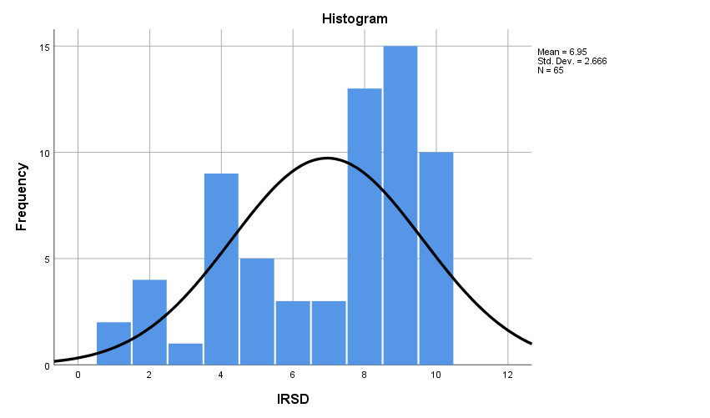

Supplemental Digital Content 3 - Table S2: Energy, macronutrient, sugar and fiber intake in children with CD categorized by SEIFA

 | SEIFA 1-5 (n=19) | SEIFA 6-10 (n=46) | p-value | q-value
Total Energy
Energy (kcal) | 2250.4 ± 312.9 | 2480.4 ± 535.2 | 0.09
Macronutrients
Protein (kcal) | 411.6 ± 77.8 | 446.2 ± 105.4 | 0.20 | 0.40
%E Protein | 19 (17-20) | 17 (18-19) | 0.27 | 0.40
Fats (kcal) | 764.3 ± 126.2 | 840.3 ± 196.1 | 0.13 | 0.39
%E Fat | 35.4 ± 4.8 | 35.1 ± 4.6 | 0.81 | 0.88
Carbohydrate (kcal) | 1032.8 ± 201.8 | 1146.4 ± 293.9 | 0.13 | 0.39
%E Carbohydrate | 46.7 ± 5.2 | 46.9 ± 4.8 | 0.88 | 0.88
Macronutrient Types
Saturated Fat (g) | 38.3 ± 8.9 | 42.8 ± 11.9 | 0.15 | 0.7
%E Saturated Fat | 16.0 ± 3.4 | 16.0 ± 2.9 | 0.93 | 0.93
Polyunsaturated Fat (g) | 8.4 (7.3-11.4) | 9.1 (7.9-11.3) | 0.28 | 0.7
%E Polyunsaturated Fat | 3.0 (3.0-4.0) | 3.5 (3.0-4.0) | 0.51 | 0.82
Monounsaturated Fat (g) | 30.4 ± 5.2 | 32.8 ± 7.4 | 0.21 | 0.7
%E Monounsaturated Fat | 12.0 (11.0-14.0) | 12.0 (11.0-13.0) | 0.72 | 0.82
Fiber (g/1000 kcal) | 11.9 ± 3.0 | 12.3 ± 2.6 | 0.68 | 0.82
Sugars %CHO | 48.9 ± 6.5 | 46.6 ± 9.6 | 0.35 | 0.7
Results presented as mean ± standard deviation or median (interquartile range)
%E - Percentage of Total Energy
%CHO - Percentage of Total Carbohydrates
q-value – FDR adjusted p-value

Supplemental Digital Content 4 - Table S3: Micronutrient intake in children with CD categorized by SEIFA
 |  | SEIFA 1-5 (n=19) | SEIFA 6-10 (n=46) | p-value | q-value
Micronutrients
Vitamin B1 (Thiamin) | %RDI | 218.9 (159.8-291.1) | 230.0 (149.3-285.0) | 0.90 | 0.9
Vitamin B2 (Riboflavin) | %RDI | 345.7 ± 122.6 | 352.7 ± 175.3 | 0.88 | 0.9
Vitamin B3 (Niacin) | %RDI | 209.6 (159.9-272.4) | 207.4 (171.8-267.0) | 0.89 | 0.9
Vitamin A | %RDI | 274.8 (158.5-341.4) | 279.9 (171.1-356.4) | 0.62 | 0.90
Vitamin C | %RDI | 297.7 (201.1-391.5) | 384.7 (276.2-505.6) | 0.12 | 0.76
Folate | %RDI | 118.2 ± 42.8 | 132.6 ± 56.5 | 0.32 | 0.76
Sodium | %AI | 645.0 ± 143.9 | 732.1 ± 233.4 | 0.07 | 0.76
Potassium | %AI | 148.9 ± 32.5 | 152.5 ± 42.3 | 0.75 | 0.9
Calcium | %RDI | 144.9 (117.2-169.7) | 161.3 (125.1-204.3) | 0.24 | 0.76
Magnesium | %RDI | 202.5 ± 84.9 | 227.3 ± 100.5 | 0.35 | 0.76
Phosphorus | %RDI | 183.3 (140.6-324.3) | 195.4 (143.3-373.8) | 0.41 | 0.76
Iron | %RDI | 146.2 ± 51.0 | 155.8 ± 56.5 | 0.26 | 0.76
Zinc | %RDI | 267.3 (210.3-378.8) | 283.6 (235.4-363.6) | 0.48 | 0.78
Results presented as mean ± standard deviation or median (interquartile range)
%RDI – Intake as a Percentage of Recommended Dietary Intake (RDI)
%AI – Intake as a Percentage of Adequate Intake (AI)
q-value – FDR adjusted p-value

Supplemental Digital Content 5 - Table S4: Energy, macronutrient, sugar and fiber intake in healthy controls categorized by SEIFA

 | SEIFA 1-5 (n=21) | SEIFA 6-10 (n=44) | p-value | q-value
Total Energy
Energy (kcal) | 2095.6 (1642.7-2438.3) | 2207.3 (1829.1-2954.4) | 0.42
Macronutrients
Protein (kcal) | 389.5 ± 142.1 | 412.1 ± 123.8 | 0.52 | 0.86
%E Protein | 19.0 (17.0-19.50) | 18.0 (17.0-20.0) | 0.72 | 0.86
Fats (kcal) | 687.3 ± 218.4 | 727.2 ± 210.5 | 0.48 | 0.86
%E Fat | 34.0 (30.5-37.0) | 34.0 (31.0-36.0) | 0.88 | 0.88
Carbohydrate (kcal) | 1055.1 (726.4-1178.5) | 1032.6 (861.3-1177.2) | 0.53 | 0.86
%E Carbohydrate | 47.6 ± 4.7 | 48.2 ± 5.3 | 0.66 | 0.86
Macronutrient Types
Saturated Fat (g) | 35.1 ± 12.6 | 35.9 ± 10.6 | 0.79 | 0.79
%E Saturated Fat | 15.6 ± 2.1 | 15.0 ± 3.1 | 0.42 | 0.75
Polyunsaturated Fat (g) | 8.4 (6.2-9.4) | 8.2 (6.8-10.2) | 0.48 | 0.75
%E Polyunsaturated Fat | 3.0 (3.0-4.0) | 4.0 (3.0-4.0) | 0.74 | 0.79
Monounsaturated Fat (g) | 26.4 ± 8.1 | 28.8 ± 9.1 | 0.32 | 0.75
%E Monounsaturated Fat | 11.0 (10.5-14.0) | 12.0 (11.0-13.0) | 0.56 | 0.75
Fiber (g/1000 kcal) | 11.9 (9.7-13.6) | 12.8 (11.1-14.2) | 0.27 | 0.75
Sugars %CHO | 47.7 ± 10.2 | 49.3 ± 8.9 | 0.50 | 0.75
Results presented as mean ± standard deviation or median (interquartile range)
%E - Percentage of Total Energy
%CHO - Percentage of Total Carbohydrates
q-value – FDR adjusted p-value

Supplemental Digital Content 6 - Table S5: Micronutrient intake in healthy controls categorized by SEIFA
 |  | SEIFA 1-5 (n=21) | SEIFA 6-10 (n=44) | p-value | q-value
Micronutrients
Vitamin B1 (Thiamin) | %RDI | 205.1 ± 91.0 | 246.9 ± 98.3 | 0.12 | 0.36
Vitamin B2 (Riboflavin) | %RDI | 301.1 (203.6-407.2) | 337.7 (217.3-426.3) | 0.63 | 0.68
Vitamin B3 (Niacin) | %RDI | 197.8 (129.9-217.6) | 224.6 (163.3-270.5) | 0.13 | 0.36
Vitamin A | %RDI | 200.7 ± 90.6 | 264.6 ± 131.5 | 0.03 | 0.36
Vitamin C | %RDI | 320.5 (166.3-397.8) | 345.1 (286.9-506.4) | 0.14 | 0.36
Folate | %RDI | 112.2 ± 50.1 | 126.0 ± 45.7 | 0.27 | 0.52
Sodium | %AI | 620.9 ± 229.3 | 651.9 ± 189.0 | 0.57 | 0.68
Potassium | %AI | 132.0 (96.8-151.1) | 128.9 (111.9-156.1) | 0.55 | 0.68
Calcium | %RDI | 143.9 (91.7-188.3) | 128.4 (102.1-175.0) | 0.93 | 0.93
Magnesium | %RDI | 190.1 ± 86.6 | 216.7 ± 94.0 | 0.28 | 0.52
Phosphorus | %RDI | 174.2 (125.7-319.8) | 206.0 (133.1-336.0) | 0.55 | 0.68
Iron | %RDI | 134.0 ± 56.2 | 141.5 ± 48.1 | 0.58 | 0.68
Zinc | %RDI | 235.0 (177.6-283.0) | 279.1 (200.0-330.3) | 0.09 | 0.36
Results presented as mean ± standard deviation or median (interquartile range)
%RDI – Intake as a Percentage of Recommended Dietary Intake (RDI)
%AI – Intake as a Percentage of Adequate Intake (AI)
q-value – FDR adjusted p-value

Supplemental Digital Content 7 – Table S6: Anthropometrics in children with CD on a short-term and long-term GFD
 | On GFD for less than 3.5 years (n = 37) | On GFD for 3.5 years or more (n = 28) | p-value
Weight (kg) | 35.5 ± 15.4 | 34.3 ± 13.2 | 0.72
Weight Z-score | 0.01 ± 1.16 | -0.16 ± 0.89 | 0.52
Height (cm) | 136.8 ± 23.0 | 140.1 ± 19.3 | 0.54
Height Z-score | -0.82 ± 1.38 | 0.13 ± 1.14 | 0.51
BMI Z-score | 0.16 ± 0.93 | -0.25 ± 0.77 | 0.06
Results presented as mean ± standard deviation or median (interquartile range)
BMI – body mass index
GFD – gluten-free diet

