Supplemental Digital Content 1

Table. Overview of Publications Identified Evaluating PEBD Clinical Outcomes in PFIC Patients
Publication | Nª | Liver Biochemistry Parameters Reported^{b} | Outcomes Reported | Responder Rate/Description
Aggregate data, early response
Ismail,  1999¹ | 16 | ALT, BA, bilirubin | Growth, histology, pruritus | - 12/16 responders (complete clinical and biochemical improvement)  - 2/16 partial responders  - 2/16 non-responders  - Biochemical improvement creates a bias toward liver biochemistry parameters  - Difficult to match bile acid levels to individuals; the group as such is regarded as “partial responders”  - Bilirubin levels are defined for 12 responders vs the rest; in the bilirubin analysis, data are therefore tabulated as responders and partial/non-responders
Melter,  2000² | 6^{c} | ALT, AST, BA, bilirubin, GGT | Growth, liver function, pruritus, QoL | - 6/6 responders (complete responses within 1 week with respect to pruritus and jaundice)
Kalicinski,  2003³ | 20 | BA | Growth, pruritus | - 15/20 responders (pruritus and jaundice resolved)  - 3/20 partial responders  - 2/20 non-responders (required liver transplant)  - As a group, this was considered as a partial-responding group
Yang,  2009⁴ | 11 | ALT, ALP, AST, BA, bilirubin, GGT | Growth, pruritus, sleep, QoL | - 5/11 responders (no pruritus)  - 3/11 partial responders (mild pruritus)  - 3/11 non-responders (severe pruritus)
Halaweish,  2010⁵ | 7 | ALT, ALP, AST, bilirubin | Pruritus | - 6/7 responders (i.e. complete or near-complete resolution of pruritus and jaundice during the initial 6 months)  - Pruritus re-occurred later in some patients  - Defined as a partial-responding group
Schukfeh,  2012⁶ | 21^{c} | ALT, AST, BA, bilirubin, GGT | Liver function, pruritus | - 13/21 responders (relief of pruritus and bile acid normalization)  - 8/21 non-responders  - Bias toward BA  - Defined as a partial-responding group
Jankowska,  2016⁷ | 26 | BA, bilirubin | Pruritus | - 18/26 responders (complete relief from pruritus and normalization of total bilirubin and BA)  - 8/26 non-responders
Individual patient data, early response
Whitington,  1988⁸ | 4 | ALT, ALP, BA, bilirubin | Growth, histology, pruritus, QoL | - 4/4 responders (complete clinical remission from pruritus within 48 hours)
Ng,  2000⁹ | 3 | ALT, BA, bilirubin | Histology, pruritus | - 3/3 responders (resolution of pruritus)
Kurbegov,  2003¹⁰ | 3 | ALT, ALP, AST, bBA, bilirubin, GGT | Histology, pruritus, growth | - 3/3 responders (resolution of jaundice, pruritus, improved growth, morphological improvement)
Ekinci,  2008¹¹ | 2 | ALP, BA, bilirubin, GGT | Pruritus | - 2/2 responders (pruritus ceased within 2 weeks, appetite and sleep improved)
Arnell, 2008^{12,d} | 12 | ALT, BA, bilirubin | Growth, histology, pruritus | - 7/12 responders (pruritus resolved)  - 2/12 partial responders  - 3/12 non-responders
Schukfeh,  2014¹³ | 2 | BA, bilirubin | Pruritus | - 2/2 responders (total relief of pruritus within 6 weeks)
Individual patient data, early response and/or long-term outcomes
Arnell,  2010^{14,d,e} | 12 | Data from Arnell, 2008 | Histology, LTX, death | - Used only for long-term outcomes^{d}  - 11 patients followed for >5 years; 2 needed LTX or died
Emerick,  2008¹⁵ | 7 | ALT, BA, bilirubin | Histology, pruritus, LTX, death | - 4/7 responders (reduction in pruritus by 2 units or BA <40 µmol/L); 3/7 non-responders (pruritus change <1 unit or BA >40 µmol/L)  - 5 needed LTX or died
Davit-Spraul,  2010¹⁶ | 15 | BA | Histology, pruritus, LTX, death | - 4/15 responders (disappearance of jaundice and pruritus)  - 4/15 partial responders (disappearance of pruritus only)  - 7/15 non-responders (no effect on pruritus or jaundice)  - 6/15 had LTX and 2 were planned
ªN=number of PFIC patients for whom liver biochemistry data could be extracted; total N may be higher.
^{b}Not all reported parameters could be included in this analysis due to limitations such as inability extract values or to link specific values to specific patients and/or outcomes.
^{c}6/21 patients in Schukfeh 2012 were also reported in Melter 2000.
^{d}Arnell 2008 and Arnell 2010 report short- and long-term outcomes, respectively, for the same 12 individuals. Individual liver biochemistry parameter data were provided and used in the current analysis in agreement with the authors and with ethical approval.
^{e}For early outcomes and liver biochemistry parameters, see Arnell et al, 2008.¹²
ALP, alkaline phosphatase; ALT, alanine transaminase; AST, aspartate transaminase; BA, bile acids; bBA, biliary bile acids (not included in analysis of bile acids); GGT, gamma-glutamyl transferase; LTX, liver transplant; PEBD, partial external biliary diversion; PFIC, progressive familial intrahepatic cholestasis; QoL, quality of life.

Supplemental Digital Content 2
Figure. Pre-PEBD Levels of Liver Biochemistry Parameters. A) Individual pre-BEBD serum bile acid levels in 42 patients from 7 studies.^{8,9,11-13,15,16} B) Individual pre-PEBD serum bilirubin levels in 31 patients from 7 studies.^{8-13,15} C) Individual pre-PEBD ALT levels in 28 patients from 5 studies.^{8-10,12,15} Solid horizontal bars indicate the median value for each group; dotted horizontal lines indicate upper limit of normal. ALT, alanine transaminase; PEBD, partial external biliary diversion.
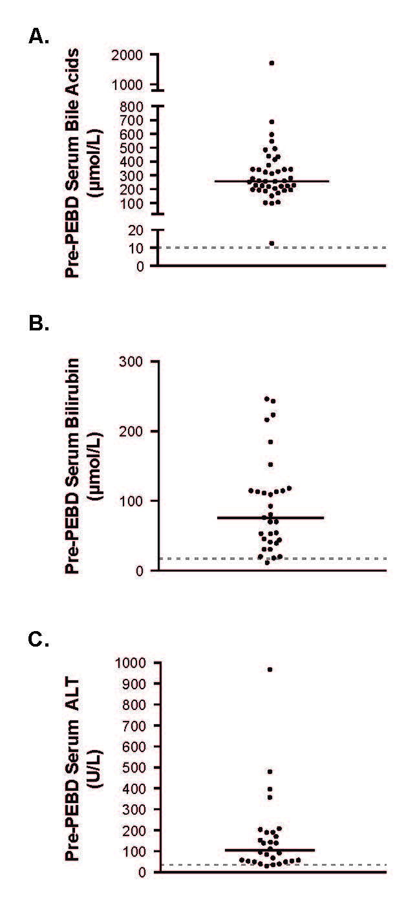

References

1. Ismail H, Kalicinski P, Markiewicz M, et al. Treatment of progressive familial intrahepatic cholestasis: liver transplantation or partial external biliary diversion. Pediatr Transplant. 1999;3(3):219-224.

2. Melter M, Rodeck B, Kardorff R, et al. Progressive familial intrahepatic cholestasis: partial biliary diversion normalizes serum lipids and improves growth in noncirrhotic patients. Am J Gastroenterol. 2000;95(12):3522-3528.

3. Kalicinski PJ, Ismail H, Jankowska I, et al. Surgical treatment of progressive familial intrahepatic cholestasis: comparison of partial external biliary diversion and ileal bypass. Eur J Pediatr Surg. 2003;13(5):307-311.

4. Yang H, Porte RJ, Verkade HJ, De Langen ZJ, Hulscher JB. Partial external biliary diversion in children with progressive familial intrahepatic cholestasis and Alagille disease. J Pediatr Gastroenterol Nutr. 2009;49(2):216-221.

5. Halaweish I, Chwals WJ. Long-term outcome after partial external biliary diversion for progressive familial intrahepatic cholestasis. J Pediatr Surg. 2010;45(5):934-937.

6. Schukfeh N, Metzelder ML, Petersen C, et al. Normalization of serum bile acids after partial external biliary diversion indicates an excellent long-term outcome in children with progressive familial intrahepatic cholestasis. J Pediatr Surg. 2012;47(3):501-505.

7. Jankowska I, Czubkowski P, Wierzbicka A, Pawlowska J, Kalicinski P, Socha P. Influence of partial external biliary diversion on the lipid profile in children with progressive familial intrahepatic cholestasis. J Pediatr Gastroenterol Nutr. 2016;63(6):598-602.

8. Whitington PF, Whitington GL. Partial external diversion of bile for the treatment of intractable pruritus associated with intrahepatic cholestasis. Gastroenterology. 1988;95(1):130-136.

9. Ng VL, Ryckman FC, Porta G, et al. Long-term outcome after partial external biliary diversion for intractable pruritus in patients with intrahepatic cholestasis. J Pediatr Gastroenterol Nutr. 2000;30(2):152-156.

10. Kurbegov AC, Setchell KD, Haas JE, et al. Biliary diversion for progressive familial intrahepatic cholestasis: improved liver morphology and bile acid profile. Gastroenterology. 2003;125(4):1227-1234.

11. Ekinci S, Karnak I, Gurakan F, et al. Partial external biliary diversion for the treatment of intractable pruritus in children with progressive familial intrahepatic cholestasis: report of two cases. Surg Today. 2008;38(8):726-730.

12. Arnell H, Bergdahl S, Papadogiannakis N, Nemeth A, Fischler B. Preoperative observations and short-term outcome after partial external biliary diversion in 13 patients with progressive familial intrahepatic cholestasis. J Pediatr Surg. 2008;43(7):1312-1320.

13. Schukfeh N, Gerner P, Paul A, Kathemann S, Metzelder M. Laparoscopic button cholecystostomy for progressive familial intrahepatic cholestasis in two children. Eur J Pediatr Surg. 2014;24(5):433-436.

14. Arnell H, Papadogiannakis N, Zemack H, Knisely AS, Nemeth A, Fischler B. Follow-up in children with progressive familial intrahepatic cholestasis after partial external biliary diversion. J Pediatr Gastroenterol Nutr. 2010;51(4):494-499.

15. Emerick KM, Elias MS, Melin-Aldana H, et al. Bile composition in Alagille syndrome and PFIC patients having partial external biliary diversion. BMC Gastroenterol. 2008;8:47.

16. Davit-Spraul A, Fabre M, Branchereau S, et al. ATP8B1 and ABCB11 analysis in 62 children with normal gamma-glutamyl transferase progressive familial intrahepatic cholestasis (PFIC): phenotypic differences between PFIC1 and PFIC2 and natural history. Hepatology. 2010;51(5):1645-1655.

