Figure, Supplemental Digital Content 1. Heatmap sorted on p-value
Heatmap presenting the individual values of lipid species concentrations in the sample set
by using color. Samples of controls and steatosis are represented on the right
and left side of the heatmap, respectively.
Abbreviations: LPE, Lysophosphatidylethanolamine; PC, Phosphatidylcholine; SM(d), Sphingomyelin; TG, Triacylglycerol; TG[O], Alkyldiacylglycerol.

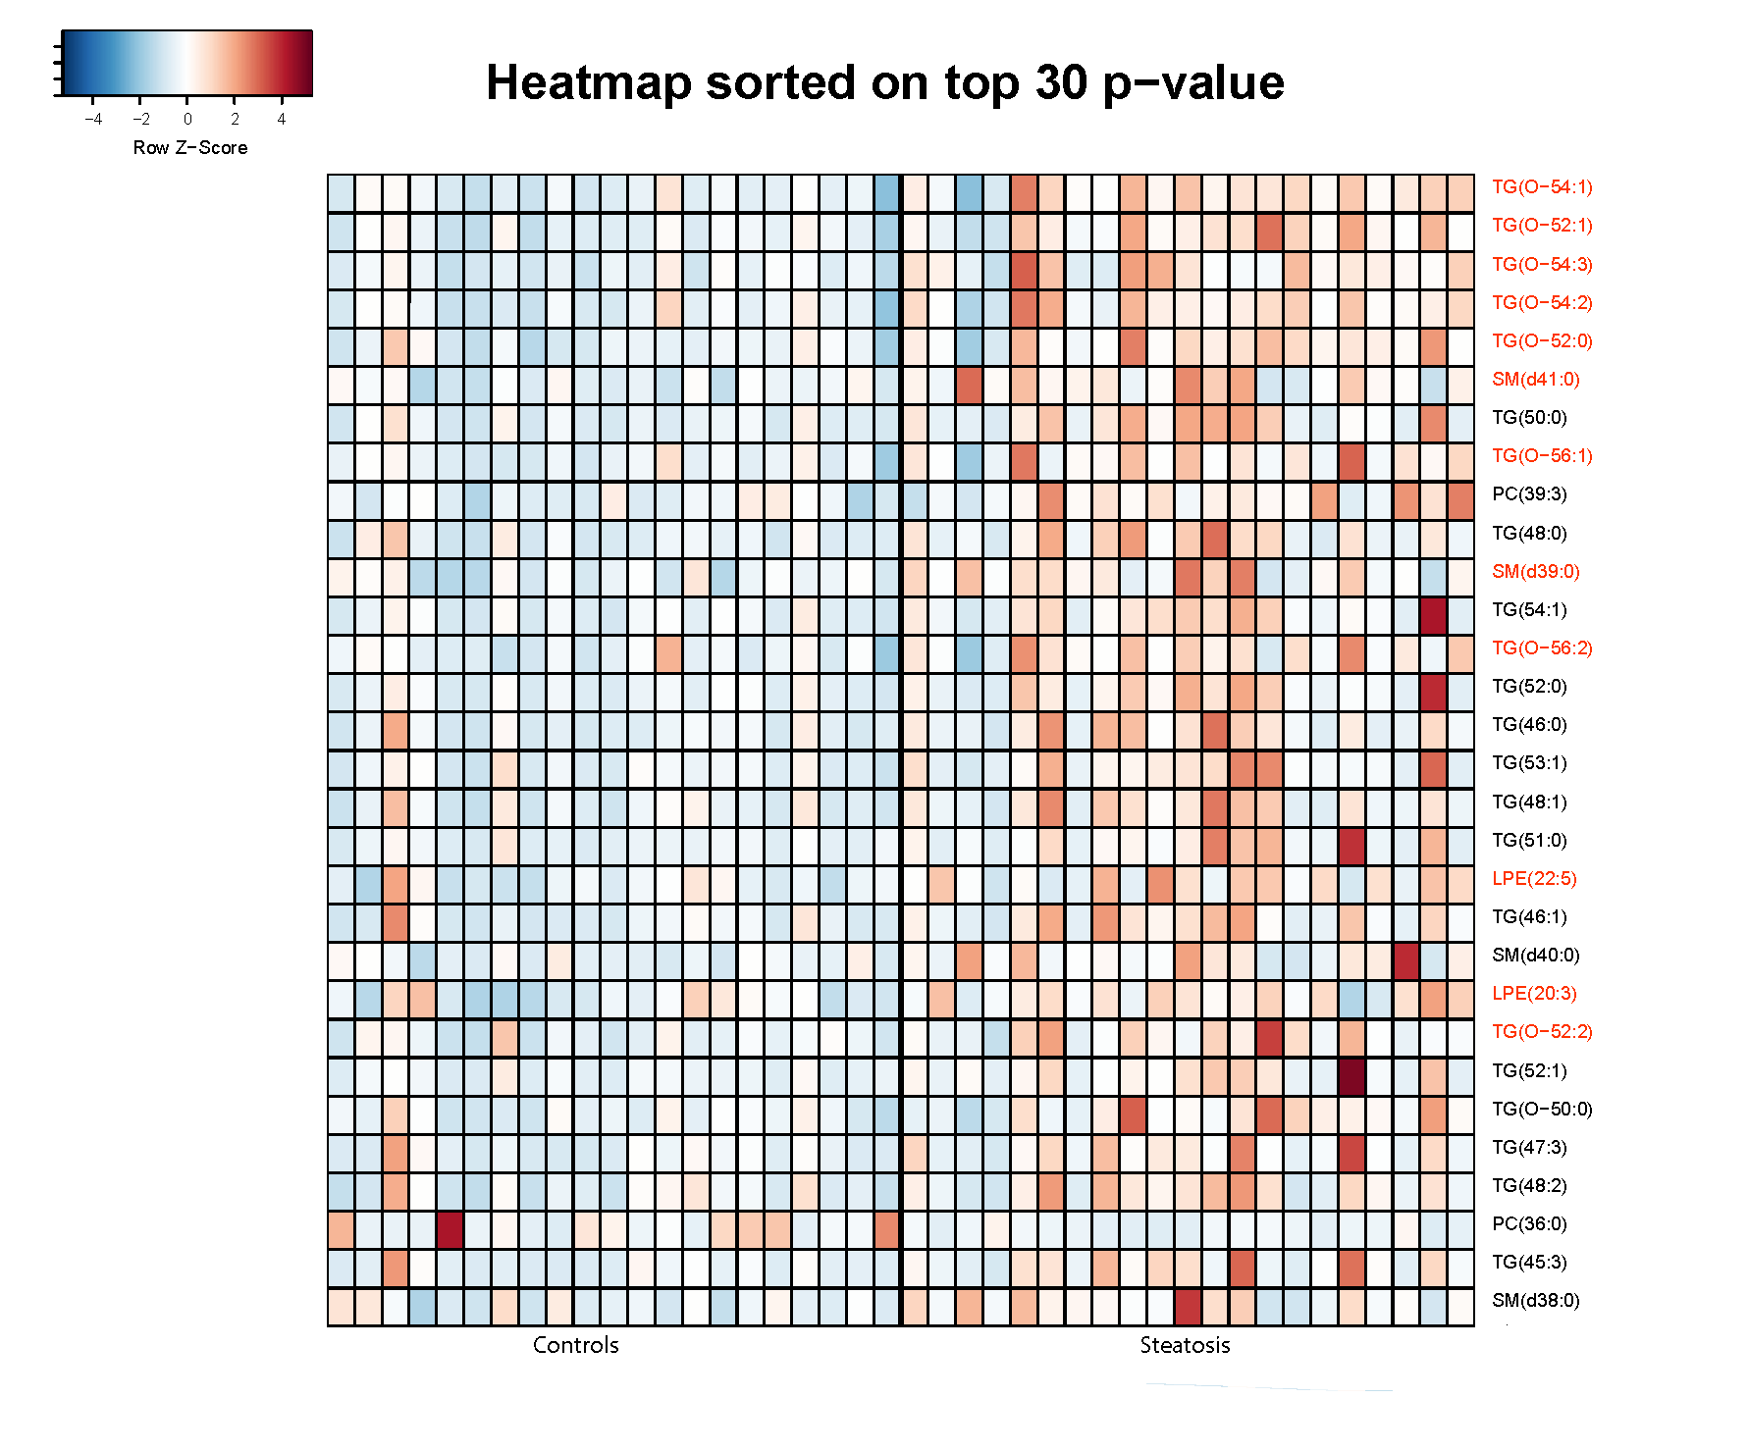
Figure, Supplemental Digital Content 2. Boxplots of significant lipid species
Boxplots of twelve lipid species that remained significant after FDR <5% limitation, with
higher concentrations in children with steatosis compared to controls.
Abbreviations: LPE, Lysophosphatidylethanolamine; SM(d), Sphingomyelin; TG[O],
Alkyldiacylglycerol

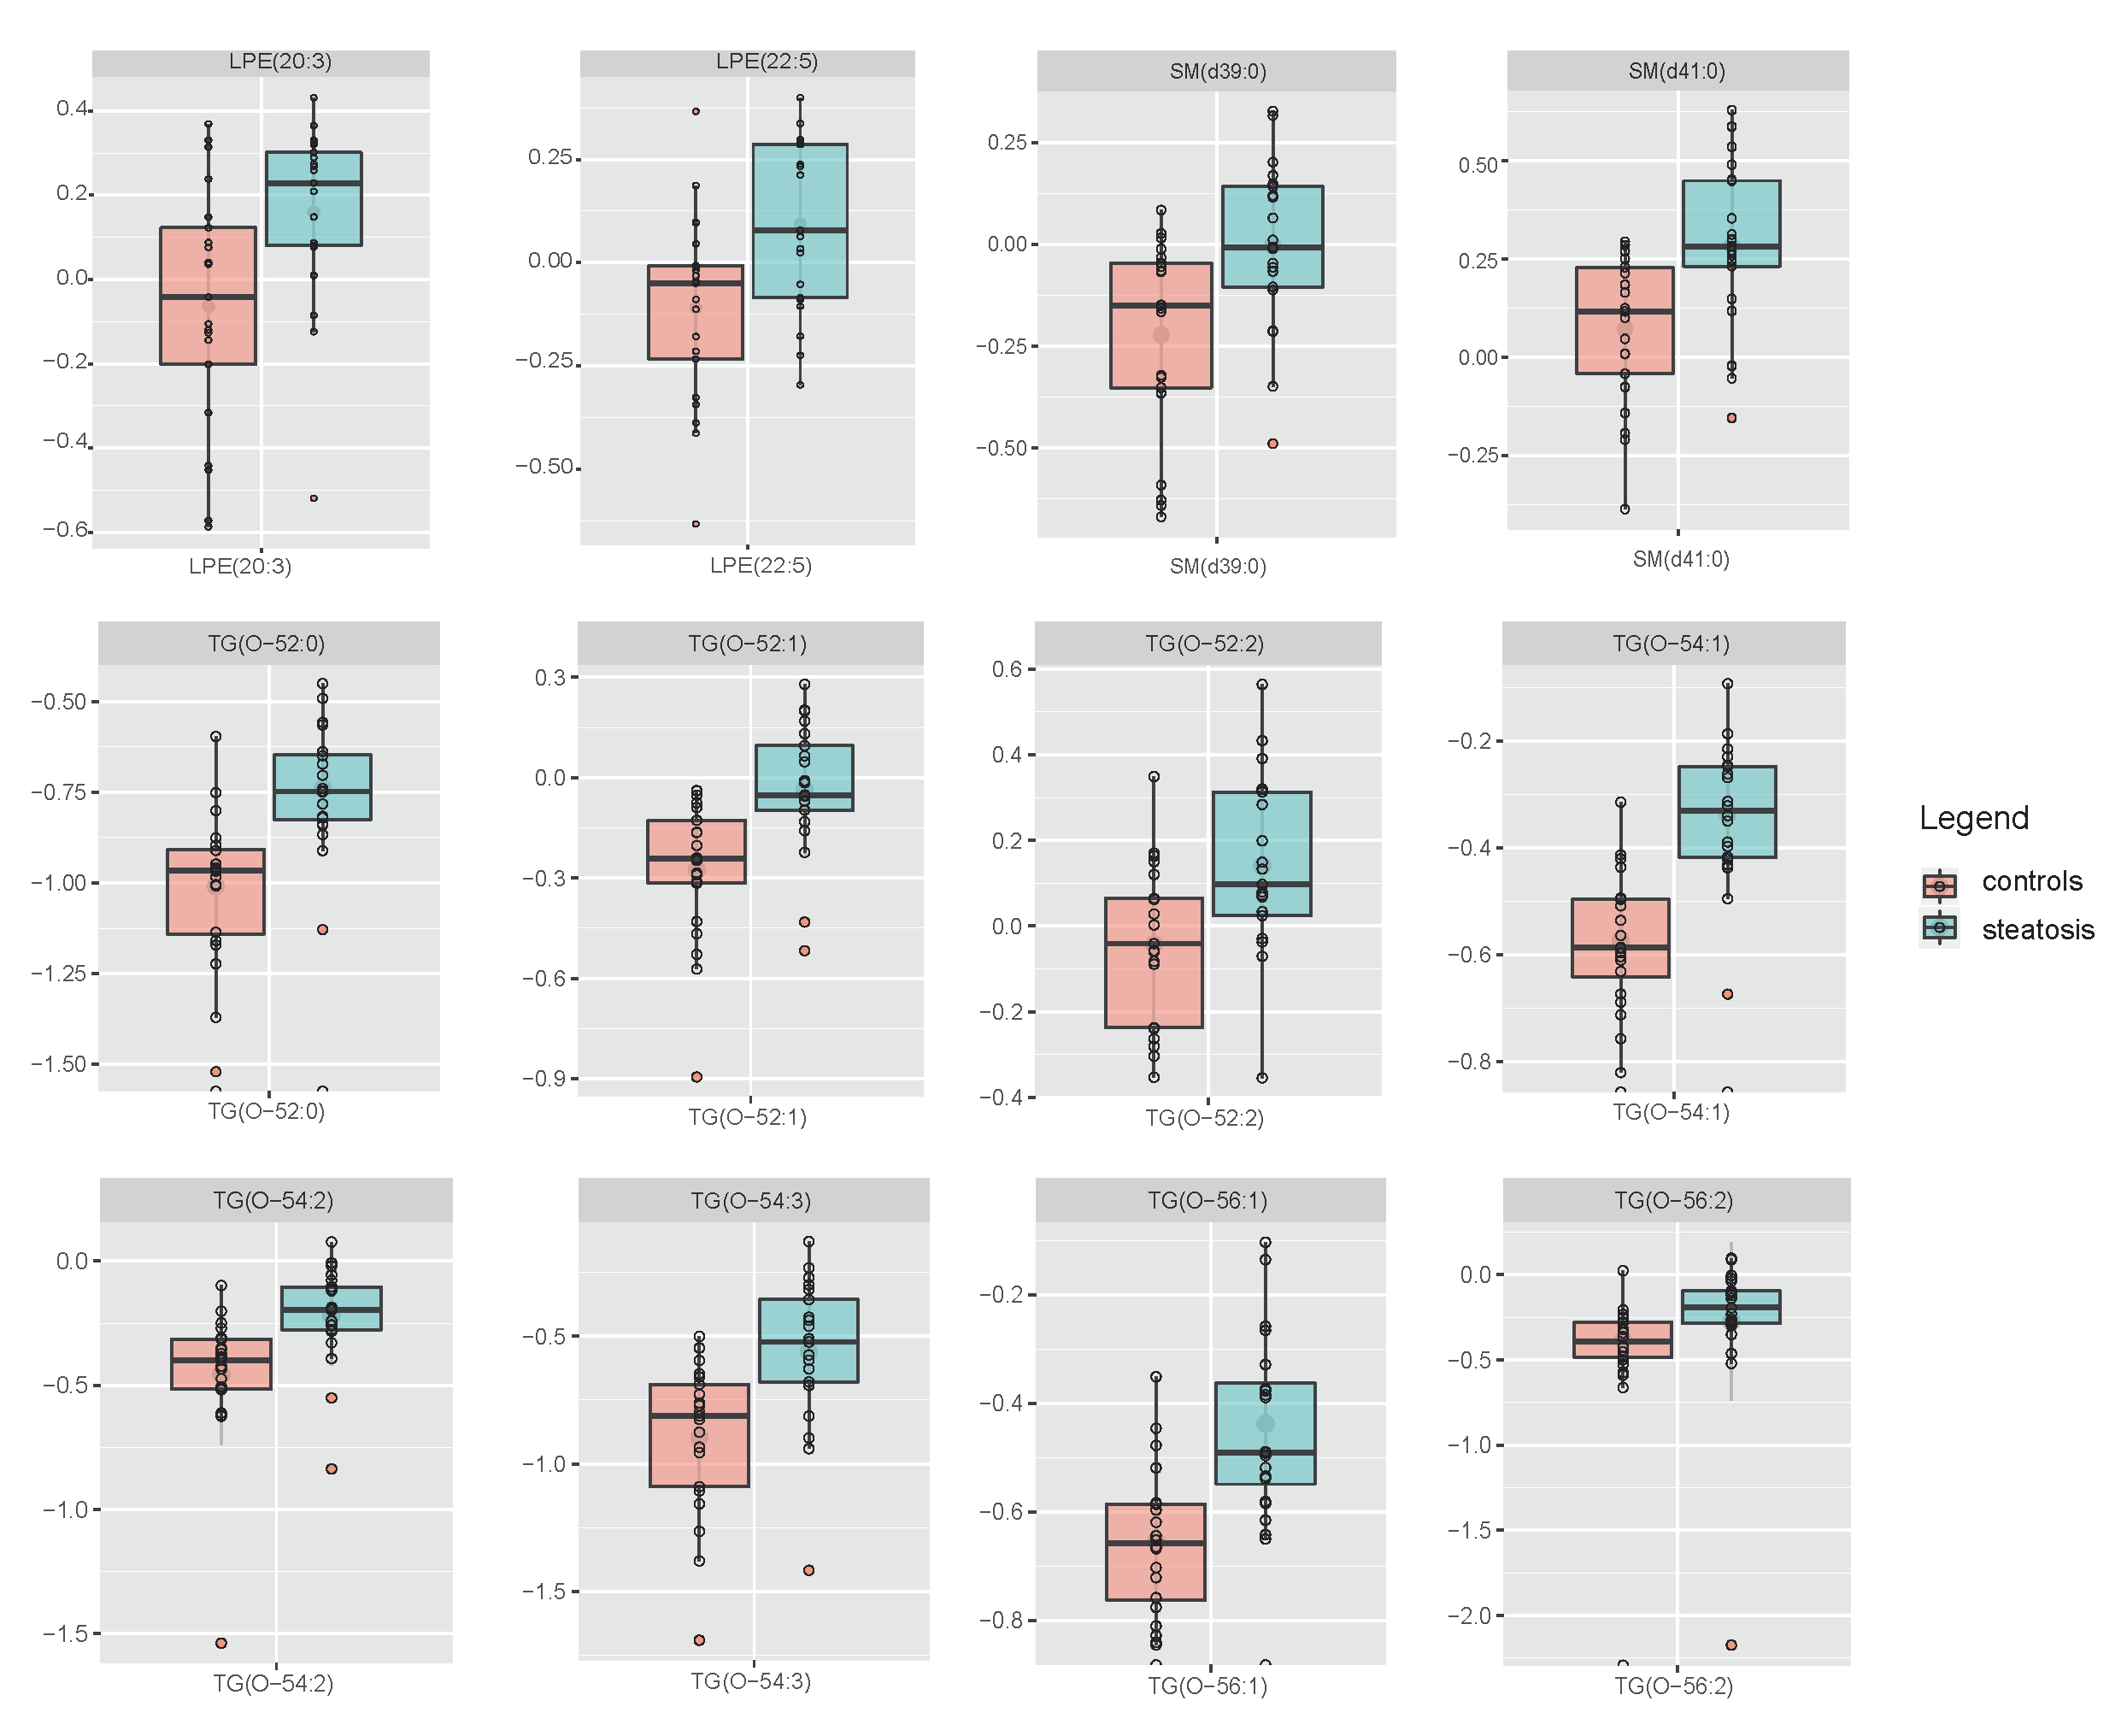

Figure, Supplemental Digital Content 3. Partial least squares regression discriminant analysis
(PLS-DA).
This technique generalizes and combines features from principal component analysis and multiple regression. PLS in combination with Discriminant Analysis (DA) is used to find the multidimensional direction in the metabolite space that explains the maximum
variance between different groups of samples. This will enable to discriminate between the
categories of the dependent variable.
