Figure, Supplemental Digital Content

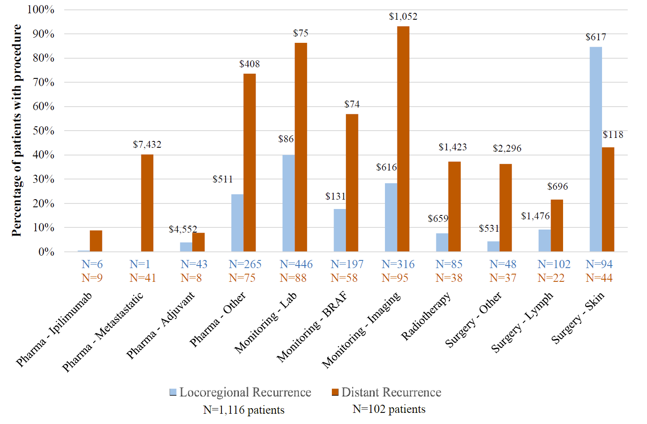
Melanoma-specificª HRU: users and mean costs^{b}

HRU: health resource utilization
ª Melanoma-specific medical services included treatments (pharmacological, surgery, radiotherapy) and disease monitoring.
^{b} Mean costs are provided if there were ≥10 patients with procedure.DC

