Supplemental Digital Content

Supplemental Table 1. Reliability of neuromuscular measures across joint angles

 | PF |  | AZ |  | DF
 | CV (%) | ICC | CV (%) | ICC | CV (%) | ICC
Electrically evoked twitch contractions
Involuntary EMD (ms) | 5.48 | 0.86 | 7.02 | 0.85 | 8.46 | 0.82
RTDI0-50 (Nm.s⁻¹) | 8.46 | 0.82 | 9.74 | 0.80 | 9.75 | 0.94
RTDI50-100 (Nm.s⁻¹) | 8.63 | 0.94 | 5.39 | 0.98 | 9.98 | 0.81
Norm. RTDI0-50 (MVT.s⁻¹) | 11.87 | 0.88 | 9.19 | 0.87 | 5.33 | 0.97
Norm. RTDI50-100 (MVT.s⁻¹) | 20.43 | 0.73 | 13.20 | 0.71 | 1.58 | 1.00
Explosive voluntary contractions
Explosive EMD (ms) | 17.78 | 0.43 | 16.88 | 0.37 | 19.38 | 0.77
RTDV0-50 (Nm.s⁻¹) | 7.95 | 0.93 | 12.05 | 0.87 | 15.03 | 0.81
RTDV50-100 (Nm.s⁻¹) | 12.36 | 0.73 | 13.54 | 0.76 | 13.25 | 0.85
RTDV100-150 (Nm.s⁻¹) | 10.39 | 0.89 | 13.97 | 0.78 | 9.27 | 0.92
Norm. RTDV0-50 (MVT.s⁻¹) | 7.28 | 0.93 | 10.40 | 0.75 | 17.45 | 0.80
Norm. RTDV50-100 (MVT.s⁻¹) | 12.11 | 0.73 | 11.09 | 0.72 | 13.20 | 0.70
Norm. RTDV100-150 (MVT.s⁻¹) | 7.25 | 0.85 | 14.71 | 0.77 | 9.47 | 0.86
Maximal voluntary contractions
MVT (Nm) | 4.78 | 0.94 | 5.95 | 0.91 | 4.70 | 0.91
Norm. MVT (Nm/kg) | 5.85 | 0.92 | 6.95 | 0.89 | 8.21 | 0.87
Absolute stiffness (N/mm) | 24.82 | 0.60 | 20.48 | 0.34 | 9.57 | 0.76
Tendon elongation max (mm) | 10.17 | 0.83 | 9.36 | 0.85 | 10.57 | 0.88
Relative peak strain (%) | 13.24 | 0.82 | 9.96 | 0.88 | 10.25 | 0.83
Angle specific peak strain (%) | 14.63 | 0.77 | 11.90 | 0.86 | 8.02 | 0.92
Tendon force max (N) | 6.51 | 0.90 | 6.75 | 0.89 | 4.98 | 0.93
Norm. tendon force max (N/kg) | 6.51 | 0.92 | 6.75 | 0.90 | 6.02 | 0.89
Time to tendon force max (s) | 15.92 | 0.27 | 15.90 | 0.23 | 8.67 | 0.65
Initial tendon length (cm) | 4.65 | 0.84 | 5.61 | 0.81 | 5.37 | 0.78
CV: coefficient of variation, ICC: intraclass correlation coefficient, EMD: electromechanical delay, RTDI: involuntary rate of torque development, RTDV: voluntary rate of torque development, MVT: maximal voluntary torque, Norm: normalized.

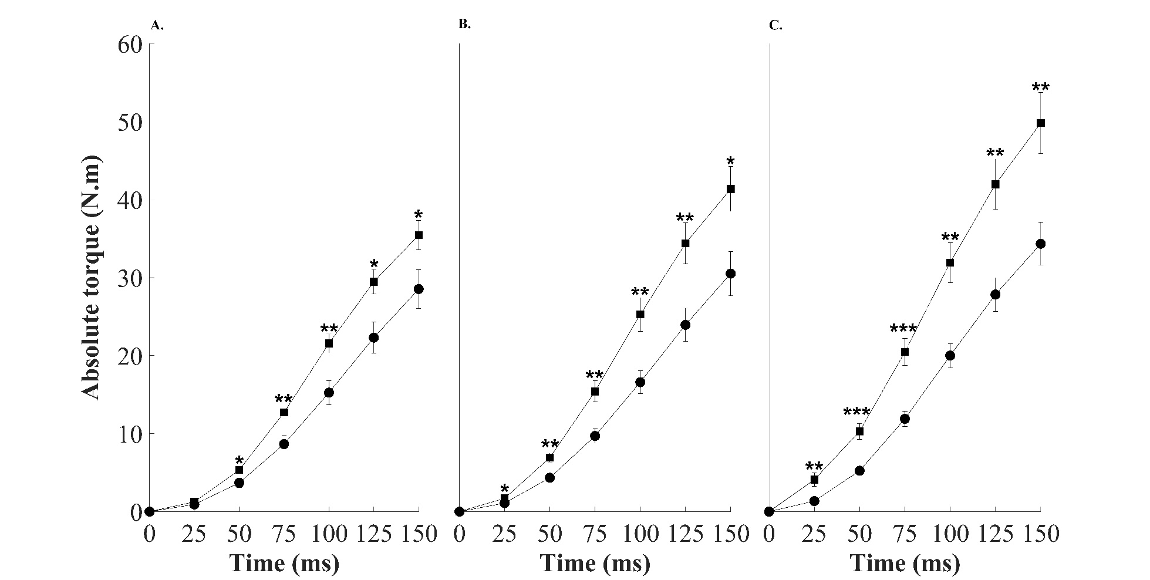

Supplemental Figure 1. Absolute (PF - A, AZ – B, DF – C) torque for sprinters (squares) and physically active (circles) during explosive voluntary contractions of the plantar flexors. Data are means ± standard error. Significant group difference at that joint angle:
*P < 0.05, **P < 0.01, ***P < 0.001.

Supplemental Table 2. Voluntary explosive rate of torque development – sprinters vs physically active

 |  | Sprinters | Physically active | Effect size
RTD
RTDV0-50 (Nm.s⁻¹) | PF* | 105 ± 28 | 73 ± 40 | 0.50
 | AZ** | 136 ± 42 | 78 ± 26 | 0.66
 | DF* | 157 ± 51 | 98 ± 34 | 0.56
RTDV50-100 (Nm.s⁻¹) | PF** | 324 ± 71 | 229 ± 75 | 0.65
 | AZ** | 367 ± 119 | 230 ± 65 | 0.52
 | DF** | 427 ± 133 | 280 ± 80 | 0.60
RTDV100-150 (Nm.s⁻¹) | PF | 313 ± 40 | 257 ± 92 | 0.45
 | AZ | 352 ± 67 | 266 ± 102 | 0.48
 | DF** | 394 ± 87 | 280 ± 99 | 0.60
Data are means ± SD. Significant group difference at that joint angle: *P < 0.05, **P < 0.01, ***P < 0.001. Bonferroni correction for multiple comparisons applied. Note: Normalised RTD values showed similar group-level differences across ankle angles.

Supplemental Table 3. Involuntary rate of torque development – sprinters vs physically active

 |  | Sprinters | Physically active | Effect size
RTD
RTDI0-50 (Nm.s⁻¹) | PF*** | 68 ± 18 | 40 ± 14 | 0.80
 | AZ*** | 120 ± 26 | 68 ± 29 | 0.83
 | DF*** | 163 ± 38 | 88 ± 41 | 0.84
RTDI50-100 (Nm.s⁻¹) | PF*** | 90 ± 21 | 54 ± 22 | 0.73
 | AZ** | 144 ± 31 | 98 ± 50 | 0.70
 | DF*** | 201 ± 39 | 121 ± 54 | 0.72
Data are means ± SD. Significant group difference at that joint angle: **P < 0.01, ***P < 0.001. Bonferroni correction for multiple comparisons applied. Note: Normalised RTD values showed similar group-level differences across ankle angles.

