**Title**: Neuromuscular Exercise Program ALIGN

This document provides details of the exercises used the ALIGN neuromuscular exercise program.



Neuromuscular Exercise Program

**ALIGN**

|  |
| --- |
| **A**bs  **A**LIGN |

|  |
| --- |
| Each training session start with this exercise  **Starting position:**   * Lying on your back bend your knees to about 90 degrees on the slosh ball and hold a cloth or towel between your knees * Tighten your stomach and bottom * Feel your stomach muscles tighten by placing your hand on your stomach * Place your hands beside your head or across your chest   **Exercise:**   * Contract your stomach muscles and sit-up so that your shoulder blades are off the floor. Remember to hold the cloth * Exhale on the way-up and inhale as you relax towards to floor * Start with 2 sets of 12 repetitions |

|  |
| --- |
|  |

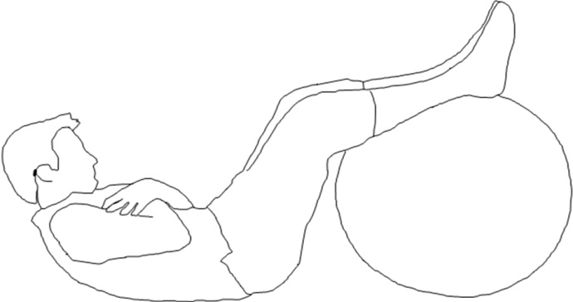Bridge: Level 1

ALIGN

|  |
| --- |
| **Starting position:**   * Lying on your back with both feet on the slosh ball, place the cloth or towel between your knees * Tighten your stomach and bottom * Feel your stomach muscles tighten by placing your hand on your stomach * Stretch out your arms to help you to balance or to increase difficulty, place your arms across your chest   **Exercise:**   * Raise and lower your pelvis in a controlled manner. Remember to hold the cloth * Start with 2 sets of 12 repetitions * Ensure good control |

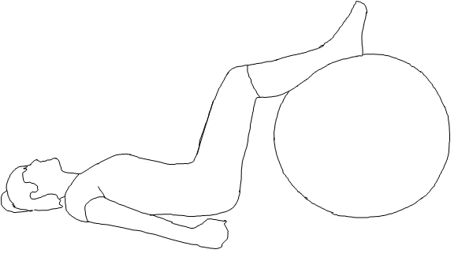

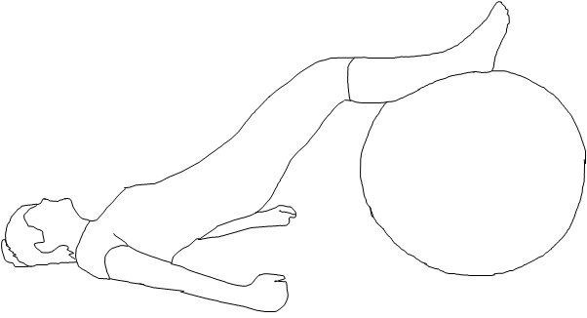Bridge: Level 2

ALIGN

|  |
| --- |
| **Starting position:**   * Lying on your back with both feet on the slosh ball, place the cloth or towel between your knees * Tighten your stomach and bottom * Feel your stomach muscles tighten by placing your hand on your stomach * Stretch out your arms to help you to balance or to increase difficulty, place your arms across your chest   **Exercise:**   * Raise your pelvis and hold this position for 20 seconds and lower your pelvis in a controlled manner. Remember to hold the cloth * Start with 2 sets **holding** the elevated bridge position for 20 seconds * Ensure good control |



Bridge: Level 3

ALIGN

|  |
| --- |
| **Starting position:**   * Lying on your back with both feet on the slosh ball, place the cloth or towel between your knees * Tighten your stomach and bottom * Feel your stomach muscles tighten by placing your hand on your stomach * Stretch out your arms to help you to balance or to increase difficulty, place your arms across your chest   **Exercise:**   * Raise your pelvis and once you have control, straighten and bend your knees to bring the ball towards your bottom. Remember to hold the cloth * Start with 2 sets of 12 repetitions * Ensure good control |



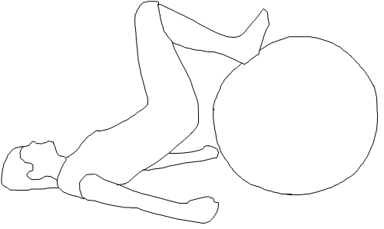

Bridge: Level 4

ALIGN

|  |
| --- |
| **Starting position:**   * Lying on your back with one leg on the slosh ball and the other leg lifted * Bridge Level 1(b)Tighten your stomach and bottom * Feel your stomach muscles tighten by placing your hand on your stomach * Stretch out your arms to help you to balance or to increase difficulty, place arms across your chest   **Exercise:**   * Bridge Level 3(a)Raise your pelvis and hold this position for 20 seconds and lower your pelvis in a controlled manner. * Start with 2 sets **holding** the elevated position for 20 seconds * Perform the exercise alternately on both legs ie. right and left leg * Ensure good control |

Bridge: Level 5

ALIGN

|  |
| --- |
| **Starting position:**   * Lying on your back with one leg on the slosh ball and the other leg lifted * Tighten your stomach and bottom * Feel your stomach muscles tighten by placing your hand on your stomach * Stretch out your arms to help you to balance or to increase difficulty, place arms across your chest.   **Exercise:**   * Raise your pelvis and once you have control, straighten and bend your knee to bring the ball towards your bottom. * Perform the exercise alternately on both legs ie. right and left leg * Ensure good control |

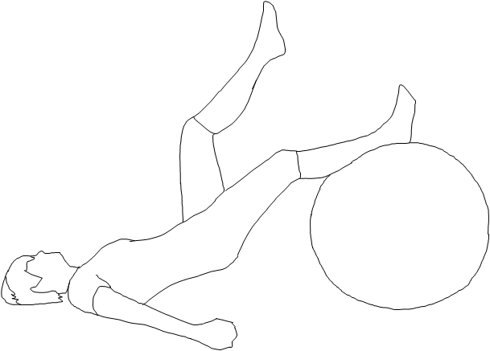

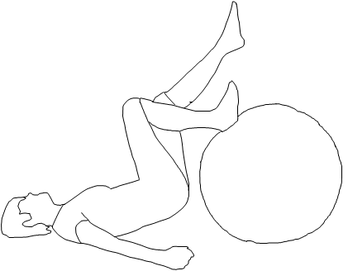

**L**unge: Level 1

A**L**IGN

|  |
| --- |
| **Starting position:**   * Stand with feet hip width apart * Use your arms for balance   **Exercise:**   * Take a step forward and land in a controlled smooth manner * Lower your body straight down so that your back knee nearly touches the floor * Keep your front heel on the floor * Do not allow your front knee to travel past your toes * Push off the front leg and return to standing upright * Start with 2 sets of 12 repetitions * Perform the exercise alternately on both legs ie. right and left leg * Ensure good alignment |

**L**unge: Level 2

A**L**IGN

|  |
| --- |
| **Starting position:**   * Stand with feet hip width apart * Hold the slosh ball in front of the chest   **Exercise:**   * Take a step forward and land in a controlled smooth manner * Lower your body straight down so that your back knee nearly touches the floor * Keep your front heel on the floor * Do not allow your front knee to travel past your toes * Push off the front leg and return to standing upright * Start with 2 sets of 12 repetitions * Perform the exercise alternately on both legs ie. right and left leg * Ensure good alignment |

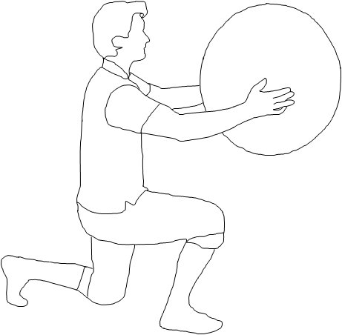

**L**unge: Level 3

A**L**IGN

|  |
| --- |
| **Starting position:**   * Stand with feet hip width apart * Use your arms for balance   **Exercise:**   * Take a step forward onto the foam and land in a controlled smooth manner * Lower your body straight down so that your back knee nearly touches the floor * Keep your front heel on the floor * Do not allow your front knee to travel past your toes * Push off the front leg and return to standing upright * Start with 2 sets of 12 repetitions * Perform the exercise alternately on both legs ie. right and left leg * Ensure good alignment |

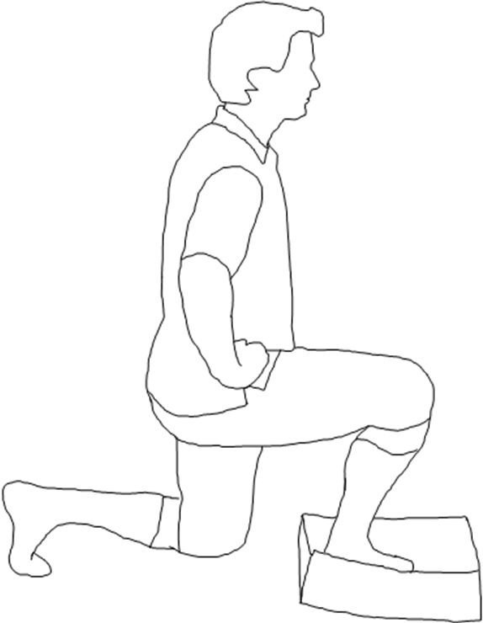

**L**unge: Level 4

A**L**IGN

|  |
| --- |
| **Starting position:**   * Stand with feet hip width apart * Hold the slosh ball in front of chest   **Exercise:**   * Take a step forward onto the foam and land in a controlled smooth manner * Lower your body straight down so that your back knee nearly touches the floor * Keep your front heel on the floor * Do not allow your front knee to travel past your toes * Push off the front leg and return to standing upright * Start with 2 sets of 12 repetitions * Perform the exercise alternately on both legs ie. right and left leg * Ensure good alignment |

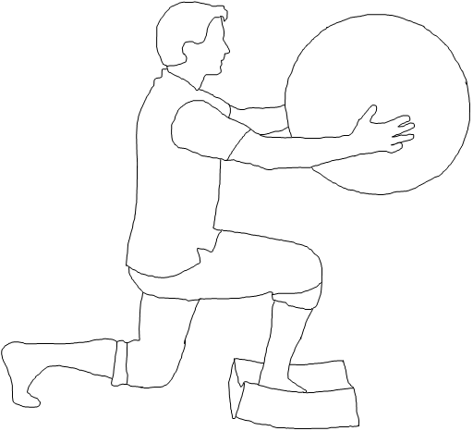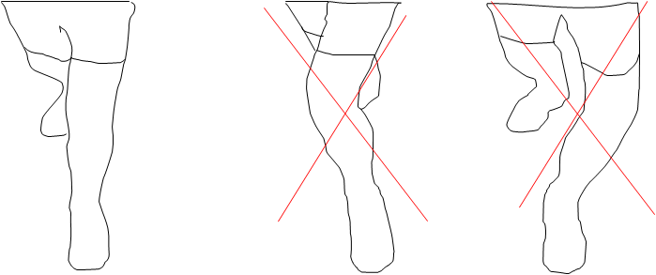**I**ncomplete circle: Level 1

AL**I**GN

|  |
| --- |
| **Starting position:**   * Stand with feet hip width apart, then place your weight through one (standing) leg * Slightly bend your standing leg * Use your arms for balance   **Exercise:**   * Place a cloth or plastic bag underneath the circling leg (non-weight bearing leg). * Using this leg, make clockwise and anti-clockwise incomplete circles * Perform the exercise alternately on both legs ie. right and left leg * Start with 2 sets of 12 repetitions * Ensure good alignment and pelvis control |

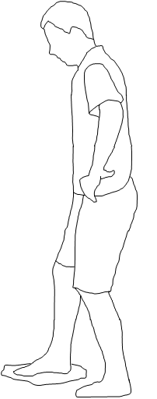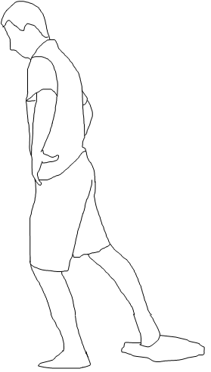**I**ncomplete circle: Level 2

Circling Leg

Circling Leg

AL**I**GN

|  |
| --- |
| **Starting position:**   * Stand with feet hip width apart, then place your weight through one (standing) leg * Slightly bend your standing leg * Hold the slosh ball in front of chest   **Exercise:**   * Place a cloth or plastic bag underneath the circling leg (non-weight bearing leg). * Using this leg, make clockwise and anti-clockwise incomplete circles * Perform the exercise alternately on both legs ie. right and left leg * Start with 2 sets of 12 repetitions * Ensure good alignment and pelvis control |

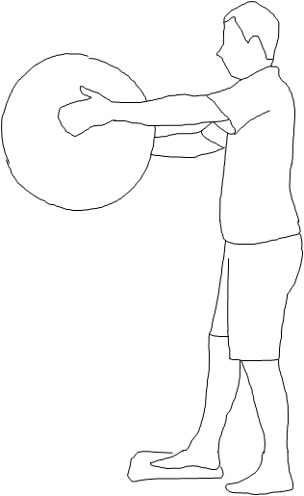**I**ncomplete circle: Level 3

Circling Leg

AL**I**GN

|  |
| --- |
| **Starting position:**   * Stand with feet hip width apart * With the foam underneath, place your weight through one leg * Slightly bend your standing leg * Use your arms for balance   **Exercise:**   * Place a cloth or plastic bag underneath the circling leg (non-weight bearing leg). * Using this leg, make clockwise and anti-clockwise incomplete circles * Perform the exercise alternately on both legs ie. right and left leg * Start with 2 sets of 12 repetitions * Ensure good alignment and pelvis control |

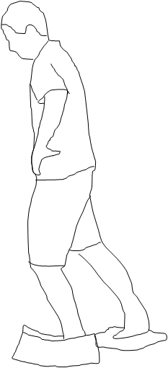**I**ncomplete circle: Level 4

Circling Leg

AL**I**GN

|  |
| --- |
| **Starting position:**   * Stand with feet hip width apart, * With the foam underneath, place your weight through one leg * Slightly bend your standing leg * Hold the slosh ball in front of chest   **Exercise:**   * Place a cloth or plastic bag underneath the circling leg (non-weight bearing leg). * Using this leg, make clockwise and anti-clockwise incomplete circles * Perform the exercise alternately on both legs ie. right and left leg * Start with 2 sets of 12 repetitions * Ensure good alignment and pelvis control |

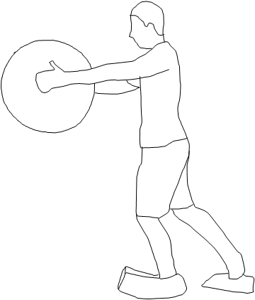**G**et tapping: Level 1

Circling Leg

ALI**G**N

|  |
| --- |
| **Starting position:**   * Stand with feet hip width apart, in the centre of the steps and then place your weight through one (standing) leg * Slightly bend your standing leg * Keep your heel of the standing leg on the step * Use your arms for balance   **Exercise:**   * Bend and straighten the knee of the standing leg until you can toe-tap the ground with your opposite leg behind the step * Perform the exercise alternately on both legs ie. right and left leg * Start with 2 sets of 12 repetitions * Ensure good alignment and pelvis control |

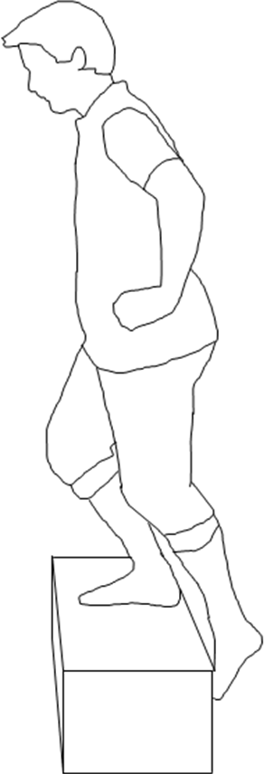

**G**et tapping: Level 2

ALI**G**N

|  |
| --- |
| **Starting position:**   * Stand with feet hip width apart, in the centre of the steps and then place your weight through one (standing) leg * Slightly bend your standing leg * Keep your heel of the standing leg on the step * Use your arms for balance   **Exercise:**   * Bend and straighten the knee of the standing leg until you can toe-tap the ground with your opposite leg in front and behind the step. * Perform the exercise alternately on both legs ie. right and left leg * Start with 2 sets of 12 repetitions * Ensure good alignment and pelvis control |

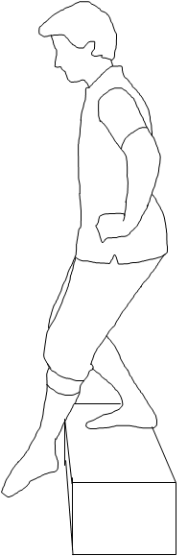

**G**et tapping: Level 3

ALI**G**N

|  |
| --- |
| **Starting position:**   * Stand with feet hip width apart, in the centre of the steps and then place your weight through one leg * Slightly bend your standing leg * Keep your heel of the standing leg on the step * Hold the slosh ball in front of chest   **Exercise:**   * Bend and straighten the knee of the standing leg until you can toe-tap the ground with your opposite leg in front and behind the step. * Perform the exercise alternately on both legs ie. right and left leg * Start with 2 sets of 12 repetitions * Ensure good alignment and pelvis control |

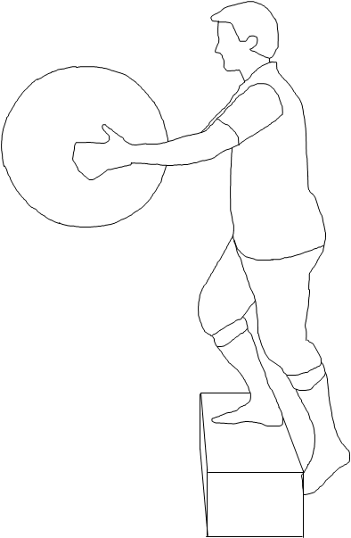**G**et tapping: Level 4

ALI**G**N

|  |
| --- |
| **Starting position:**   * Stand with feet hip width apart, in the centre of the steps and then place your weight through one (standing) leg * Slightly bend your standing leg * Keep your heel of the standing leg on the step * Use your arms for balance   **Exercise:**   * While standing on foam, bend and straighten the knee of the standing leg until you can toe-tap the ground with your opposite leg in front and behind the step * Perform the exercise alternately on both legs ie. right and left leg * Start with 2 sets of 12 repetitions * Ensure good alignment and pelvis control |

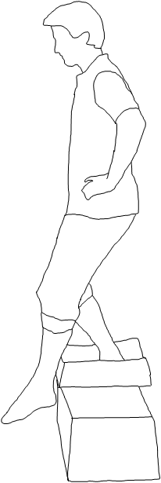 **G**et tapping: Level 5

ALI**G**N

|  |
| --- |
| **Starting position:**   * Stand with feet hip width apart, in the centre of the steps and then place your weight through one (standing) leg * Slightly bend your standing leg * Keep your heel of the standing leg on the step * Hold the slosh ball in front of chest   **Exercise:**   * Bend and straighten the knee of the standing leg until you can toe-tap the ground with your opposite leg in front and behind the step * Perform the exercise alternately on both legs ie. right and left leg * Start with 2 sets of 12 repetitions * Ensure good alignment and pelvis control |

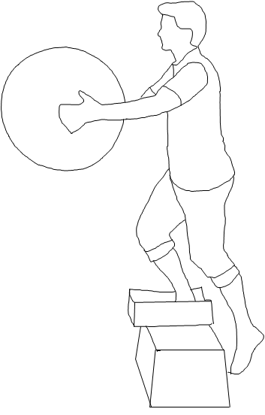k**N**ee bends: Level 1

ALIG**N**

|  |
| --- |
| **Starting position:**   * Stand with feet hip width apart, in front of a chair * Keep your heels on the ground * Use your arms for balance   **Exercise:**   * Bend your knees until your bottom nearly touches the chair, without actually sitting down on the chair * Rise up to an upright standing position * Start with 2 sets of 12 repetitions * Ensure good alignment |

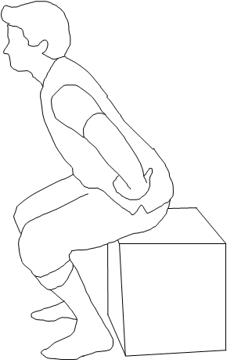 k**N**ee bends: Level 2

ALIG**N**

|  |
| --- |
| **Starting position:**   * Stand with feet hip width apart, in front of a chair * Keep your heels on the ground * Hold the slosh ball in front of chest   **Exercise:**   * Bend your knees until your bottom nearly touches the chair, without actually sitting down on the chair * Rise up to an upright standing position * Start with 2 sets of 12 repetitions * Ensure good alignment |

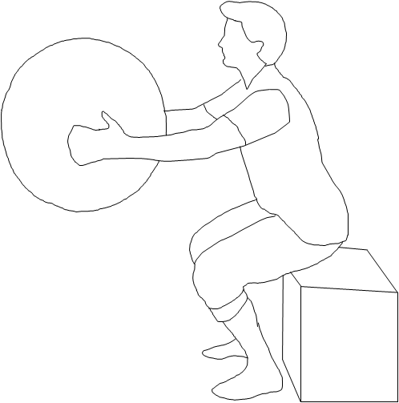k**N**ee bends: Level 3

ALIG**N**

|  |
| --- |
| **Starting position:**   * Place a loop of thera-band around your knees and stand with feet hip width apart, in front of a chair * Keep your heels on the ground * Use your arms for balance   **Exercise:**   * Bend your knees until your bottom nearly touches the chair, without actually sitting down on the chair * Rise up to your upright starting position * Start with 2 sets of 12 repetitions * Ensure good alignment (you will need to press your knees outwards to do so) |

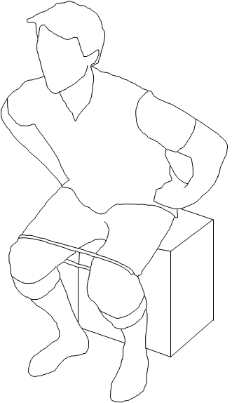k**N**ee bends: Level 4

ALIG**N**

|  |
| --- |
| **Starting position:**   * Stand with feet hip width apart, in front of a chair. Raise one leg, placing your weight through one standing leg * Keep your heel of the standing leg on the ground * Use your arms for balance   **Exercise:**   * Bend your knee until your bottom nearly touches the chair, without actually sitting down on the chair * Rise up to your upright starting position * Perform the exercise alternately on both legs ie. right and left leg * Start with 2 sets of 12 repetitions * Ensure good alignment and pelvis control |

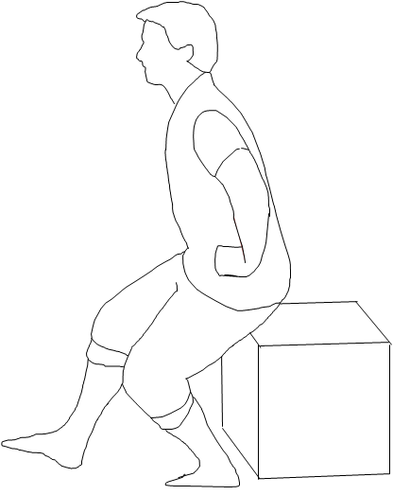k**N**ee bends: Level 5

ALIG**N**

|  |
| --- |
| **Starting position:**   * Place the foam underneath one leg and stand feet hip width apart, in front of a chair * Place your weight through the one leg standing on the foam and raise the other leg * Keep your heel of the standing leg on the ground * Use your arms for balance   **Exercise:**   * Bend your knee until your bottom nearly touches the chair, without actually sitting down on the chair * Rise up to your upright starting position * Perform the exercise alternately on both legs ie. right and left leg * Start with 2 sets of 12 repetitions * Ensure good alignment and pelvis control |

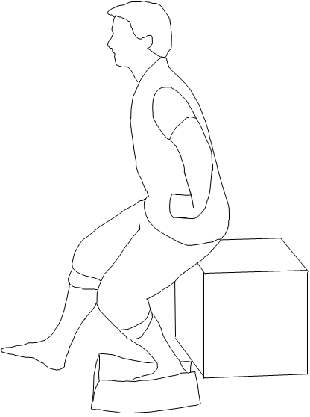k**N**ee bends: Level 6

ALIG**N**

|  |
| --- |
| **Starting position:**   * Place the foam underneath one leg and stand feet hip width apart, in front of a chair * Place your weight through the one leg standing on the foam and raise the other leg * Keep your heel of the standing leg on the ground * Hold the slosh ball in front of your chest   **Exercise:**   * Bend your knee until your bottom nearly touches the chair, without actually sitting down on the chair * Rise up to your upright starting position * Perform the exercise alternately on both legs ie. right and left leg * Start with 2 sets of 12 repetitions * Ensure good alignment and pelvis control |

