Pre-test Questionnaire

Please check only one response per question unless instructed otherwise.

- Do you warm-up ON YOUR INSTRUMENT :
  - Before PERFORMING or REHEARSING?
- Yes
- No
- Occasionally
  - Before PRACTISING?
- Yes
- No
- Occasionally

- Do you warm up AWAY FROM YOUR INSTRUMENT :
  - Before PERFORMING or REHEARSING?
- Yes
- No
- Occasionally
  - Before PRACTISING?
- Yes
- No
- Occasionally
  - What does this warm-up involve? ________________________________________

- If you warm-up, what factors influence your decision to do this? (check all that apply)
- Advice from teacher
- Advice from health professional
- Advice from friends
- Positive personal experiences with warm-up
- Other (please describe) _____________________________________________

- How do you think warm-up will affect your sound quality?
- Improve sound quality
- No effect
- Degrade sound quality

- Are you currently experiencing any physical symptoms, such as aches, pain, weakness, lack of control, numbness or tingling?
- Yes
- No

Note: if you answered “no” to question 5, your questionnaire ends here! If you answered “yes” to question 5, continue to the 2nd page.

- Please indicate the location(s) of your current physical symptoms (PS) on the body chart below. Shade an area and label the first PS as A, the second as B, etc. (see provided example)
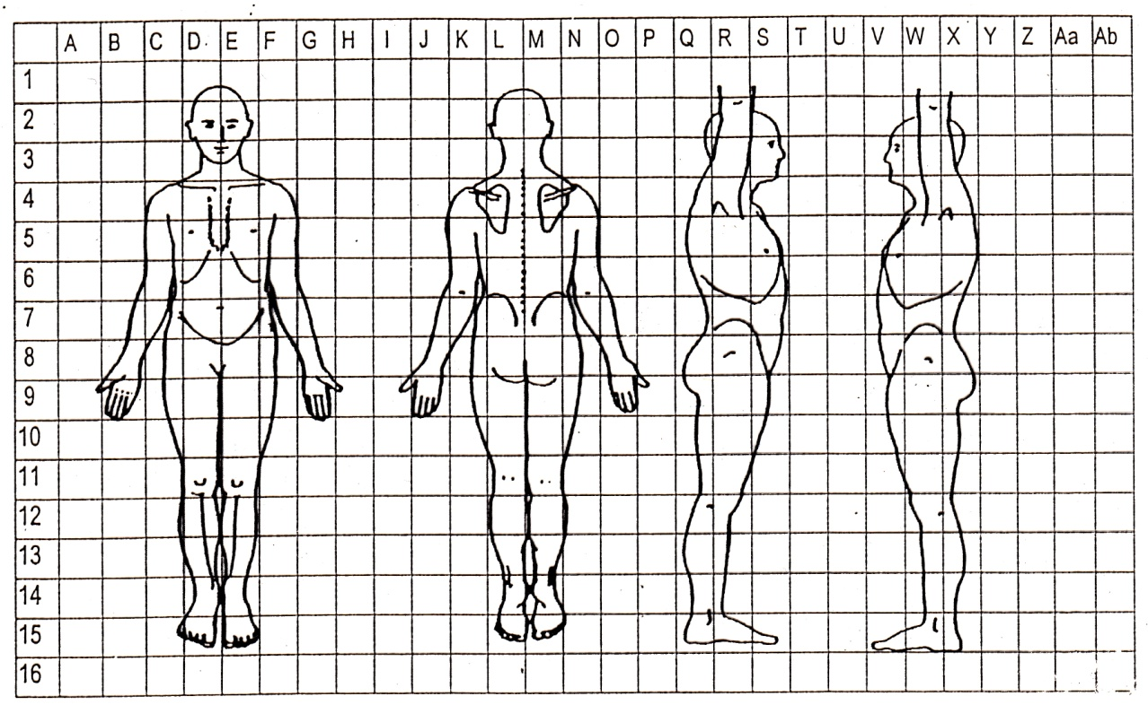
Ackermann, 2012
For each shaded area above, please complete details below on the PS. Please also rate the severity of the PS out of 10, where 0 is no pain and 10 is the worst pain you can imagine. If the PS varies, please indicate the lowest to highest pain ratings.
PS (letter) | Duration (weeks) | Affecting playing? (Y/N) | Type of PS (from list below) | Intermittent or constant? | Severity (/10)
Type of PS: Aching, sharp, burning, throbbing, cramping, pulling, tingling, hot, numb, cold, shooting, heavy, tender, weak, loss of control, tiring, other (specify)

