Exercise | Description | Modification | Diagram
Dual loading gluteal bridges | Participants lay on their back with knees bent, both feet flat on the ground, and arms resting beside the torso. Driving through the heels and contracting the gluteals, hips were lifted off the ground to form a straight line between the knees, hips, and torso. The participant paused in this position before slowly returning the hips back to the ground. Movement was repeated for a total of 10 repetitions. | Decreased intensity—participants contracted gluteals and lifted their body weight off the pelvis before returning to the ground. Formation of a straight line between the knees, hips, and torso was not required. | 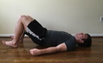  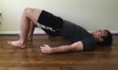  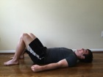  Modified
Single loading gluteal bridge leg marches | Participants lay on their back with knees bent and both feet flat on the ground. Hips were lifted off the ground to form a straight line between their knees, hips and torso. From this position, one foot was lifted off the ground, bringing the thigh perpendicular to the ground and keeping the hips high. The raised foot was then returned to the starting position and the same movement was performed with the opposite leg without dropping the hips. This sequence was repeated for a total of 20 total repetitions, 10 on each leg. | Decreased intensity—participants contracted gluteals to lift body weight off the pelvis. From this position, one leg was extended until straight and then returned to the starting position. Movement was replicated with the opposite leg. | 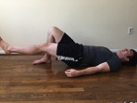  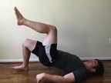  Modified
Leg crossovers | Participants lay on their back, extended both arms perpendicularly to the torso, and extended the legs vertically. Without lifting the scapulae off the ground, legs were rotated as far as possible to one side of the torso before being returned to the starting position. This movement was then repeated in the opposite direction. A total of 20 repetitions were performed, 10 in each direction. | Decreased intensity—participants performed the same movement with knees flexed to 90-degrees. | 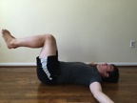  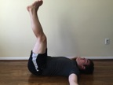  Modified
Opposite arm/leg extension | Participants began on hands and knees with a flat back. From this position, participants extended an arm and leg on opposite sides of the body (e.g. left arm, right leg) until straight, keeping the torso steady. The arm and leg were then returned to the starting position. A total of 20 repetitions were performed, 10 on each side. | Decreased intensity—participants were instructed to decrease the range of motion if lower intensity movement was required. | 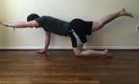  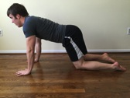
Dynamic side plank | Participants began lying on their side with the trunk propped up on their forearm. Participants then contracted their oblique muscles to form a straight line between the feet, hips, and torso. The hips were then dropped back down towards the ground in a slow and controlled fashion. After briefly touching the hip back to the floor, the movement was repeated. A total of 20 repetitions were performed, 10 on each side. | Decreased intensity—participants lifted their hips off the ground such that a straight line was formed between the knees, hips, and torso. Feet remained rested on the ground throughout the duration of the activity | 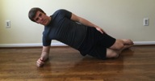  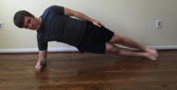  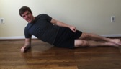  Modified
Shoulder ‘A’ | Participants began standing, with feet shoulder width apart, knees slightly bent, and arms by the sides. In a slow, controlled manner, arms were raised directly in front of the torso, finishing fully extended on both sides of the head. Arms were then slowly lowered back to the starting position, with a focus on maintaining contraction of the trapezius and anterior deltoid muscles throughout the descent. A total of 10 repetitions were performed. | No modifications of this exercise were necessary. | 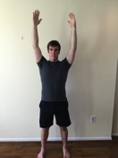  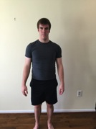

Shoulder ‘T’ | Participants began with knees flexed to approximately 45-degrees and the torso leaning over the toes, parallel to the ground. Participants were instructed to extend their arms toward the ground with palms facing each other, and then retract the scapulae and lift the arms to bring the arms parallel to the ground and fully extended out from the torso. The arms were then slowly returned to the starting position. A total of 10 repetitions were performed. | No modifications of this exercise were necessary. | 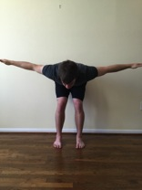  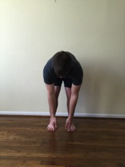
Shoulder ‘W’ | Participants began with knees flexed to approximately 45-degrees and the torso leaning over the toes, parallel to the ground. With elbows flexed 90-degrees and the palms facing away from the thighs, participants externally rotated the humerus until the hands were parallel with the torso. The hands were then returned to the starting position in a slow, controlled manner. Care was taken to ensure that the elbows remained near the torso throughout the movement. A total of 10 repetitions were performed. | No modifications of this exercise were necessary. | 