Exercise (arm) | Description of movement | Diagram (arrows point direction of applied force)
Empty can (R/L) | Participant sat in erect posture with no back support. Shoulder abducted 90° with elbow extended and internal humeral rotation; arm abducted as resistance applied at wrist. | 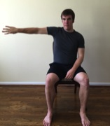
Flexion 125° (R/L) | Participant sat in erect posture with no back support. Shoulder flexed at 125°. Shoulder flexed as resistance applied above the elbow and at the inferior angle of the scapula to de-rotate scapula. | 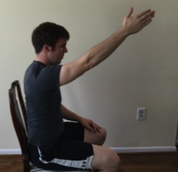
Internal rotation 90° (R/L) | Participant sat in erect posture with no back support. Shoulder abducted 90° in plane of scapula with elbow flexed 90° and neutral humeral rotation. Arm internally rotated as resistance applied to wrist. | 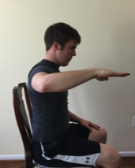
Shoulder extension (R/L) | Participant sat in erect posture with no back support. Shoulder abducted 30°, elbow fully extended. Shoulder extended as resistance applied at wrist. | 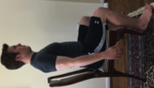
Palm press | Participant sat in erect posture with no back support. Shoulders bilaterally flexed 90° with heel of hands together, elbows flexed 20°, and arms horizontally adducting. | 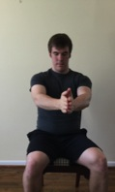
Elbow flexion (R) | Participants sat in erect posture with no back support. Right elbow flexed 90° and right forearm supinated such that the right palm was parallel to the ceiling. Elbow flexed as resistance applied at palm towards floor. | 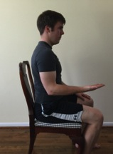
Elbow extension (R) | Participants assumed same starting position as elbow flexion MVC. Elbow extended as resistance applied at palm towards ceiling. | 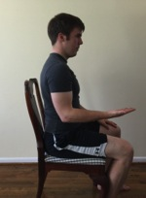
Wrist flexion (R) | Participants placed right forearm on a table, palm facing the ceiling, with the edge of the table in line with the wrist; padding under the forearm was provided when requested. Wrist flexed as resistance applied to palm towards floor. | 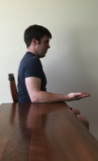
Wrist extension (R) | Participants placed right forearm on a table, palm facing the floor, with the edge of the table in line with the wrist; padding under the forearm was provided when requested. Wrist extended as resistance applied to back of hand towards floor. | 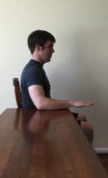
Crunch | Participants lay on their back with feet flat on the floor and arms crossed across the chest. Torso flexed such that shoulder blades were ~20cm off the ground as resistance applied bilaterally to upper chest. | 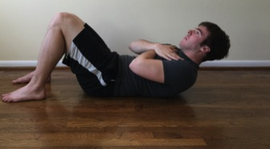
Crossover crunch (R/L) | Participants lay on their back with feet flat on the floor and arms crossed across the chest. Torso rotated to bring 1 shoulder ~30 off the ground as counter-rotary force applied to the lifted shoulder. | 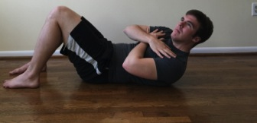
Back extension | Participants lay prone on their torso, with both hands resting lightly on the back of the head. Back was extended such that lifted the chest ~20cm off the ground as force was applied bilaterally to scapulae. | 