Supplementary File 3

Marker set

Figure 1 – Modified in-shoe marker set and model

Definition of Anatomical frames

Lower leg

MFE
LFE
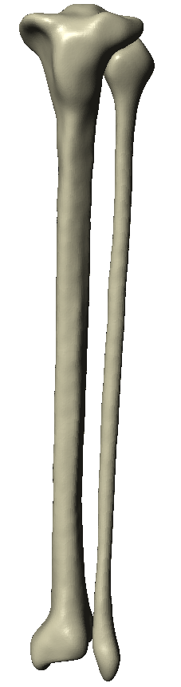
LM
MM

Figure 2 – The lower leg segment

Definition Markers
 | Medial | Lateral
Proximal | Medial femoral epicondyle (MFE) | Lateral femoral epicondyle (LFE)
Distal | Medial malleolus (MM) | Lateral Malleolus (LM)

Anatomical Reference Frames
O_{shank} The midpoint between the MFE and LFE
x_{shank} The x-axis joints the origin and the LFE marker
y_{shank} The y-axis is orthogonal to the x-axis and lies in the coronal plane.
z_{shank} The z-axis is orthogonal to the xy plane.

Hindfoot
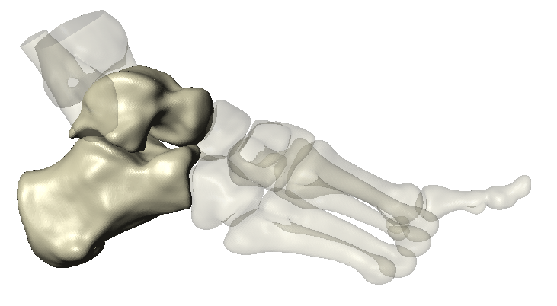
LM
SP
MM
NT
Figure 3 – The hindfoot segment

Definition Markers
 | Medial | Lateral
Proximal | Medial malleolus (MM) | Lateral malleolus (LM)
Distal | Navicular tuberosity (NT) | Styloid process (SP)

Anatomical Reference Frames
O_{hindfoot segment} The midpoint between the MM and LM
x _{hindfoot segment} The x-axis joins the origin and LM marker
z _{hindfoot segment} The z-axis is orthogonal to the x-axis and lies in the transverse plane
y _{hindfoot segment} The y-axis is orthogonal to the xz plane.

Midfoot-Forefoot Complex Segment

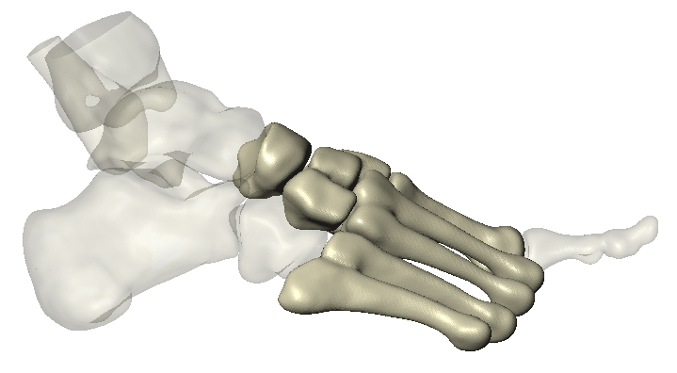
SP
5MTP
1MTP
NT
Figure 4 –The midfoot-forefoot complex segment

Definition Markers
 | Medial | Lateral
Proximal | Navicular tuberosity (NT) | Styloid process (SP)
Distal | 1st metatarsal head (1MTP) | 5th metatarsal head (5MTP)

Anatomical Reference Frames
O_{midfoot/forefoot segment} The midpoint between the NT and SP
x _{midfoot/forefoot segment} The x-axis joins the origin and SP marker
z _{midfoot/forefoot segment} The z-axis is orthogonal to the x-axis and lies in the transverse plane
y _{midfoot/forefoot segment} The y-axis is orthogonal to the xz plane.

Hallux
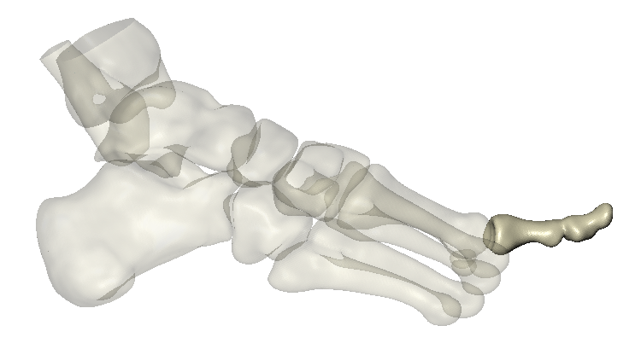
1MTP
A1
2MTP
Figure 5 –The hallux segment

Definition Markers
 | Medial | Lateral
Proximal | 1st metatarsal head (1MTP) | 2nd metatarsal head (2MTP)
Distal | Joint: Apex hallux (A1)

Anatomical Reference Frames
O_{Hallux} The midpoint between the 1MTH and 2MTH
x _{Hallux} The x-axis joins the origin and the 2MTH marker
z _{Hallux} The z-axis is orthogonal to the x-axis and lies in the transverse plane
y _{Hallux} The y-axis is orthogonal to the xz plane.

Definition of Model Joints
The articulation between each segment and the corresponding proximal segment defined a joint. The three joints established in the model accurately reflect the surrounding anatomical articulation and are defined as:
1. the tibiocalcaneal joint (defined as the articulation between the lower leg and hindfoot segment)
2. the tarsometatarsal joint (defined as the articulation between the hindfoot segment and the midfoot/forefoot complex)
3. the 1st metatarsophalangeal joint (defined as the articulation between the midfoot/forefoot complex and the hallux segment).

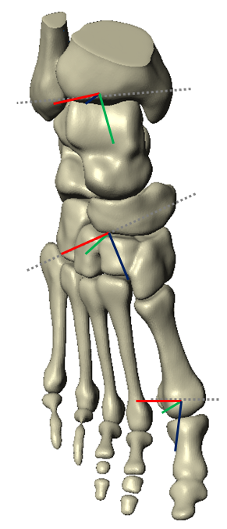
Marker: Lateral Malleolus
Marker: Navicular tuberosity
Virtual Marker: 5th Metatarsal base
Marker: Apex 1
Virtual Marker: 2nd Metatarsal head
Virtual Marker: 5th Metatarsal head
Marker: 1st Metatarsal head
Marker: Lateral Malleolus

Figure 6 – The complete multi-segment foot-shoe complex model (Bishop et al. 2013)

Joint parameters of the in-shoe foot kinematic model

The joint rotations are expressed as a movement around the three orthogonal axes of the segment coordinate system (SCS). Each joint is modelled as three rotations and zero translations along each axis (except for the hallux which is a one DOF hinge). The methods proposed by Lu & O’Connor (1999) are used to optimise the joints.

Table 1 – Parameters for modelling foot joints

Joint | Order of Rotations | Degrees of freedom |  |  |  |  | Normalisation
 |  | Rotations |  |  | Translations
Tibiocalcaneal | X - Y - Z | x | Flex-extension | Nil |  | Yes
 |  | y | Abd-Adduction | Nil |  | No
 |  | z | Inv-Eversion | Nil |  | No
Tarsometatarsal | X - Y - Z | x | Flex-extension | Nil |  | No
 |  | y | Abd-Adduction | Nil |  | No
 |  | z | Inv-Eversion | Nil |  | No
Metatarsophalangeal | X - Y - Z | x | Flex-extension | Nil |  | No

