Supplemental Figure 3: Adjusted odds ratioª of clustering^{b} of cardiovascular risk factors in combined categories of cardiorespiratory fitness (directly measured) and sedentary time
Men
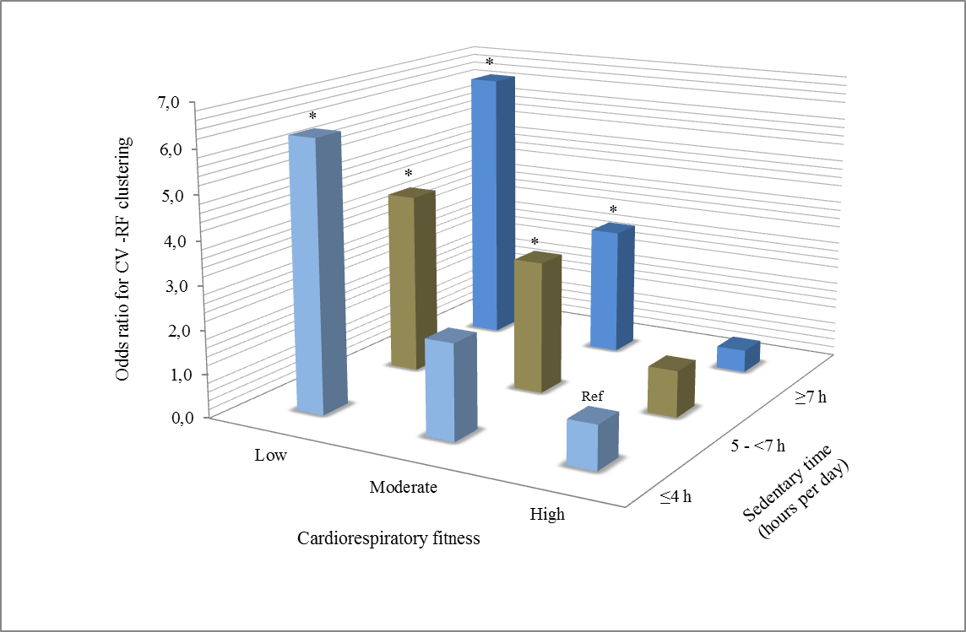
Women
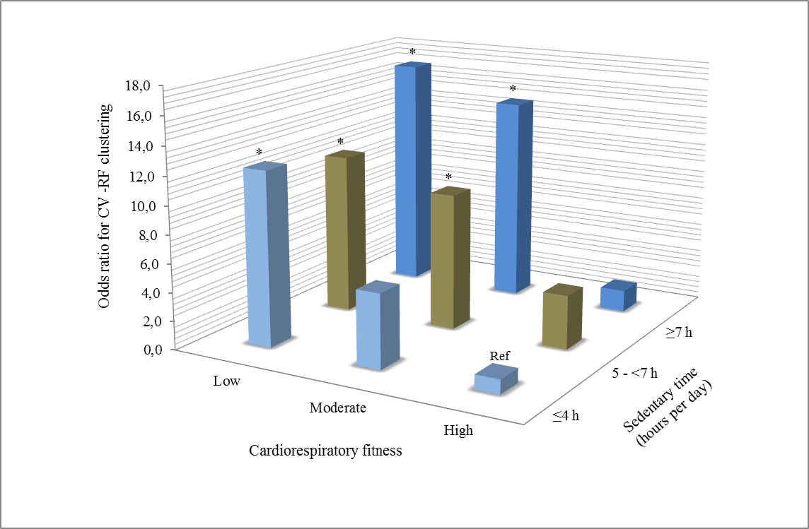
ª Adjusted for age, non-fasting serum glucose, and smoking status.
^{b} Cardiovascular risk factor clustering was a waist circumference ≥94 cm in men and ≥80 cm in women, combined with HDL-cholesterol <1.0 mmol.L⁻¹ in men and <1.3 mmol.L⁻¹ in women, systolic blood pressure ≥130 mmHg and/or diastolic blood pressure ≥85 mmHg, and serum triglycerides ≥1.7 mmol.L⁻¹.
Low, moderate and high fitness was defined as the least fit 20%, the next fit 40% and the most fit 40%, respectively.
Cardiorespiratory fitness values were <36.0 for low, 36.0-46.5 for moderate, and >46.5 mL·kg⁻¹·min⁻¹ for high fitness in men; and <29.1 for low, 29.1-37.3 for moderate, and >37.3 mL·kg⁻¹·min⁻¹ for high fitness in women.
*denotes significant difference (P<0.05) from reference category.

