SDC3: Contour Enhanced Funnel Plots of Windsorized and Unwindsorized Effect Sizes

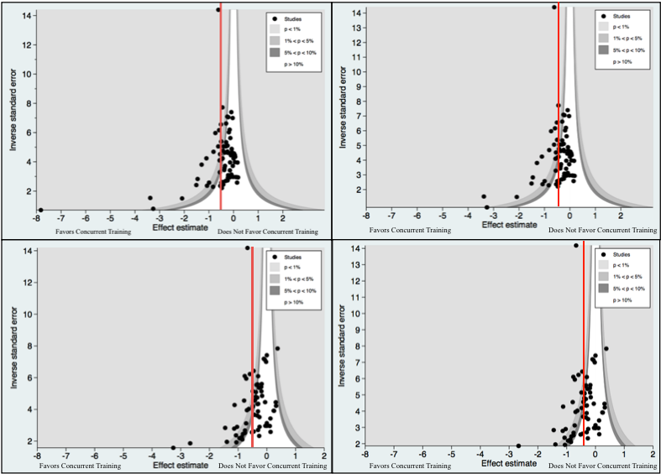

Note: Contour enhanced funnel plots of the unwindsorized (left) and windsorized (right) within-group mean standardized effect (d_{w}) of concurrent exercise training on systolic (top) and diastolic (bottom) BP. Data are presented as the standardized mean difference effect size estimate on the horizontal and the inverse standard error on the vertical. Negative effect sizes, or observations to the left in the funnel indicate a favorable blood pressure response to concurrent exercise training. The red line indicated the overall mean effect size (d_{w+}).

