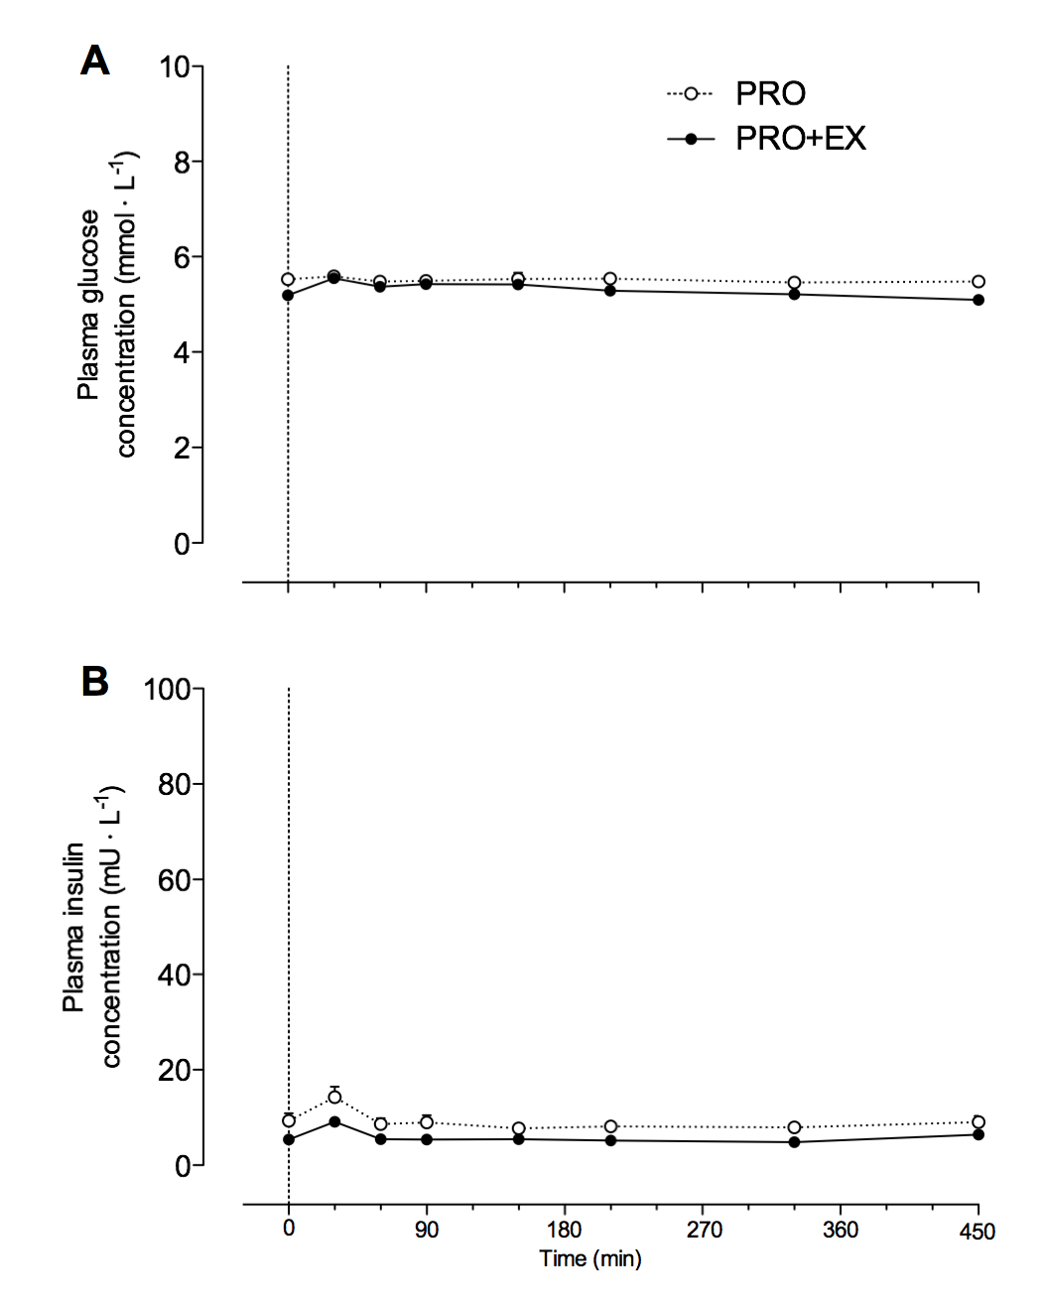

Supplemental Figure 1. Overnight plasma glucose (A, mmol∙L⁻¹) and insulin concentrations (B, mU∙L⁻¹) following protein ingestion with (PRO+EX) and without (PRO) prior exercise. The dotted line represents the ingestion of the treatment. Values represent means±SEM. Data were analyzed with a two-way repeated-measures (time x treatment) ANOVA. Glucose: time effect: P=0.004; treatment effect: P=0.0077; time x treatment interaction: P=0.075. Insulin: time effect: P<0.001; treatment effect: P=0.014; time x treatment interaction: P=0.476.

