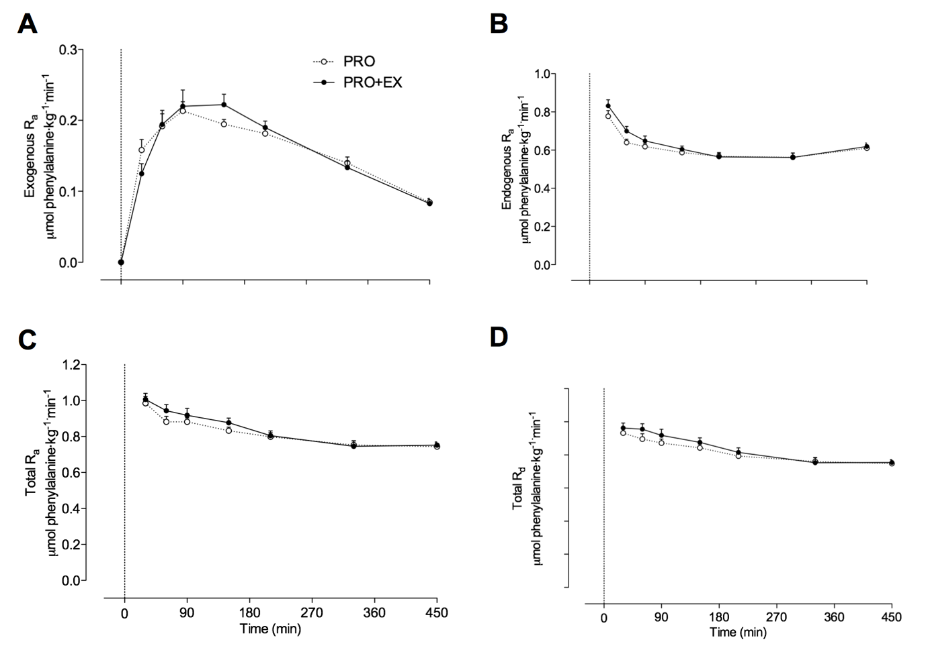

Supplemental Figure 2. Overnight exogenous phenylalanine rate of appearance (R_{a}) (A), endogenous phenylalanine R_{a} (B), total phenylalanine R_{a} (C), and total phenylalanine rate of disappearance (R_{d}) (D). The dotted line represents the ingestion of the treatment. Values represent means±SEM. Data were analyzed with repeated-measures (time x treatment) ANOVA. Exogenous phenylalanine R_{a}: time effect: P<0.001; treatment effect: P=0.957; time x treatment interaction: P=0.334. Endogenous phenylalanine R_{a}: time effect: P<0.001; treatment effect: P=0.368; time x treatment interaction: P=0.179. Total phenylalanine R_{a}: time effect: P<0.001; treatment effect: P=0.468; time x treatment interaction: P=0.366. Total phenylalanine R_{d}: time effect: P<0.001; treatment effect: P=0.421; time x treatment interaction: P=0.370. PRO: pre-sleep protein ingestion without prior exercise, PRO+EX: pre-sleep protein ingestion with prior exercise.

