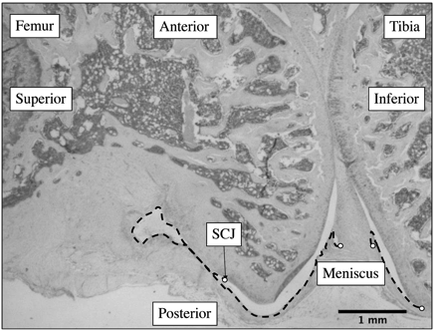
Supplementary Figure 1. Anatomical structures and orientation of the rat knee joint. 7µm section of the rat knee at the medial mid-condylar level were made in the sagittal plane. The segmented lines delineate the posterior capsule length measured from superior and inferior posterior horns of the meniscus to the femoral and tibial synovio-cartilage junction (endpoints represented by open circles). Note the longer femoral posterior capsule length compared to tibial. SCJ: synovio-cartilage junction. Magnification of 3.3X.

