Supplementary DATA
Metabolic implications of diet and energy intake during physical inactivity
Nathan C. Winn¹, Ryan Pettit-Mee¹, Lauren K. Walsh¹, Robert M. Restaino², Sean T. Ready¹, Jaume Padilla^{1,3,4}, Jill A. Kanaley¹
¹Department of Nutrition and Exercise Physiology, University of Missouri, Columbia, MO.
²Department of Medical Pharmacology and Physiology, University of Missouri, Columbia, MO.
³Dalton Cardiovascular Research Center, University of Missouri, Columbia, MO.
⁴Department of Child Health, University of Missouri, Columbia, MO.

Supplementary Figure 1
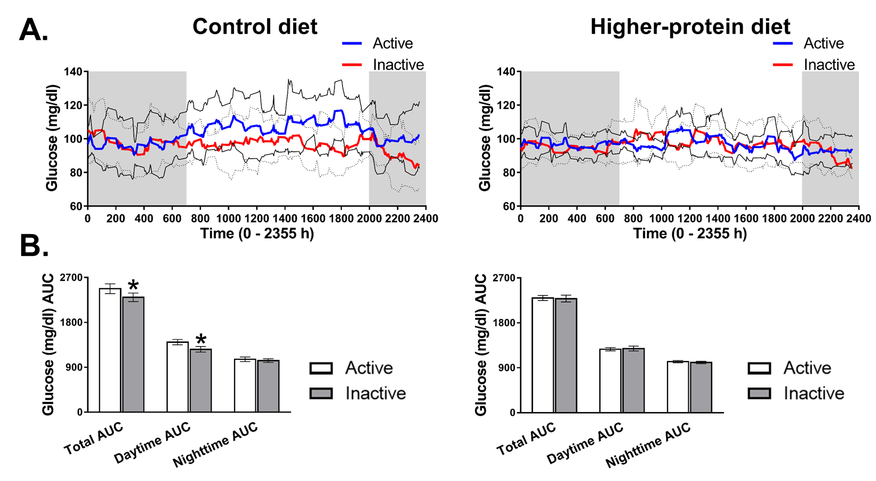
Supplementary Figure 1. Effect of physical inactivity on free-living glycemic control in response to a Control diet and Higher-protein diet. Physically active and physically inactive A) Mean 24-hour CGM-measured glucose excursions from a single day and B) CGM-measured glucose AUCs during the Control diet and High-protein diet conditions. Glucose excursions are presented as means with 95% confidence intervals (95%CI) (Active 95%CI – solid line; Inactive 95%CI – dashed line). Gray shaded area represents nighttime. AUC data are means ± SEM. AUC, area under the curve. Paired-samples t tests were run to compare Active and Inactive CGM-measured glucose excursions. n=7/Control diet; n=9/Higher protein diet. *P<0.05 vs Active.

