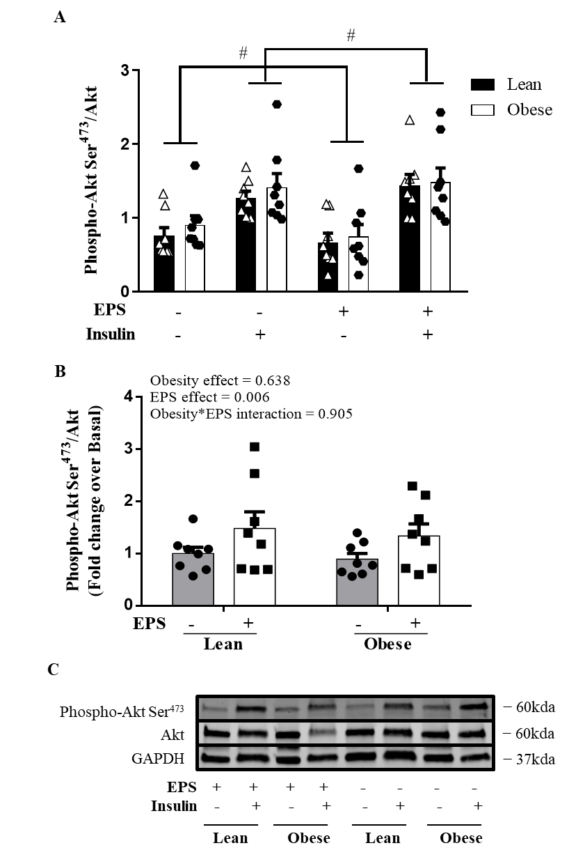
Supplemental Fig. 1 Insulin signaling in primary myotubes derived from lean humans and humans with severe obesity with or without EPS. EPS significantly reduced basal levels of Akt Ser473 phosphorylation and increased the insulin-stimulated Akt Ser473 phosphorylation from both lean subjects and subjects with severe obesity when compared to the non-EPS groups. A) Phosphorylation of Akt Ser⁴⁷³ /Akt under basal and insulin-stimulated conditions. B) Fold change of the phosphorylation of Akt Ser⁴⁷³ /Akt in response to insulin stimulation. C) Representative immunoblots. Data are presented as mean ± SEM. n=8/group. # P<0.05 EPS main effect.

