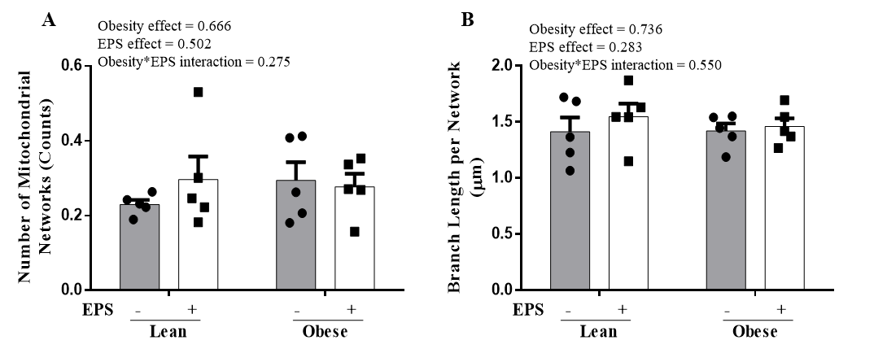
Supplemental Fig. 2 Mitochondrial morphology in primary myotubes derived from lean humans and humans with severe obesity with or without EPS. There is no obesity or EPS effect on the number of mitochondrial networks and average branch length per mitochondrial network. A) Number of mitochondrial networks (Counts). B) Average branch length per network (μm, network size). Data are presented as mean ± SEM. n=5/group.

