**SUPPLEMENTAL MATERIAL**

**Breaking Up Prolonged Sitting to Improve Cardiometabolic Risk: Dose-Response Analysis of a Randomized Cross-Over Trial**

Andrea T. Duran1, Ciaran P. Friel2, Maria A. Serafini1, Ipek Ensari3, Ying Kuen Cheung4, Keith M. Diaz1

1Center for Behavioral Cardiovascular Health, Department of Medicine, Columbia University Medical Center, New York, NY 10032; 2Institute of Health System Science, Feinstein Institutes of Medical Research, Northwell Health, Manhasset, New York; 3Data Science Institute, Columbia University, New York, NY; 4Department of Biostatistics, Mailman School of Public Health, Columbia University, New York, NY

**Address for Correspondence:**

Keith M. Diaz

Columbia University Medical Center

622 West 168th Street, PH9-301

New York, NY 10032

212-305-1170

Email: kd2442@columbia.edu

**SUPPLEMENTAL METHODS**

**Accelerometer Protocol:** To determine study eligibility (sedentary for >8 h/d and accumulated ≥50% of their sedentary time per day from prolonged (>30 min) sedentary bouts), habitual levels of physical activity and sedentary behavior were ascertained via accelerometry. At the screening and familiarization visit, participants were fitted with an activPAL (V.3, PAL Technologies, Glasgow, UK), a thigh-worn triaxial accelerometer and inclinometer that has been validated for determining physical activity intensities, posture (sitting/lying, standing or stepping), and sedentary time in healthy adults.1 Participants were instructed to wear the device continuously for 7 days and to not remove the monitor unless it was to be fully submerged in water (e.g., swimming, bath). Participants were also asked to complete a sleep and wear-time log sheet to record daily sleep (‘lights out’) and wake times, and times when the device was removed (if any).

Time-stamped 15-second epoch data files were exported using the activPAL software for subsequent processing and analysis in SAS 9.4. Non-wear and sleep time recorded in the logs were excluded from analyses. For each participant, minutes of sedentary time, standing time, and stepping time were summed for each day and averaged across the number of valid days (≥10 h of wear) to derive ‘per day’ values. Sedentary bouts ≥30 min (an indicator of prolonged, uninterrupted sedentary bouts) were also quantified. A sedentary bout was defined as consecutive epochs in which the activPAL registered no standing or stepping events of any length.

**Exploratory Measures:** Exploratory measures included fatigue, mood, and cognitive performance:

*Fatigue:* Fatigue was measured every hour using a single-item visual analog scale (VAS) with anchors of: ‘no fatigue at all (0)’ and ‘extremely fatigued (100)’.2 The VAS was 100 mm in length and participants were asked to place a mark along the line to indicate how fatigued they currently felt. Scores range from 0 to 100, measured in millimeters across the line, with higher scores reflecting higher fatigue. Single-item fatigue VAS has been demonstrated to have good validity and is sensitive to change.3, 4

*Mood:* The Profile of Mood States (POMS) questionnaire was administered at three timepoints (0h, 4h, and 8h) and was used to assess mood. The POMS has six dimensions of mood state: depression-dejection, anger-hostility, tension-anxiety, confusion-bewilderment, fatigue-inertia, and vigor-activity. Subscales are summed (with exception of the vigor-activity score which is subtracted) to create an overall mood score, with higher scores indicating worse mood. The POMS has been reported to have adequate levels of internal consistency, as well as good criterion and construct validity.5, 6

*Cognitive Performance:* The Symbol Digit Modalities Test (SDMT) was administered at three time points (0h, 4h, and 8h) and was used to assess aspects of cognitive function. The SDMT measures sustained attention, psychomotor functioning, and information processing speed. The SDMT presents a series of 9 symbols, each paired with a single-digit number from one to nine. The symbols and their matching digit are located at the top of the paper and serve as the key. Below the key are boxes containing the symbols in randomized order. Participants are asked to write the correct digit number associated with each symbol in the box as fast as possible in 90 seconds. The participant’s score is the number of correct answers. Higher scores indicate better cognitive performance. To minimize practice effects, three equivalent alternate forms were used in randomized order during trials.7 The SDMT has been reported to have good predictive validity, reliability, and psychometric properties and is sensitive to change acutely.8

**Acceptability:** Acceptability of the sedentary break frequency/duration dose combinations was evaluated using a four-item questionnaire (“I found today’s dose easy to follow”, “I would be willing to follow today’s dose for a longer period of time [such as 3 months] in my everyday life”, “the length of today’s movement breaks were too long”, “the frequency of today’s movement breaks was too often”) with responses on a 5-point Likert scale from strongly disagree to strongly agree.

**SUPPLEMENTAL REFERENCES**

1. Edwardson CL, Winkler EAH, Bodicoat DH, Yates T, Davies MJ, Dunstan DW and Healy GN. Considerations when using the activPAL monitor in field-based research with adult populations. *J Sport Health Sci*. 2017;6:162-178.

2. Lee KA, Hicks G and Nino-Murcia G. Validity and reliability of a scale to assess fatigue. *Psychiatry Res*. 1991;36:291-8.

3. Wolfe F. Fatigue assessments in rheumatoid arthritis: comparative performance of visual analog scales and longer fatigue questionnaires in 7760 patients. *J Rheumatol*. 2004;31:1896-902.

4. Hewlett S, Dures E and Almeida C. Measures of fatigue: Bristol Rheumatoid Arthritis Fatigue Multi-Dimensional Questionnaire (BRAF MDQ), Bristol Rheumatoid Arthritis Fatigue Numerical Rating Scales (BRAF NRS) for severity, effect, and coping, Chalder Fatigue Questionnaire (CFQ), Checklist Individual Strength (CIS20R and CIS8R), Fatigue Severity Scale (FSS), Functional Assessment Chronic Illness Therapy (Fatigue) (FACIT-F), Multi-Dimensional Assessment of Fatigue (MAF), Multi-Dimensional Fatigue Inventory (MFI), Pediatric Quality Of Life (PedsQL) Multi-Dimensional Fatigue Scale, Profile of Fatigue (ProF), Short Form 36 Vitality Subscale (SF-36 VT), and Visual Analog Scales (VAS). *Arthritis Care Res (Hoboken)*. 2011;63 Suppl 11:S263-86.

5. Curran SL, Andrykowski MA and Studts JL. Short form of the profile of mood states (POMS-SF): psychometric information. *Psychological assessment*. 1995;7:80.

6. Nyenhuis DL, Yamamoto C, Luchetta T, Terrien A and Parmentier A. Adult and geriatric normative data and validation of the profile of mood states. *J Clin Psychol*. 1999;55:79-86.

7. Benedict RH, Smerbeck A, Parikh R, Rodgers J, Cadavid D and Erlanger D. Reliability and equivalence of alternate forms for the Symbol Digit Modalities Test: implications for multiple sclerosis clinical trials. *Mult Scler*. 2012;18:1320-5.

8. Jaeger J. Digit symbol substitution test: the case for sensitivity over specificity in neuropsychological testing. *J Clin Psychopharmacol*. 2018;38:513.



**Supplemental Figure 1.** Consort diagram.

**Supplemental Figure 2.** Collection time points of study measurements taken throughout each 8.0 hour experimental condition. Glucose was measured continuously throughout the 8-hour condition. Blood pressure and fatigue were measured every hour. Mood and cognition were measured every 4 hours.

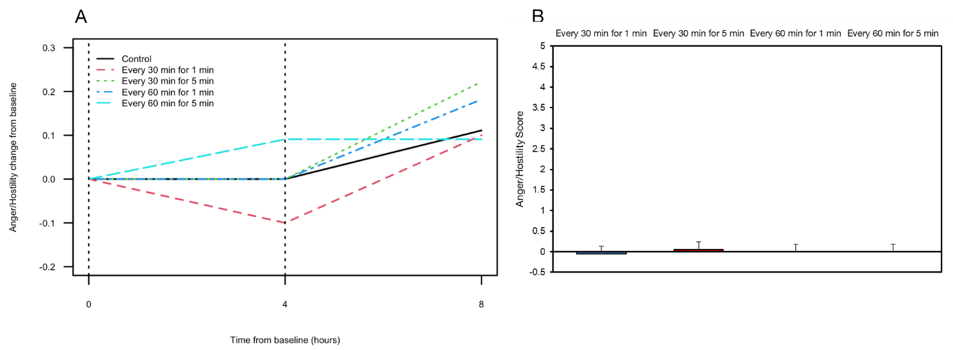

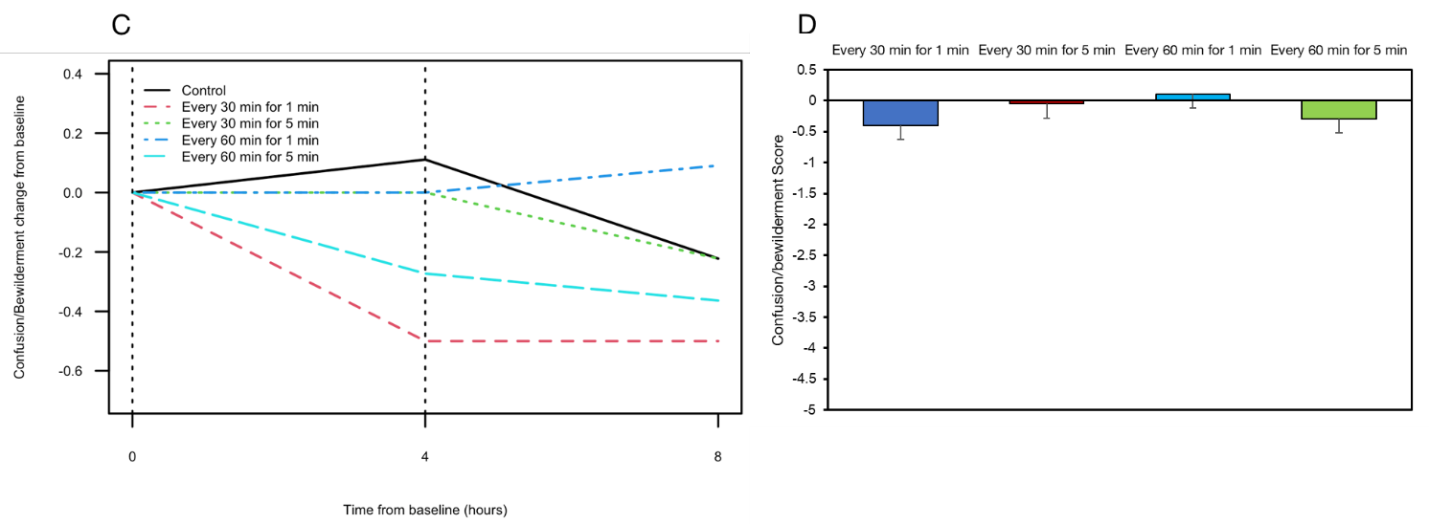

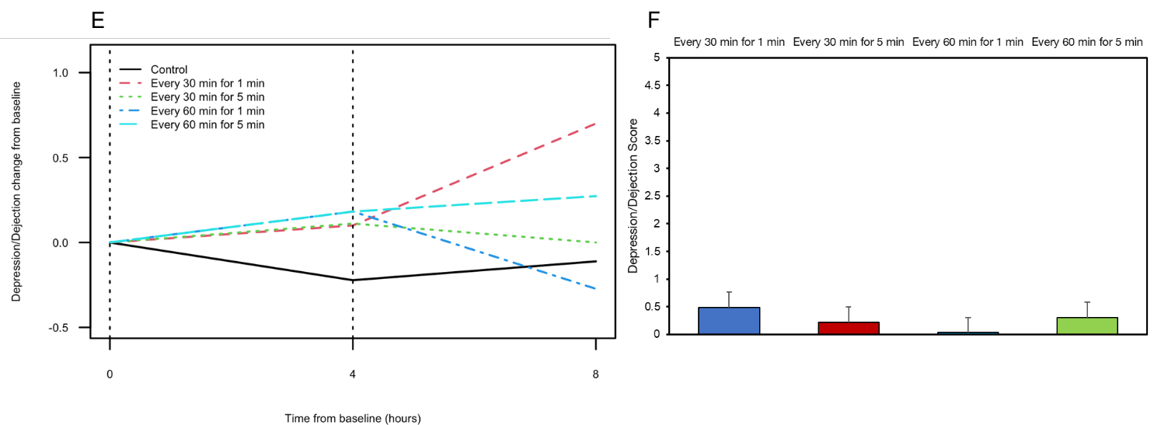

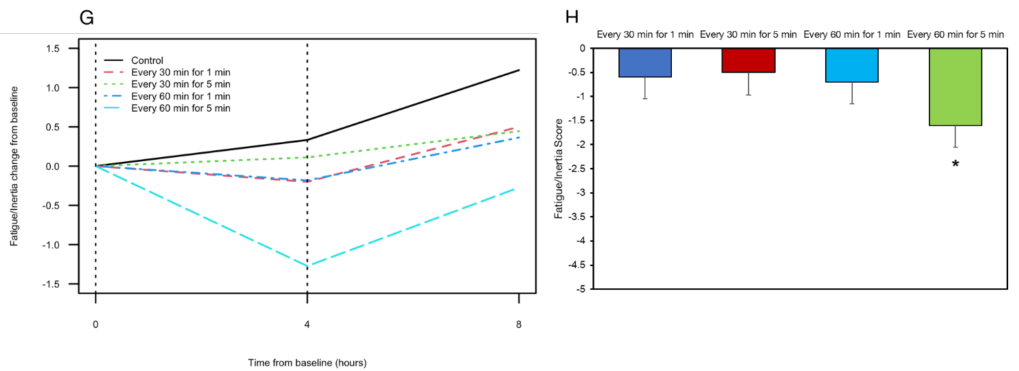

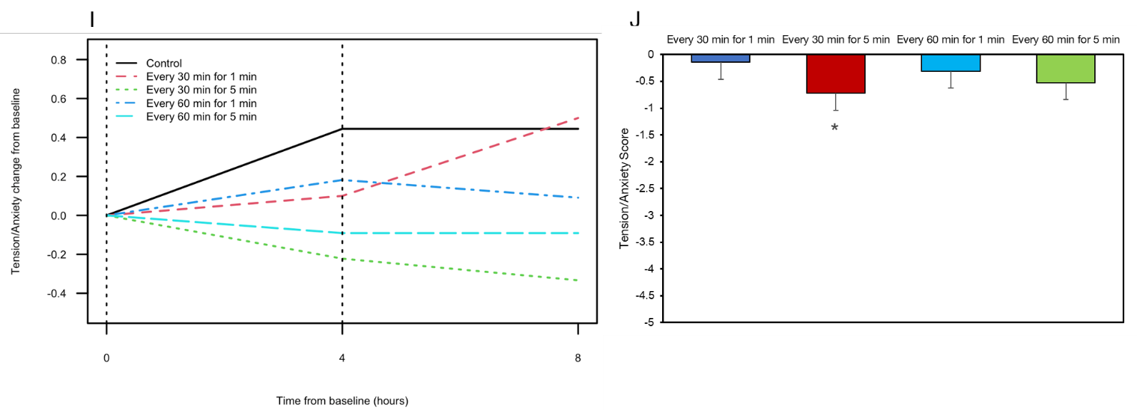

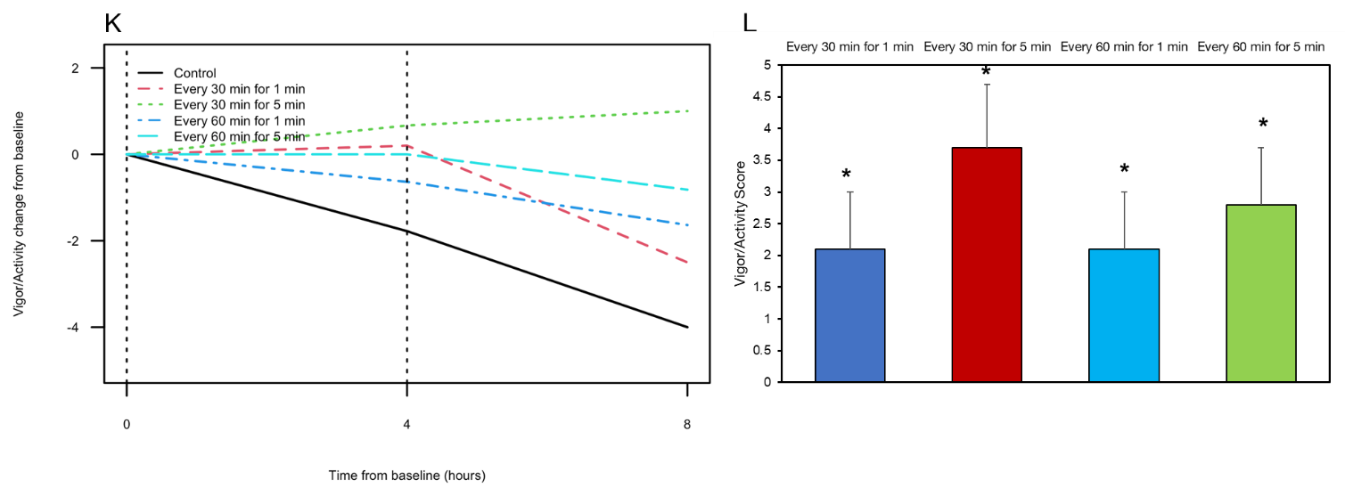

**Supplemental Figure 3.** The effect of sedentary break and control conditions on Profile of Mood States (POMS) subscales over time (A [anger], C [confusion], E [depression], G [fatigue], I [tension], and K [vigor]) and POMS subscales expressed as net change from baseline across the 8-hour condition compared to the control condition (B [anger], D [confusion], F [depression], H [fatigue], J [tension], and L [vigor]). Vertical dashed line in Panels A, C, E, G, I, and K indicates timing of breakfast (0 h) and lunch (4 h) meals. Data presented as mean change from baseline in Panels A, C, E, G, I, and K. Tabular data, including standard errors, are presented in Supplemental Table 7. Data presented as mean net change in outcome compared to control and standard error in Panels B, D, F, H, J, and L. * indicates significant difference from control condition (p<0.05).

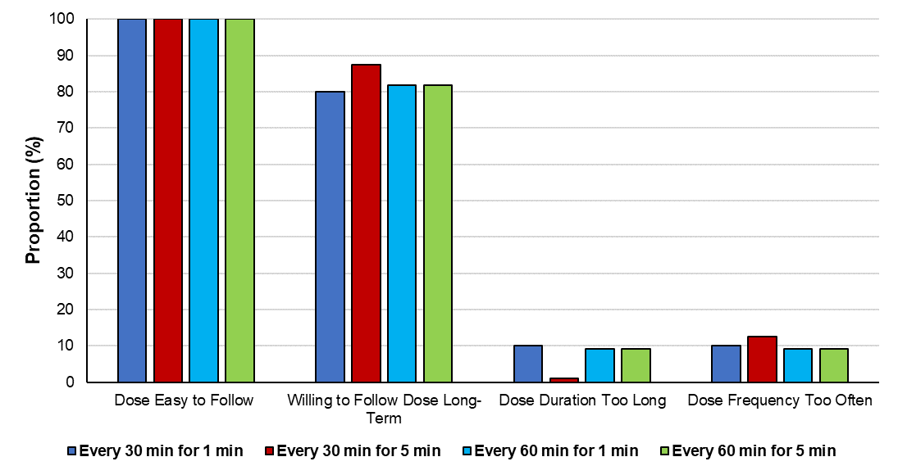

**Supplemental Figure 4.** Acceptability of the sedentary break frequency/duration dose combinations. Data are presented as proportion (%) of participants reporting agree/strongly agree to each item.

|  |  |  |  |  |
| --- | --- | --- | --- | --- |
| **Supplemental Table 1.** Perceived exertion and heart rate during activity break for each trial condition. | | | | |
|  | Every 60 min for 1 min | Every 30 min for 1 min | Every 60 min for 5 min | Every 30 min for 5 min |
| Borg RPEa | 0 (0.5) | 0 (0.5) | 0.5 (2.0) | 1.25 (1.75) |
| Heart rate | 90.7 (12.4) | 87.6 (13.5) | 96.2 (16.7) | 94.1 (14.4) |
| Data presented as median (IQR) and mean (SD) for Borg RPE and heart rate, respectively. | | | | |
| RPE, rating of perceived exertion. | | | | |

|  |  |  |  |  |  |
| --- | --- | --- | --- | --- | --- |
| **Supplemental Table 2.** The effect of sedentary break conditions on change in glucose from baseline. | | | | | |
| ***Time Point*** | **Control** | **Every 30 min for 1 min** | **Every 30 min for 5 min** | **Every 60 min for 1 min** | **Every 60 min for 5 min** |
| 0 h | 0.0 (0.0) | 0.0 (0.0) | 0.0 (0.0) | 0.0 (0.0) | 0.0 (0.0) |
| 0.25 h | 11.0 (6.5) | 7.6 (5.9) | 8.4 (7.0) | 6.0 (3.8) | 10.2 (5.3) |
| 0.5 h | 29.6 (8.7) | 23.0 (6.0) | 18.8 (8.0) | 20.9 (5.3) | 28.8 (8.6) |
| 0.75 h | 39.1 (9.4) | 23.8 (7.0) | 16.2 (8.6) | 27.0 (6.0) | 29.2 (9.9) |
| 1 h | 31.2 (8.8) | 14.5 (6.9) | 6.2 (7.6) | 16.8 (6.8) | 12.5 (8.6) |
| 1.25 h | 16.9 (8.4) | 5.3 (6.4) | -1.2 (6.1) | 5.7 (6.5) | 2.5 (7.0) |
| 1.5 h | 6.0 (7.0) | 0.9 (5.5) | -5.2 (4.9) | 3.9 (5.7) | 3.5 (6.8) |
| 1.75 h | -1.2 (5.4) | -2.7 (4.1) | -8.8 (4.1) | 4.5 (4.6) | 4.2 (6.2) |
| 2 h | -3.4 (4.4) | -5.6 (3.8) | -8.8 (4.1) | 3.3 (4.1) | 0.6 (5.4) |
| 2.25 h | -3.0 (4.2) | -7.8 (4.2) | -8.1 (4.2) | 1.3 (4.5) | -3.1 (5.5) |
| 2.5 h | -2.9 (4.2) | -9.2 (4.1) | -8.3 (3.6) | -0.5 (4.7) | -1.9 (5.4) |
| 2.75 h | -4.2 (4.1) | -10.4 (3.7) | -11.4 (3.3) | 0.4 (4.2) | -0.6 (4.7) |
| 3 h | -5.3 (4.1) | -10.3 (3.9) | -14 (4.0) | 0.0 (3.7) | -2.5 (4.1) |
| 3.25 h | -5.2 (4.1) | -10.1 (4.2) | -14.4 (4.3) | -3.2 (3.2) | -4.6 (4.3) |
| 3.5 h | -4.4 (4.3) | -9.4 (4.3) | -13.3 (4.2) | -4.3 (2.9) | -5.0 (4.5) |
| 3.75 | -4.6 (4.3) | -9.0 (4.8) | -12.9 (4.8) | -3.5 (3.0) | -5.4 (3.8) |
| 4 h | -5.1 (4.6) | -8.3 (4.9) | -11.9 (4.9) | -4.4 (2.7) | -6.5 (3.5) |
| 4.25 h | -2.0 (5.1) | -4.3 (5.5) | -5.6 (4.6) | -1.4 (3.7) | -2.5 (4.5) |
| 4.5 h | 11.9 (6.1) | 8.6 (7.7) | 8.2 (7.4) | 14.2 (5.6) | 13.2 (7.0) |
| 4.75 h | 28.0 (7.6) | 22.0 (8.3) | 18.4 (8.8) | 29.1 (6.0) | 26.2 (9.0) |
| 5 h | 32.6 (8.5) | 22.5 (7.1) | 15.6 (7.7) | 27.9 (5.3) | 21.8 (10.2) |
| 5.25 h | 30.7 (9.2) | 16.3 (5.7) | 9.4 (7.0) | 18.5 (6.0) | 14.8 (10.0) |
| 5.5 h | 27.1 (8.6) | 13.5 (4.5) | 7.6 (7.0) | 16.4 (6.5) | 16.7 (9.0) |
| 5.75 h | 22.9 (7.6) | 11.4 (3.8) | 6.0 (6.6) | 15.9 (6.1) | 17.8 (7.6) |
| 6 h | 20.8 (6.7) | 10.2 (3.5) | 4.6 (5.2) | 13.7 (5.3) | 12.2 (6.3) |
| 6.25 h | 20.0 (6.7) | 9.9 (2.9) | 1.7 (4.0) | 12.2 (5.8) | 8.0 (5.6) |
| 6.5 h | 17.2 (6.5) | 8.9 (3.3) | -2.0 (4.0) | 10.9 (5.4) | 8.4 (5.3) |
| 6.75 h | 10.0 (5.7) | 6.8 (4.2) | -5.6 (4.7) | 8.7 (4.0) | 8.5 (5.2) |
| 7 h | 4.9 (5.6) | 5.3 (4.5) | -6.9 (4.8) | 5.6 (4.3) | 7.1 (5.0) |
| 7.25 | 5.7 (4.9) | 1.8 (5.0) | -10.1 (4.6) | 2.1 (4.1) | 2.4 (5.2) |
| 7.5 h | 3.5 (4.9) | 0.8 (5.9) | -10.1 (4.5) | 1.2 (4.1) | 3.0 (5.8) |
| 7.75 h | 0.7 (4.3) | -3.3 (6.4) | -11.3 (4.8) | 1.9 (3.0) | 3.0 (6.5) |
| 8 h | 2.5 (5.1) | -8.2 (6.7) | -11.1 (6.6) | 3.5 (3.0) | -0.2 (6.9) |
| Data presented as mean change from baseline (standard error) in glucose (mg/dL) | | | | | |

|  |  |  |
| --- | --- | --- |
| **Supplemental Table 3.** The effect of sedentary break conditions on change in blood pressure from baseline. | | |
|  | Systolic BP (mmHg) | Diastolic BP (mmHg) |
| **Baseline (0 h) Time Point** |  |  |
| Control | 0.0 (0.0) | 0.0 (0.0) |
| Every 30 min for 1 min | 0.0 (0.0) | 0.0 (0.0) |
| Every 30 min for 5 min | 0.0 (0.0) | 0.0 (0.0) |
| Every 60 min for 1 min | 0.0 (0.0) | 0.0 (0.0) |
| Every 60 min for 5 min | 0.0 (0.0) | 0.0 (0.0) |
|  |  |  |
| **1 h Time Point** |  |  |
| Control | 3.1 (0.8) | -4.0 (0.5) |
| Every 30 min for 1 min | -2.0 (0.8) | -4.5 (0.7) |
| Every 30 min for 5 min | -1.8 (0.9) | -4.4 (0.6) |
| Every 60 min for 1 min | -1.3 (0.7) | -4.1 (0.4) |
| Every 60 min for 5 min | -0.6 (0.6) | -3.4 (0.5) |
|  |  |  |
| **2 h Time Point** |  |  |
| Control | 1.9 (1.1) | -2.5 (0.6) |
| Every 30 min for 1 min | -1.0 (0.9) | -3.4 (0.8) |
| Every 30 min for 5 min | -3.1 (1.2) | -3.4 (0.8) |
| Every 60 min for 1 min | -2.8 (0.8) | -4.9 (0.6) |
| Every 60 min for 5 min | -2.7 (0.7) | -3.3 (0.5) |
|  |  |  |
| **3 h Time Point** |  |  |
| Control | 5.0 (1.5) | -0.8 (0.9) |
| Every 30 min for 1 min | 3.4 (1.2) | -0.9 (0.7) |
| Every 30 min for 5 min | 2.7 (1.2) | -1.4 (0.6) |
| Every 60 min for 1 min | -1.6 (0.8) | -3.0 (0.6) |
| Every 60 min for 5 min | 1.8 (0.9) | 0.4 (0.6) |
|  |  |  |
| **4 h Time Point** |  |  |
| Control | 8.8 (0.9) | 2.3 (0.8) |
| Every 30 min for 1 min | 6.7 (1.0) | 1.4 (0.9) |
| Every 30 min for 5 min | 2.1 (1.2) | 1.4 (0.9) |
| Every 60 min for 1 min | 4.1 (0.9) | 2.2 (0.7) |
| Every 60 min for 5 min | 6.7 (0.9) | 4.1 (0.4) |
|  |  |  |
| **5 h Time Point** |  |  |
| Control | 3.3 (1.1) | -1.9 (1.1) |
| Every 30 min for 1 min | 2.6 (1.3) | -1.9 (1.1) |
| Every 30 min for 5 min | 0.0 (1.3) | -5.2 (1.0) |
| Every 60 min for 1 min | 1.5 (0.8) | -2.0 (0.5) |
| Every 60 min for 5 min | 4.6 (0.9) | -0.6 (0.6) |
|  |  |  |
| **6 h Time Point** |  |  |
| Control | 2.2 (1.3) | -1.8 (1.0) |
| Every 30 min for 1 min | -0.7 (1.1) | -1.8 (0.8) |
| Every 30 min for 5 min | -0.2 (1.5) | -4.0 (0.9) |
| Every 60 min for 1 min | -1.4 (0.7) | -1.8 (0.6) |
| Every 60 min for 5 min | 1.6 (0.8) | -1.4 (0.5) |
|  |  |  |
| **7 h Time Point** |  |  |
| Control | 8.4 (1.3) | 1.7 (1.0) |
| Every 30 min for 1 min | 4.6 (1.6) | 1.5 (1.1) |
| Every 30 min for 5 min | 5.2 (1.8) | 0.5 (1.2) |
| Every 60 min for 1 min | 2.4 (0.9) | 1.1 (0.6) |
| Every 60 min for 5 min | 2.0 (1.2) | 1.4 (0.5) |
|  |  |  |
| **8 h Time Point** |  |  |
| Control | 14.2 (1.8) | 6.3 (1.3) |
| Every 30 min for 1 min | 13.5 (2.4) | 4.0 (1.2) |
| Every 30 min for 5 min | 7.7 (1.7) | 4.4 (1.3) |
| Every 60 min for 1 min | 8.4 (1.2) | 4.5 (0.9) |
| Every 60 min for 5 min | 13.5 (1.0) | 8.4 (0.7) |
| Data presented as mean change from baseline (standard error) | | |
| BP, blood pressure. | | |

|  |  |  |  |  |  |  |  |  |  |  |  |  |  |  |  |
| --- | --- | --- | --- | --- | --- | --- | --- | --- | --- | --- | --- | --- | --- | --- | --- |
| **Supplemental Table 4.** The net effect of sedentary break conditions on glucose and blood pressure compared to control condition. | | | | | | | | | | | | | | | |
|  | Every 30 min for 1 min | | |  | Every 30 min for 5 min | | |  | Every 60 min for 1 min | | |  | Every 60 min for 5 min | | | |
|  | Mean (SE)a | P-Valueb | Cohen’s *d* |  | Mean (SE) a | P-Valueb | Cohen’s *d* |  | Mean (SE) a | P-Valueb | Cohen’s *d* |  | Mean (SE) a | P-Valueb | Cohen’s *d* | |
| Glucose AUC | -6.7 (4.6) | 0.159 | 0.49 |  | -11.8 (4.7) | 0.017 | 0.85 |  | -2.4 (4.5) | 0.605 | 0.18 |  | -3.5 (4.6) | 0.451 | 0.26 | |
|  |  |  |  |  |  |  |  |  |  |  |  |  |  |  |  | |
| Systolic BP (mmHg) | -3.2 (1.4) | 0.024 | 0.23 |  | -4.3 (1.4) | 0.003 | 0.31 |  | -5.2 (1.4) | <0.001 | 0.38 |  | -3.0 (1.4) | 0.033 | 0.22 | |
|  |  |  |  |  |  |  |  |  |  |  |  |  |  |  |  | |
| Diastolic BP (mmHg) | -0.9 (0.9) | 0.300 | 0.11 |  | -1.4 (0.9) | 0.110 | 0.16 |  | -1.2 (0.9) | 0.160 | 0.15 |  | 0.5 (0.9) | 0.595 | 0.05 | |
| AUC, area under the curve; BP, blood pressure; SE, standard error. | | | | | | | | | | | | | | | |
| aRepresents the mean net change from baseline | | | | | | | | | | | | | | | |
| bCompared to control condition | | | | | | | | | | | | | | | |

|  |  |  |  |
| --- | --- | --- | --- |
| **Supplemental Table 5.** The effect of sedentary break conditions on change in fatigue, mood, and cognitive performance from baseline. | | | |
|  | Fatigue (VAS Score) | Total Mood Disturbance Score | SDMT Performance (Number Correct) | |
| **Baseline (0 h) Time Point** |  |  |  | |
| Control | 0.0 (0.0) | 0.0 (0.0) | 0.0 (0.0) | |
| Every 30 min for 1 min | 0.0 (0.0) | 0.0 (0.0) | 0.0 (0.0) | |
| Every 30 min for 5 min | 0.0 (0.0) | 0.0 (0.0) | 0.0 (0.0) | |
| Every 60 min for 1 min | 0.0 (0.0) | 0.0 (0.0) | 0.0 (0.0) | |
| Every 60 min for 5 min | 0.0 (0.0) | 0.0 (0.0) | 0.0 (0.0) | |
|  |  |  |  | |
| **1 h Time Point** |  |  |  | |
| Control | 4.4 (2.5) | - | - | |
| Every 30 min for 1 min | -2.1 (0.9) | - | - | |
| Every 30 min for 5 min | -0.5 (0.3) | - | - | |
| Every 60 min for 1 min | 2.6 (1.2) | - | - | |
| Every 60 min for 5 min | 0.3 (0.6) | - | - | |
|  |  |  |  | |
| **2 h Time Point** |  |  |  | |
| Control | 3.6 (3.9) | - | - | |
| Every 30 min for 1 min | -1.9 (1.0) | - | - | |
| Every 30 min for 5 min | 1.5 (1.3) | - | - | |
| Every 60 min for 1 min | 1.6 (1.2) | - | - | |
| Every 60 min for 5 min | 1.0 (0.6) | - | - | |
|  |  |  |  | |
| **3 h Time Point** |  |  |  | |
| Control | 4.4 (4.6) | - | - | |
| Every 30 min for 1 min | 1.1 (1.6) | - | - | |
| Every 30 min for 5 min | 0.3 (0.4) | - | - | |
| Every 60 min for 1 min | 2.1 (1.1) | - | - | |
| Every 60 min for 5 min | -0.6 (0.8) | - | - | |
|  |  |  |  | |
| **4 h Time Point** |  |  |  | |
| Control | 4.2 (3.1) | 2.4 (0.6) | -2.9 (0.9) | |
| Every 30 min for 1 min | 0.2 (1.5) | -0.8 (0.5) | -0.1 (0.9) | |
| Every 30 min for 5 min | 1.4 (0.4) | -0.7 (0.4) | 1.1 (0.6) | |
| Every 60 min for 1 min | -0.5 (0.7) | 0.8 (0.5) | -0.6 (0.8) | |
| Every 60 min for 5 min | -1.6 (1.3) | -1.4 (0.4) | -1.2 (0.7) | |
|  |  |  |  | |
| **5 h Time Point** |  |  |  | |
| Control | 7.4 (5.3) | - | - | |
| Every 30 min for 1 min | 0.5 (1.4) | - | - | |
| Every 30 min for 5 min | -0.1 (0.3) | - | - | |
| Every 60 min for 1 min | 5.1 (1.8) | - | - | |
| Every 60 min for 5 min | -2.4 (1.0) | - | - | |
|  |  |  |  | |
| **6 h Time Point** |  |  |  | |
| Control | 5.8 (4.5) | - | - | |
| Every 30 min for 1 min | 6.5 (2.3) | - | - | |
| Every 30 min for 5 min | 2.3 (0.4) | - | - | |
| Every 60 min for 1 min | 1.3 (1.0) | - | - | |
| Every 60 min for 5 min | 1.1 (0.6) | - | - | |
|  |  |  |  | |
| **7 h Time Point** |  |  |  | |
| Control | 9.9 (5.5) | - | - | |
| Every 30 min for 1 min | 6.8 (2.4) | - | - | |
| Every 30 min for 5 min | 1.9 (0.5) | - | - | |
| Every 60 min for 1 min | 2.1 (2.0) | - | - | |
| Every 60 min for 5 min | 0.2 (1.1) | - | - | |
|  |  |  |  | |
| **8 h Time Point** |  |  |  | |
| Control | 10.5 (3.9) | 5.4 (0.7) | -2.8 (0.6) | |
| Every 30 min for 1 min | 2.7 (1.8) | 3.8 (0.6) | -0.1 (0.5) | |
| Every 30 min for 5 min | -3.3 (1.9) | -0.9 (0.8) | 0.9 (1.1) | |
| Every 60 min for 1 min | 1.1 (1.7) | 2.1 (0.4) | 0.4 (0.6) | |
| Every 60 min for 5 min | 1.6 (1.4) | 0.4 (0.4) | -1.7 (0.3) | |
| Data presented as mean change from baseline (standard error) | | | |
| SDMT, symbol digit modalities test; SE, standard error; VAS, visual analog scale. | | | |

|  |  |  |  |  |  |  |  |  |  |  |  |  |  |  |  |
| --- | --- | --- | --- | --- | --- | --- | --- | --- | --- | --- | --- | --- | --- | --- | --- |
| **Supplemental Table 6.** The net effect of sedentary break conditions on fatigue, mood, and cognitive performance compared to control condition. | | | | | | | | | | | | | | | |
|  | Every 30 min for 1 min | | |  | Every 30 min for 5 min | | |  | Every 60 min for 1 min | | |  | Every 60 min for 5 min | | |
|  | Mean (SE)a | P-Valueb | Cohen’s *d* |  | Mean (SE) a | P-Valueb | Cohen’s *d* |  | Mean (SE) a | P-Valueb | Cohen’s *d* |  | Mean (SE) a | P-Valueb | Cohen’s *d* |
| Fatigue (VAS Score) | -4.4 (2.0) | 0.030 | 0.29 |  | -5.8 (2.1) | 0.006 | 0.37 |  | -3.9 (2.0) | 0.050 | 0.26 |  | -5.9 (2.0) | 0.003 | 0.40 |
|  |  |  |  |  |  |  |  |  |  |  |  |  |  |  |  |
| Total Mood Disturbance Score | -2.8 (1.4) | 0.049 | 0.43 |  | -4.7 (1.4) | 0.001 | 0.72 |  | -3.1 (1.4) | 0.028 | 0.49 |  | -5.0 (1.4) | <0.001 | 0.79 |
|  |  |  |  |  |  |  |  |  |  |  |  |  |  |  |  |
| SDMT Performance (Number Correct) | 2.9 (2.2) | 0.183 | 0.29 |  | 3.8 (2.3) | 0.105 | 0.36 |  | 2.8 (2.2) | 0.193 | 0.29 |  | 1.5 (2.2) | 0.485 | 0.15 |
| SDMT, symbol digit modalities test; SE, standard error; VAS, visual analog scale. | | | | | | | | | | | | | | | |
| aRepresents the mean net change from baseline | | | | | | | | | | | | | | | |
| bCompared to control condition | | | | | | | | | | | | | | | |

|  |  |  |  |  |  |  |
| --- | --- | --- | --- | --- | --- | --- |
| **Supplemental Table 7.** The effect of sedentary break conditions on change in Profile of Mood States (POMS) subscale scores from baseline. | | | | | | |
|  | Anger | Confusion | Depression | Fatigue | Tension | Vigor | |
| **Baseline (0 h) Time Point** |  |  |  |  |  |  | |
| Control | 0.0 (0.0) | 0.0 (0.0) | 0.0 (0.0) | 0.0 (0.0) | 0.0 (0.0) | 0.0 (0.0) | |
| Every 30 min for 1 min | 0.0 (0.0) | 0.0 (0.0) | 0.0 (0.0) | 0.0 (0.0) | 0.0 (0.0) | 0.0 (0.0) | |
| Every 30 min for 5 min | 0.0 (0.0) | 0.0 (0.0) | 0.0 (0.0) | 0.0 (0.0) | 0.0 (0.0) | 0.0 (0.0) | |
| Every 60 min for 1 min | 0.0 (0.0) | 0.0 (0.0) | 0.0 (0.0) | 0.0 (0.0) | 0.0 (0.0) | 0.0 (0.0) | |
| Every 60 min for 5 min | 0.0 (0.0) | 0.0 (0.0) | 0.0 (0.0) | 0.0 (0.0) | 0.0 (0.0) | 0.0 (0.0) | |
|  |  |  |  |  |  |  | |
| **4 h Time Point** |  |  |  |  |  |  | |
| Control | 0.0 (0.1) | 0.1 (0.0) | -0.2 (0.1) | 0.3 (0.1) | 0.4 (0.1) | -1.8 (0.4) | |
| Every 30 min for 1 min | -0.1 (0.0) | -0.5 (0.1) | 0.1 (0.0) | -0.2 (0.2) | 0.1 (0.0) | 0.2 (0.3) | |
| Every 30 min for 5 min | 0.0 (0.0) | 0.0 (0.1) | 0.1 (0.0) | 0.1 (0.1) | -0.2 (0.1) | 0.7 (0.3) | |
| Every 60 min for 1 min | 0.0 (0.0) | 0.0 (0.0) | 0.2 (0.1) | -0.2 (0.1) | 0.2 (0.1) | -0.6 (0.3) | |
| Every 60 min for 5 min | 0.1 (0.1) | -0.3 (0.1) | 0.2 (0.1) | -1.3 (0.1) | -0.1 (0.1) | 0.0 (0.3) | |
|  |  |  |  |  |  |  | |
| **8 h Time Point** |  |  |  |  |  |  | |
| Control | 0.1 (0.1) | -0.2 (0.0) | -0.1 (0.1) | 1.2 (0.2) | 0.4 (0.1) | -4.0 (0.4) | |
| Every 30 min for 1 min | 0.1 (0.1) | -0.5 (0.1) | 0.7 (0.1) | 0.5 (0.2) | 0.5 (0.1) | -2.5 (0.4) | |
| Every 30 min for 5 min | 0.2 (0.1) | -0.2 (0.1) | 0.0 (0.0) | 0.4 (0.3) | -0.3 (0.1) | 1.0 (0.6) | |
| Every 60 min for 1 min | 0.2 (0.0) | 0.1 (0.0) | -0.3 (0.1) | 0.4 (0.2) | 0.1 (0.1) | -1.6 (0.3) | |
| Every 60 min for 5 min | 0.1 (0.0) | -0.4 (0.1) | 0.3 (0.1) | -0.3 (0.1) | -0.1 (0.1) | -0.8 (0.4) | |
| Data presented as mean change from baseline (standard error) | | | | | | |
| SE, standard error. | | | | | | |

|  |  |  |  |  |  |  |  |  |  |  |  |  |  |  |  |
| --- | --- | --- | --- | --- | --- | --- | --- | --- | --- | --- | --- | --- | --- | --- | --- |
| **Supplemental Table 8.** The net effect of sedentary break conditions on Profile of Mood States (POMS) subscale scores compared to control condition. | | | | | | | | | | | | | | | |
|  | Every 30 min for 1 min | | |  | Every 30 min for 5 min | | |  | Every 60 min for 1 min | | |  | Every 60 min for 5 min | | |
|  | Mean (SE)a | P-Valueb | Cohen’s *d* |  | Mean (SE) a | P-Valueb | Cohen’s *d* |  | Mean (SE) a | P-Valueb | Cohen’s *d* |  | Mean (SE) a | P-Valueb | Cohen’s *d* |
| Anger | -0.1 (0.2) | 0.776 | 0.06 |  | 0.1 (0.2) | 0.777 | 0.06 |  | 0.0 (0.2) | 0.965 | 0.01 |  | 0.0 (0.2) | 0.965 | 0.01 |
|  |  |  |  |  |  |  |  |  |  |  |  |  |  |  |  |
| Confusion | -0.4 (0.2) | 0.056 | 0.42 |  | -0.1 (0.2) | 0.812 | 0.05 |  | 0.1 (0.2) | 0.657 | 0.10 |  | -0.3 (0.2) | 0.242 | 0.26 |
|  |  |  |  |  |  |  |  |  |  |  |  |  |  |  |  |
| Depression | 0.5 (0.3) | 0.084 | 0.38 |  | 0.2 (0.3) | 0.439 | 0.17 |  | 0.0 (0.3) | 0.897 | 0.03 |  | 0.3 (0.3) | 0.267 | 0.24 |
|  |  |  |  |  |  |  |  |  |  |  |  |  |  |  |  |
| Fatigue | -0.6 (0.4) | 0.200 | 0.28 |  | -0.5 (0.5) | 0.289 | 0.23 |  | -0.7 (0.4) | 0.123 | 0.34 |  | -1.6 (0.4) | 0.001 | 0.76 |
|  |  |  |  |  |  |  |  |  |  |  |  |  |  |  |  |
| Tension | -0.1 (0.3) | 0.652 | 0.10 |  | -0.7 (0.3) | 0.030 | 0.48 |  | -0.3 (0.3) | 0.326 | 0.21 |  | -0.5 (0.3) | 0.090 | 0.37 |
|  |  |  |  |  |  |  |  |  |  |  |  |  |  |  |  |
| Vigor | 2.1 (0.9) | 0.034 | 0.47 |  | 3.7 (1.0) | <0.001 | 0.83 |  | 2.1 (0.9) | 0.029 | 0.48 |  | 2.8 (0.9) | 0.004 | 0.65 |
| SE, standard error. | | | | | | | | | | | | | | | |
| aRepresents the mean net change from baseline | | | | | | | | | | | | | | | |
| bCompared to control condition | | | | | | | | | | | | | | | |