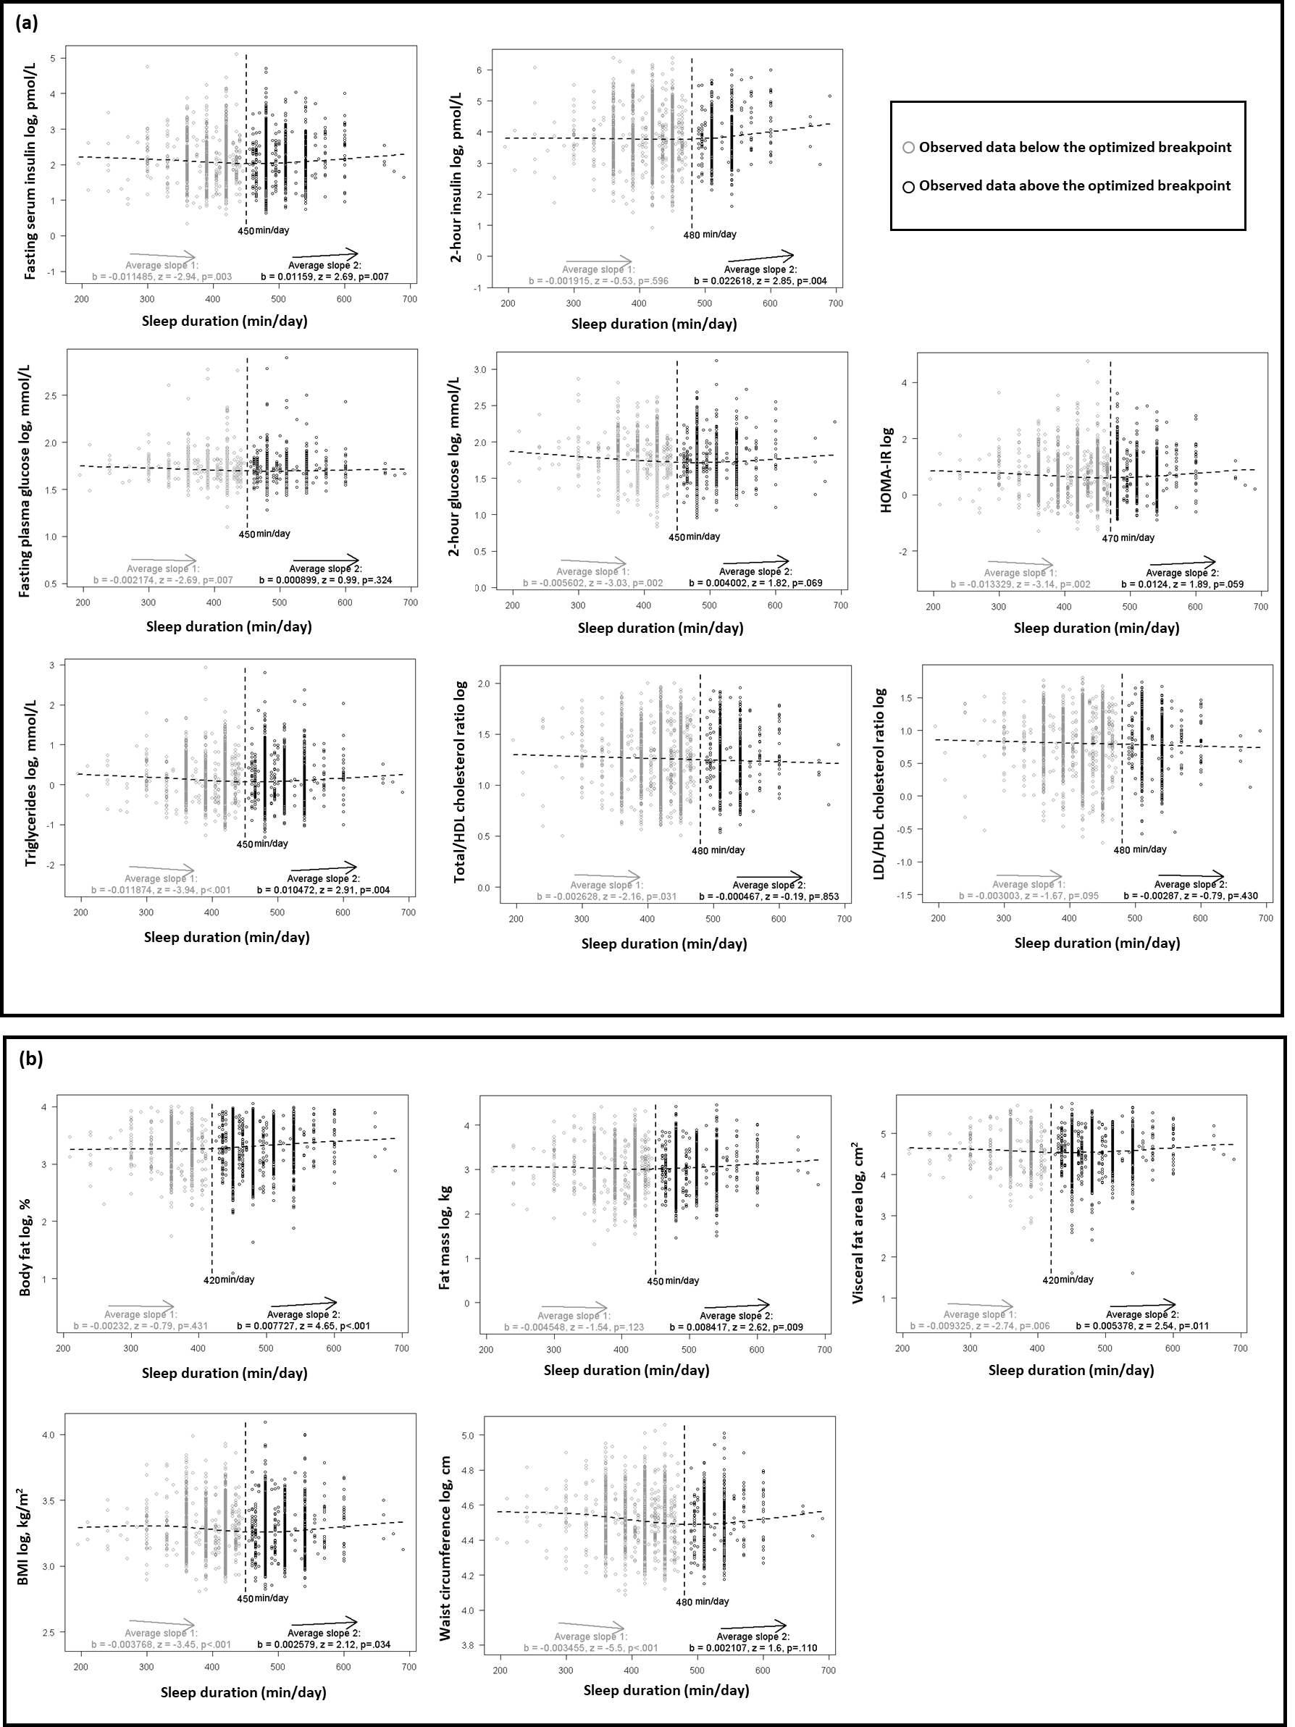

Supplementary Figure 1. The results of tests for U-shaped relationship between sleep duration and outcomes.
(a) tests for cardiometabolic biomarkers and (b) for adiposity measures.
A U-shape relationship is present if the two lines have an opposite slope sign (b coefficient), and are individually significant (p < 0.10). The vertical dashed line indicates the algorithmically selected breakpoint.
Abbreviations: min/day = minutes per day, BMI = body mass index, LDL = low-density lipoprotein, HDL = high-density lipoprotein, HOMA-IR = homeostatic model assessment of insulin resistance.

