SUPPLEMENTAL DIGITAL CONTENT

***Faith-Based Cognitive Behavioral Therapy:***

***Easing Depression in the Elderly with Cognitive Decline – Artwork Images***

*Journal of Christian Nursing,* 29:1, January/March 2012

Dagmar M. Ceramidas, PhD, OT, Centre for Mental Health Research and

Menzies Centre for Health Policy, The Australian National University

**Session 1**

*Theme:* Opening, introductions – winter becomes spring

*Aim:* Recognize that life has a balance of good and of difficult times; good can come out of what initially appears bad (Romans 8:28).

*Intervention:* Abstract painting using watercolors, vinyl paints, crayons, felt pens, charcoal and colored pencils.

*Image:* Being the first session and rapport had not yet been established, it was not appropriate to take photographs.

**Session 2**

*Theme:* Spring – colorful, joyous; new life, new beginnings; forgiveness.

*Aim:* Recall specific instances of joyous outcomes of life’s difficulties; trusting in God

(Proverbs 3:5; Hebrews 11)

*Intervention:* Air-dry clay modeling of baby animal, or of life emerging

*Image:* Clay model of mother kangaroo with joey. Sculptor: Participant MC.

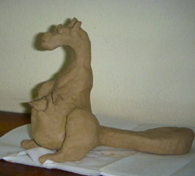

**Session 3**

*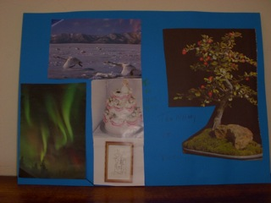Theme:* Celebration of personal joys of life

*Aim:* Facilitate residents’ recollection of actual joyous events in their lives (reflect on the goodness of God).

*Intervention:* Individual collages depicting individual joys of life; tearing pictures from

magazines and old books.

*Image*: This collage depicts the personal joys of the artist, participant MM. MM scored the

lowest of all participants on the MMSE.

MM spoke about the joy it brought her to grow and care for bonsai plants, “so many bonsais.” In the background, participant TF (non-verbal) made exhalation-sighs and ‘giggles’ as she maintained her involvement with the group. Participant MM referred to a “sad story” in response to identifying the wedding cake atop which only the bride remains. From other groups, we learned that MM had been happily married, twice, but both of her husbands died following stroke. She corrected the art therapist, “Its not a sad story, it's a *good* story.” MM considers artwork is “inspirational for everyone”.

MM’s sole international travelling experience was to Canada where she and her husband saw the aurelius borealis. Earlier in this session, participant MC asked her about the curious picture, and MM perfectly and without hesitation named the phenomenon.

*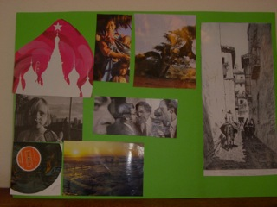Image:* Created by participant SA, this collage presents not only some of the joys of SAs life, but also her cheeky personality.

Participant SA had difficult speaking as a result of her long-term use of older-style anti-depressant medication. She speaks slowly and makes noticeable effort to be understood.

From previous sessions, we learned that SA loved art and music, and that she had travelled extensively following her divorce. Her favorite countries were Turkey, Greece and the Middle East. Referring to the middle-eastern looking laneway in the picture far right of the collage MC commented, “I’ve seen that on television lately.” The local news stories at that time featured the war in Iraq and in Afghanistan.

In conversation SA focused on the “cheeky little girl” and on the woman protecting young children. The researcher and art therapist both wondered whether the “cheeky girl” depicted SA herself. In a later session, SA revealed she had lost a child. On reflection, we wondered whether there might have been a link between the protective woman in the collage, and the loss of SAs child.

*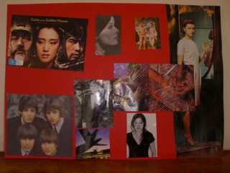 Image:* The red cardboard background for this collage was quickly chosen, almost ‘snatched’ by participant TF, the non-verbal participant.

TFs sister, participant SA, provided some of the possible explanation of the story of this collage.

To evoke explanation, art therapist Holly pointed to the picture of Adam and Eve’s nakedness, to which TF exclaimed, “It’s awful!”

Participant SA revealed later in the group that her sister TF had been a very beautiful young woman, but SA was unable to shed light on the Asian people featuring in the collage.

**Session 4**

*Theme:* God the healer, the glue of life; God restores all things

*Aim:* Explore what gives purpose, meaning to residents’ lives; explore residents’ concepts of God. (Psalm 23:3; John 3:16).

*Intervention:* Classical music; religious symbols (chalice, crucifix, praying hands, baptismal bracelet, etc); free artwork.

*Image:* The photographs from this session show participants’ faces and cannot be used.

**Session 5**

*Theme:* Life sustaining water – can God be trusted?

*Aim:* Explore residents’ learned concepts of God, discuss concept of God’s trustworthiness (John

4:10-14; 1 John 5:6-13).

*Intervention:* Collage done in pairs; tactile items – feathers, fluffy wool, bright colored gift

wraps, colored pipe cleaners, etc.

*Image:* Participants SA and MC spontaneously placed the river of God’s living water winding

vertically from the bottom to the top of the page. The red ‘arc’ at the left of the page is a

rainbow, “because the sun is shining and it’s raining (SA).

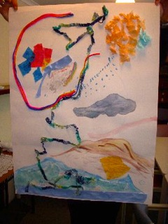

**Session 6**

*Theme:* Closure

*Aim:* Resolve that being in the Residential aged care facility community is a positive life event, with various benefits (Romans 8:28; 1 Timothy 4:10; 1 Timothy 6:17)

*Intervention:* Tea, cake; presentation of small bouquets for each participant. Decorating a mask – which face do we show?

*Image:* The photographs for this session showed each participant holding their mask to their face. Personal identification is possible from these photographs.