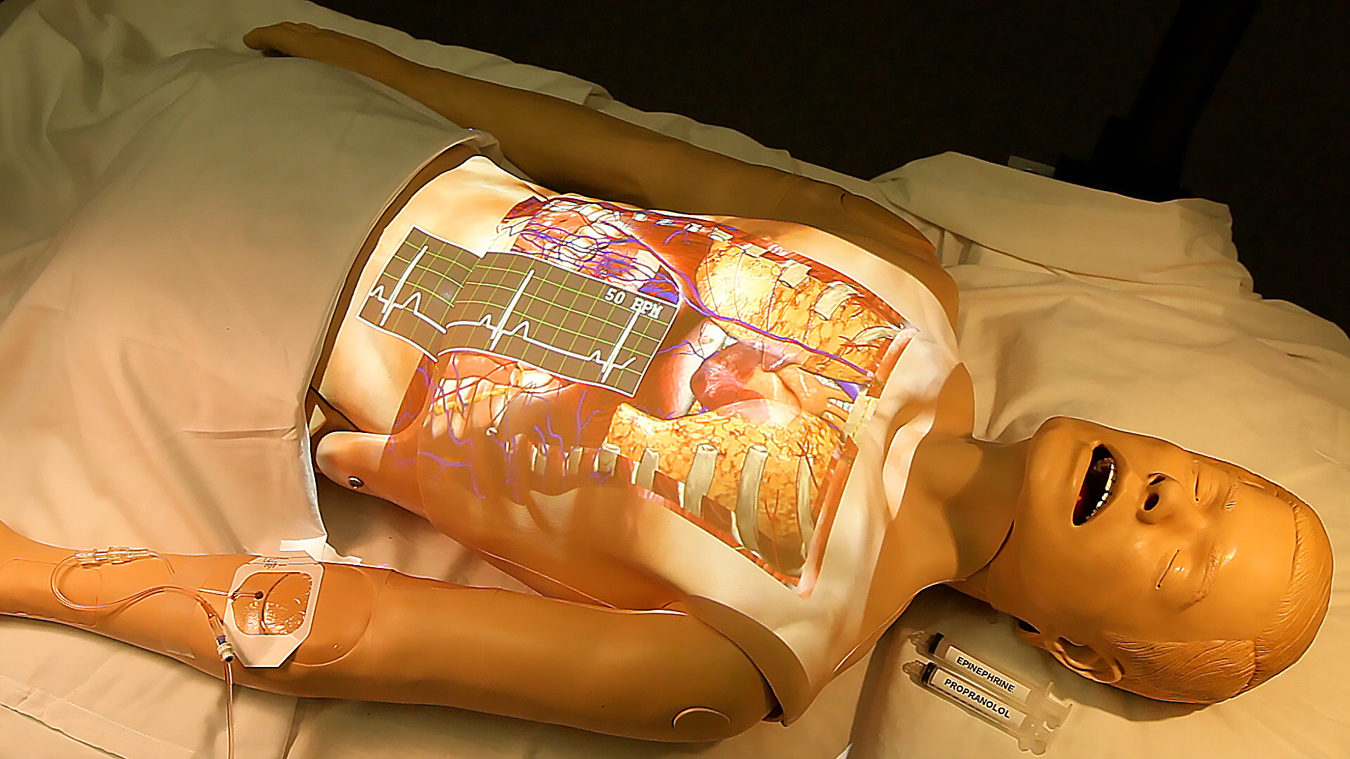
Figure 1. BodyExplorer augmented reality patient simulator. Copyright Joseph T. Samosky, University of Pittsburgh, Pittsburgh, PA, 2015. Reprinted by permission of Joseph T. Samosky, University of Pittsburgh, Pittsburgh, PA, 2015.

A video demonstration can be viewed at the following url: https://www.youtube.com/watch?v=FNWfDLjv1cg.

