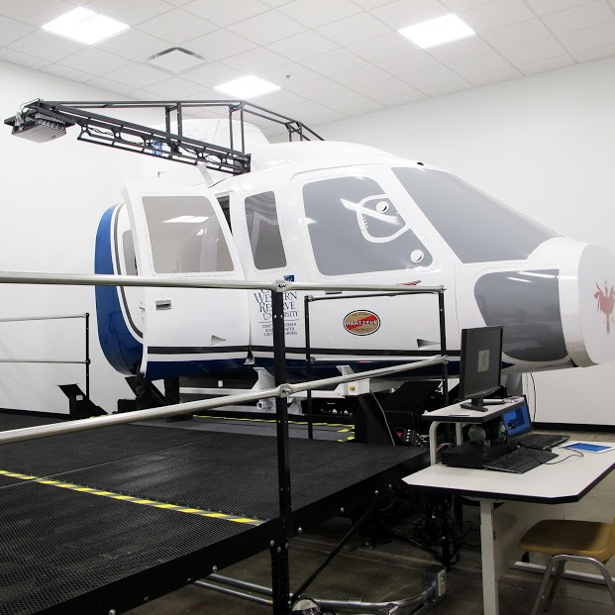
Figure 2. Flight Simulator. Copyright Frances Payne Bolton School of Nursing at Case Western University, Cleveland, Ohio, 2015, Reprinted by permission of Frances Payne Bolton School of Nursing at Case Western University, Cleveland, Ohio, 2015.

A video demonstration can be viewed at the following url:
https://www.youtube.com/watch?v=w-F9s9Qukqo

