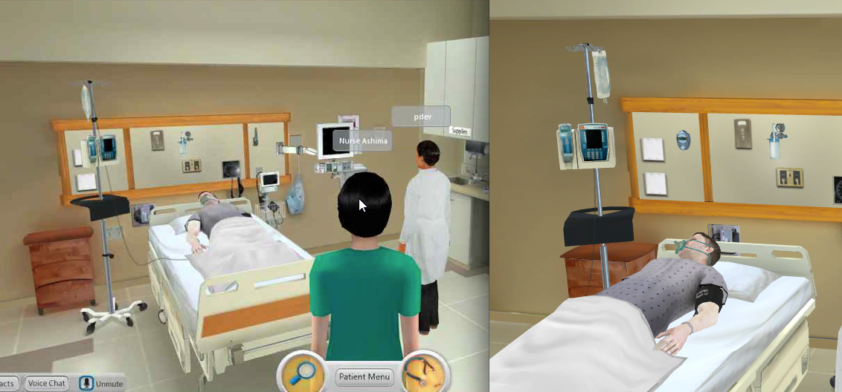
Figure 4. CliniSpace. Copyright Innovation in Learning, Inc., 2015. Reprinted by permission of Innovation in Learning, Inc., Los Altos Hills, CA, 2015.

A video demonstration can be viewed at the following url: http://virtualsimcenter.clinispace.com/

