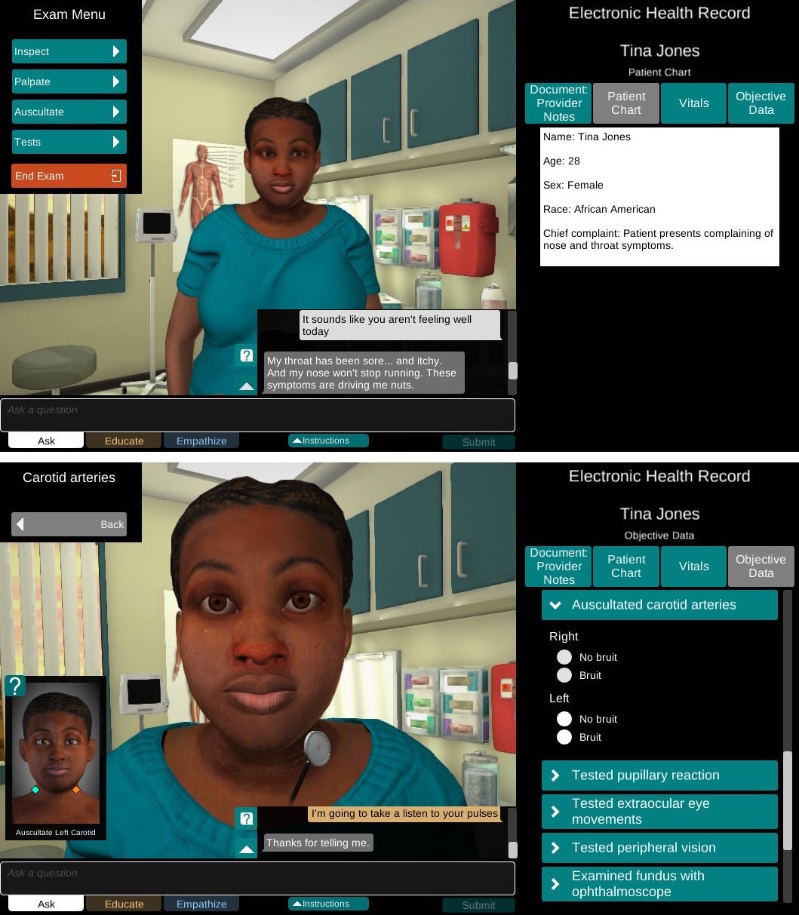
Figure 5. Shadow Health Digital Clinical Experience. Copyright Shadow Health, Gainesville FL, 2015. Reprinted by permission of Shadow Health, Gainesville, FL, 2016.

A video demonstration can be viewed at the following url: http://www.shadowhealth.com/advanced-health-assessment.html

