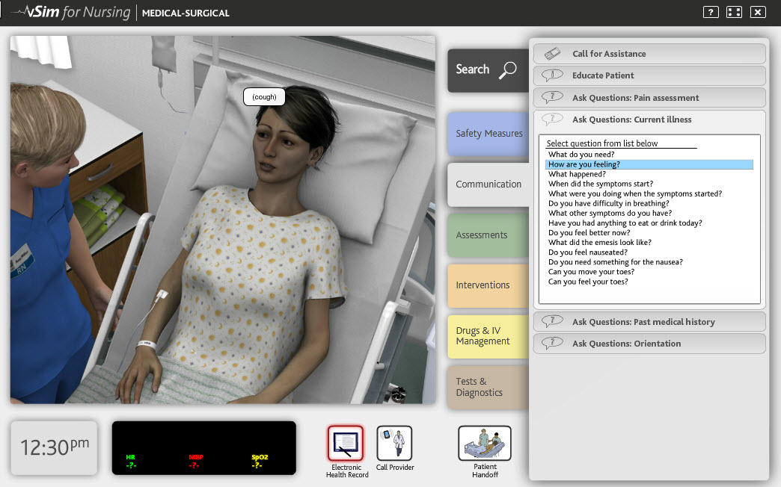
Figure 6. vSim for Nursing. Copyright Laerdal Medical and Wolters Kluwer Health, 2015. Reprinted by permission of Laerdal Medical and Wolters Kluwer Health, Philadelphia, PA, 2016

A video demonstration can be viewed at the following url: http://www.laerdal.com/us/vsim

