Supplemental Data. Figure. Estimate of Faculty trained in QSEN Competencies
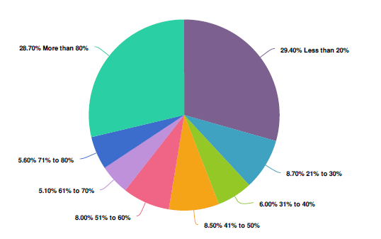
Reprinted by permission of the National League for Nursing, 2017.

